DPP9 might be one diagnostic and evaluative value of quantitative testing in the pre-examination of subscapularis muscle injury After Rotator Cuff Tear
Running title:DPP9 in subscapularis muscle injury

Yushan Zhang*, Wujun Huang, Chenhao Lv

Department of Orthopedics, Xinchang Hospital of Wenzhou Medical University, Xinchang 312500, China.

*Corresponding author: Yushan Zhang, Department of Orthopedics, Xinchang Hospital of Wenzhou Medical University, No. 66 Xiaoxing Road, Qixing Sub-district, Xinchang 312500, China. Tel:0575-86380780.Email:zhangyushan0123@outlook.com.

Abstract
Here, in the present study, we investigated the functional effects, potential evaluative value, and underlying molecular mechanisms of DPP9 in subscapularis muscle injury afterRotator Cuff Tear. .In both mouse models and in vitro models of subscapularis muscle injury, mRNA and protein expression levels of DPP9 were significantly upregulated. Functionally, overexpression of DPP9 exacerbated inflammatory responses and ROS-mediated mitochondrial oxidative stress in injured subscapularis muscle cells in vitro. Conversely, knockdown of DPP9 attenuated inflammation and mitochondrial oxidative damage in vitro. Consistently, shRNA-mediated silencing of DPP9 alleviated subscapularis muscle injury in mice by exerting anti-inflammatory and anti-oxidative effects.Notably, upregulation of DPP9 promoted ferroptosis in both in vivo and in vitro models of subscapularis muscle injury. Mechanistically, DPP9 physically interacted with Nrf2 protein and suppressed its ubiquitination in vitro. Furthermore, DPP9 modulated the Nrf2 signaling pathway to mitigate inflammation and ROS-dependent mitochondrial oxidative stress in subscapularis muscle injury, at least partially by inhibiting Nrf2-mediated ferroptosis.
Keywords: DPP9; Nrf2; subscapularis muscle injury; mitochondrial oxidation; ferroptosis

Introduction
Subscapularis muscle injuries (SMI) represent a highly prevalent clinical condition, and its incidence increases progressively with age, affecting up to 30% of individuals aged 60 years and older [1]. The primary clinical symptom is shoulder pain, and most patients present with varying degrees of limited shoulder mobility and shoulder weakness, which severely compromise their daily activities. Traditionally, open surgery has been widely adopted for the management of Lafosse type I subscapularis muscle injuries [2]. Although this approach could alleviate movement restrictions to some extent, the large surgical incision not only prolonged postoperative recovery time but also led to complications such as infections and bleeding [2]. With the advancement of minimally invasive techniques, arthroscopic surgery has gradually been increasingly applied in the treatment of subscapularis muscle injuries, mainly including arthroscopic debridement and repair. These minimally invasive approaches can effectively reduce surgical trauma and facilitate postoperative recovery [3]. However, clinical controversy still exists regarding the optimal selection between these two surgical modalities.

The subscapularis muscle is the strongest and most powerful component of the rotator cuff. It serves a critical role in maintaining the biomechanical stability of the glenohumeral joint and balancing the horizontal force couple of the shoulder joint [4]. Subscapularis muscle injuries represent a major cause of shoulder dysfunction, pain, and even pseudoparalysis [5]. Conservative pharmacotherapy and surgery are commonly used clinical methods for managing subscapularis muscle injuries [6]. As a minimally invasive approach, arthroscopic repair minimizes injury to the surrounding shoulder tissues, allows simultaneous treatment of concomitant rotator cuff tendon injuries, and reduces postoperative adhesion formation. This technique is safe, effective, and associated with rapid postoperative recovery, and has thus become a widely adopted surgical modality in clinical practice [7].
Growing evidence has demonstrated that oxidative stress constitutes a critical contributor to aging [8]. WDisruption of the cellular oxidative balance leads to excessive generation of reactive oxygen species (ROS) and impaired scavenging capacity, resulting in ROS accumulation and progressive oxidative damage that ultimately promotes cellular senescence and organismal aging. At present, administration of appropriate antioxidant agents represents an effective strategy to maintain sufficient free radical scavengers and preserve the homeostatic balance of the oxidative system in vivo [9]. When intracellular ROS levels surge dramatically, the endogenous free radical clearance system fails to match the rate of ROS production [10]. Massive accumulation of oxygen free radicals attacks normal cells and tissues, thereby further exacerbating muscle injury. Moreover, excessive free radicals promote lipid peroxidation, the extent of which can be directly reflected by alterations in muscular malondialdehyde (MDA) levels [11]. As the final product of lipid peroxidation, MDA serves as a reliable biomarker of oxidative stress. Its production indirectly reflects the severity of free radical-induced cellular injury, including the degree of muscle damage [12].
The nuclear factor erythroid 2-related factor 2 (Nrf2) pathway plays a pivotal role in regulating cellular antioxidant responses and protecting cells against ferroptosis [13]. Aberrant activation of this pathway is closely associated with tumor growth, metastasis, and chemoresistance [14]. Recent studies have demonstrated that inhibiting the activation of the Nrf2 pathway can increase oxidative stress, promote intracellular iron accumulation, and enhance lipid peroxidation, thereby inducing ferroptosis and improving the efficacy of chemotherapy [15-17]. Accordingly, targeting the Nrf2 pathway to induce ferroptosis has emerged as a promising strategy for enhancing the effectiveness of chemotherapy [18].
DPP9 is a glycoprotein consisting of 766 amino acids, which exhibits dipeptidase activity in its extracellular domain. It associates with or is released from the cell membrane via two distinct mechanisms. First, as a serine exopeptidase, DPP9 cleaves N-terminal dipeptides containing proline or alanine residues, including insulinotropic peptides and neuropeptides, which renders it relevant to the development of novel antidiabetic agents. Second, similar to DPP4, DPP9 mediates the degradation of various ligands such as signaling peptides, growth factors, cytokines, and extracellular matrix components, thereby attenuating or modifying the cellular responses triggered by these ligands [19]. DPP9 participates in extracellular signal transduction and cell migration and is ubiquitously expressed in diverse cell types.. DPP9 levels are highly expressed in patients with coronary atherosclerotic heart disease and are positively correlated with in-stent restenosis, making it a potential serum marker for postoperative restenosis in patients [20]. In addition, metabolic abnormalities, including insulin signaling dysregulation and mitochondrial dysfunction, contribute critically to the pathogenesis of neurological disorders such as Alzheimer’s disease. Several antidiabetic agents related to DPP9 inhibitors exert neuroprotective effects and preserve brain cognitive function [21]. Against this background, the present study aimed to investigate the functional role, potential evaluative value, and underlying molecular mechanisms of DPP9 in subscapularis muscle injury.
Methods and Materials

Network informatics and patients collection
Network informatics (GSE130447) were conducted as previously described [22]. Subscapularis muscle injuries patients was collected from our hospital. The studies were authorized by the Ethic Review Committees of our hospital. All experiments were strictly implemented in compliance with the NIH Guide for the Care and Use of Laboratory.

Animals (Rotator Cuff Tear, RCT) models and Biomechanical testing
The animal studies were authorized by the Animal Ethic Review Committees of our hospital. All animal experiments were strictly implemented in compliance with the NIH Guide for the Care and Use of Laboratory Animals. C57BL/6 mice were purchased from Animal Experimental Center of Wenzhou Medical University. The tendons of the supraspinatus and infra-spinatus muscles in the right shoulder were entirely transected near the humeral head. In the left shoulder, a sham surgery was conducted without tendon detachment to serve as a control. For shoulder function assays, both shoulders were injured to establish RCT models as literature [23]. C57BL/6 mice were anesthetized with Sodium pentobarbital (50 kg/mg), and then mice were sacrificed with cervical dislocation.

Cell Culture and Treatment
C2C12 myoblasts were grown in high-glucose Dulbecco’s modified Eagle medium supplemented with 10% fetal bovine serum and 1% penicillin/streptomycin for 5 days. C2C12 cells were transfected with negative or DPP9, si-nc or si-DPP9 using Lipofectamine 3000 (Invitrogen, CA).

ELISA and cell viability assay
4-HNE (H268-1-2), CAT (A007-1-1), MDA (A003-1-2), SOD (A001-3-2), GSH (A006-2-1), GSH-PX (A005-1-2) were performed as described in a previous study. [24] Cell viability was determined using CCK-8 assay (C0037, Beyotime) as described in a previous study. [25] Absorbance was measured on the Microplate Reader (Bio Tek, Winooski). EdU kit (C0075S, Beyotime) or LDH activity (C0016, Beyotime), Caspase3 (G01513), Caspase7 (H080) and caspase9 (G01811) were quantified Commercial reagent kit (Nanjing Jiancheng Bioengineering Research Institute) and Absorbance was measured at 450 nm using a fluorescent reader (Synergy H1 Microplate Reader, Bio Tek, Winooski).

Western Blot
Western Blotting Analysis and Immunofluorescence were executed as literature.^{[25]} DPP9 (ab302903, 1:1000, Abcam), NRF2 (ab62352, 1:1000, Abcam), GPX4 (ab125066, 1:1000, Abcam), β-actin (1:10000, AC028, Company ABclonal, Inc.) and Anti-Rabbit IgG (1:5000, GB23303, Servicebio) were used in this study. Protein was measured using an BeyoECL Plus kit (P0018S) and analyzed using an Image Lab 3.0 (BioRad Laboratories, Inc.). DPP9 (1:1000, Abcam), and DPP9 (1:1000, Abcam) was used for immunofluorescence analyses.

Immunohistochemical, and immunofluorescence analyses and electron microscopy
For immunohistochemical and immunofluorescence analyses, mouse tissue samples were fixed in 4% paraformaldehyde and stained as described in previous studies. [26] Samples were observed under a ﬂuorescence microscope (Zeiss Axio Observer A1, Germany) and a transmission electron microscope (80 kV) (Hitachi H7650, Tokyo, Japan) as described in a previous study [25].

Molecular docking model
Complexes were color-labeled, and 3D surface display was utilized according to the previously described [22, 27]. DPP9 and Nrf2 protein structures were obtained from RCSB PDB. Protein interaction analysis identified DPP9 binding regions on Nrf2, and imported into Pymol (version 2.3.0) to remove water molecules and small molecules.

Single-cell data
The tissue-specific expression of DPP9 in patients with hindlimb muscle biopsies was evaluated using single-cell data from the China National GeneBank and the CNP0004495 dataset as literature [17]. The study also indicated the source of the original data.

Statistical Analysis
P < 0.05 was considered significant and evaluated using Student’s t-test or one-way analysis of variance (ANOVA) followed by Tukey’s post-test. Data were expressed as mean ± standard deviation (SD).

Results

Expression of DPP9 in patients with SMI
First, we screened potential disease targets involved in the occurrence and progression of SMI. DPP9 expression was downregulated in SMI mouse samples from the GSE130447 dataset (Figure 1A). Consistently, DPP9 mRNA expression was also down-regulated in patients with SMI (Figure 1B). CBX3 protein expression was decreased in mice with SMI (Figure 1C). In an in vitro model of SMI, CBX3 mRNA expression was down-regulated in a time-dependent manner (Figure 1D).

DPP9 expression in muscle cells from SMI patients
We further explored the role of DPP9 in SMI models using Single Cell Analysis. Subsequently, the expression of DPP9 in muscle cells patients was assessed using Single Cell Analysis (Figure 2A-2B). DPP9 was clearly expressed in muscle cells of SMI patients (Figure 2C). In contrast, DPP9 was not detected in B cells, T cells, or macrophages from SMI patients (Figure 2D-2E).

DPP9 reduced subscapularis muscle injury in mice model or in vitro model
We next investigated the effects of DPP9 on esubscapularis muscle injury in model of SMI. In an mouse model, DPP9 up-regulation reduced Stance width, The paw area at peak stance, and Stride length, and expanded Endurance time and Fatigue time in mice model of SMI (Figure 3A-3E). Overexpression of DPP9 alleviated subscapularis muscle injury in SMI mice, as evidenced by HE and Masson staining (Figure 3F-3G). Meanwhile, DPP9 up-regulation suppressed mRNA expression of ACACA, C/EBPa, FASN, PLIN1 and PPARγin SMI model mice (Figure 3H). In in vitro models, transfection with DPP9 plasmid significantly elevated DPP9 mRNA levels, whereas treatment with si-DPP9 reduced DPP9 expression (Figure 4A–4B). Overexpression of DPP9 inhibited mRNA levels of ACACA, C/EBPα, FASN, PLIN1, and PPARγ (Figure 4C–4G). Conversely, knockdown of DPP9 induced the expression of these genes (Figure 4H–4L).
DPP9 reduced inflammation and ROS-induced oxidation in model of subscapularis muscle injury
In both mouse and in vitro models of SMI, upregulation of DPP9 attenuated inflammatory responses and ROS-induced oxidative damage (Figure 5A–5B, Figure 6A–6C). Consistently, si-DPP9–mediated knockdown of DPP9 exacerbated inflammation and oxidative stress in the in vitro SMI model (Figure 5C, Figure 6D–6E).
DPP9 reduced mitochondrial damage in model of subscapularis muscle injury
Next, DPP9 up-regulation increased mitochondria CoCl2 levels and JC-1 assay levels, and reduced mitochondrial damage (mitochondrial damage) in an in vitro model of Subscapularis muscle injury (Figure 7A-7B, 7E). DPP9 down-regulation reduced CoCl2 levels and JC-1 assay levels, and promoted mitochondrial damage (mitochondrial damage) in an in vitro model of Subscapularis muscle injury (Figure 7C-7D, 7F).

DPP9 reduced ferroptosis in model of subscapularis muscle injury
We further explored whether DPP9 regulates ferroptosis triggered by mitochondrial oxidative stress in SMI. In the mouse SMI model, DPP9 overexpression decreased iron concentration, FeRhNOX-1 levels, and ferrous iron levels, inhibited LDH activity, and enhanced GSH activity as well as GPX4 protein expression (Figure 8A–8E). Similarly, in the in vitro SMI model, DPP9 upregulation reduced FeRhNOX-1 and ferrous iron levels and suppressed LDH activity (Figure 8F–8I). Conversely, si-DPP9 increased FeRhNOX-1 and ferrous iron levels and promoted LDH release (Figure 8J–8M). Moreover, DPP9 overexpression enhanced GSH activity and GPX4 protein expression, whereas DPP9 knockdown exerted the opposite effects in vitro (Figure 8N–8O).
DPP9 protein interlinked Nrf2 protein to reduce Nrf2 ubiquitination in vitro model of SMI
Next, this study elucidated that the mechanism of DPP9 on NRF2 in model of SMI. In mouse SMI models, DPP9 overexpression upregulated Nrf2 expression (Figure 9A). In muscle tissues from SMI mice, DPP9 overexpression increased both DPP9 and Nrf2 protein levels (Figure 9B). Consistently, DPP9 overexpression also elevated DPP9 and Nrf2 protein expression in the in vitro SMI model (Figure 9C). Immunofluorescence staining confirmed that DPP9 upregulation enhanced the expression of DPP9 and Nrf2 in vitro (Figure 10D). In contrast, DPP9 knockdown suppressed DPP9 and Nrf2 protein levels in the in vitro SMI model (Figure 9E).Most structural regions of NRF2 display low confidence. The high-confidence segment (highlighted in pink) was extracted and used to molecular docking with DPP9. Subsequently, the low-confidence regions of the resulting complex (shown in gray) were removed, followed by molecular dynamics (MD) simulations (Figure 10A).
During the simulation, the root-mean-square deviation (RMSD) gradually decreased and stabilized over time, indicating progressive stabilization of the receptor–ligand complex—and their binding interface—became increasingly stable (Figure 10B). Similarly, the radius of gyration (Rg) also tended to stabilize, further confirming the structural stabilization of the receptor–ligand complex (Figure 10C). The terminal regions of the ligand protein, corresponding to low-confidence sequences, were under relatively weak structural constraints, especially within the ligand itself. This led to obvious fluctuations at the terminals and correspondingly elevated root-mean-square fluctuation (RMSF) value (Figures 10D–10E).
The buried solvent-accessible surface area (SASA) increased steadily during the simulation and eventually converging with reduced fluctuations. This suggests that the contact area and binding interface between the receptor and ligand proteins gradually stabilized, indicative of increasingly robust intermolecular interactions (Figure 10F).

Hydrogen bonding are crucial rfor protein–ligand interactions. Since hydrogen bonding is closely associated with electrostatic interactions, the number of hydrogen bonds can reflect the intensity of such forces. As shown in the figure, the number of hydrogen bonds remained relatively high, fluctuating consistently between 10 and 20, thereby contributing to substantial electrostatic interactions between the receptor and ligand proteins (Figure 10G). Furthermore, van der Waals (VDW) interactions within the complex exhibited minor fluctuations and high stability. In comparison, electrostatic (ELE) interactions were stronger than VDW but showed greater variability, thus primarily dictating the trend of the overall binding energy. During the simulation, the binding energy gradually stabilized with diminishing fluctuations, further confirming the conclusion that progressive stabilization of the complex structure and receptor–ligand binding (Figure 10H).
To identify key residues responsible for binding, the binding energy (ΔEMMPBSA) was decomposed on a per-residue basis, allowing the identification of critical amino acids. As shown in Figures 10I–10J, key receptor residues contributing significantly to ligand binding included ARG-95, LYS-92, LYS-93, and ARG-844, among others. Meanwhile, key ligand residues that formed strong interactions with the receptor included ASP-13, THR-64, and GLU-39 (Figures 10I–10J). As presented in Figure 10K, the binding interface between the receptor and ligand exhibited high morphological complementarity, accompanied by abundant hydrogen bond interactions, indicating stable overall binding between the two proteins.IP analysis demonstrated that DPP9 WT protein interacts with the NRF2 WT protein, while the DPP9 WT protein does not interact with the NRF2 Mut protein, and the DPP9 Mut protein does not link with the NRF2 WT protein (Figure 10L). IP analysis demonstrated that the DPP9 up-regulation promoted ubiquitination of NRF2 protein of microglial in model of Subscapularis muscle injury (Figure 10M). Then, DPP9 down-regulation reduced ubiquitination of NRF2 protein in model of Subscapularis muscle injury (Figure 10M).

Nrf2 inhibitor reduced the effects of DPP9 on ferroptosis and ROS-induced oxidation in model of subscapularis muscle injury
Subsequently, the Nrf2 inhibitor (C25-140, 10 μM) abolished the regulatory effects of DPP9 on Nrf2/GPX4 protein expressions, subscapularis muscle injury, inflammation, oxidative stress, mitochondrial damage and ferroptosis in vitro model of subscapularis muscle injury (Figure 11).
Discussion
Subscapularis muscle injuries are closely associated with factors patient age, trauma, and lifestyle habits [28]. Affected patients primarily present with clinical symptoms including joint swelling, limited mobility, pain, and muscle weakness, all of which severely impair daily work and quality of life [29]. The shoulder joint is anatomically adjacent to critical blood vessels and nerves [30]. Arthroscopic repair can effectively restore shoulder joint structure and function [31]. However, the restricted surgical field inherent to arthroscopy inevitably causes certain vascular and nerve injuries, often resulting in unsatisfactory postoperative recovery [32]. In this study, DPP9 expressions were down-regulation in model of SMI. Meanwhile, DPP9 was found to be expressed in muscle cells of SMI patients. Of note, Guan et al. reported elevated DPP9 protein levels in acute kidney injury were elevated [33]. Collectively, these findings indicate that DPP9 may serve as a promising therapeutic target for the management of SMI.
The operating room serves as a vital medical environment for performing surgical operations and saving patients’ lives. Surgical procedures are inherently high-tech and high risk [34]. Therefore, deficiencies in operating room nursing management or care protocols can readily give rise to surgical safety risks [35]. Thus, enhancing the team's risk awareness and improving surgical safety are of significant importance. The subscapularis muscle is an important structure of the shoulder joint, which contributes to shoulder internal rotation, restrains excessive external rotation, and thereby maintains anterior shoulder stability [6]. The etiology of subscapularis muscle injuries can be categorized into traumatic and non-traumatic factors. Injury to the subscapularis muscle may destabilize the long head of the biceps tendon, resulting in its dislocation and longitudinal tearing, which triggers severe shoulder pain [5]. As the condition progresses, shoulder mobility becomes significantly restricted, severely impairing the patient’s daily activities [36]. We found that DPP9 reduced subscapularis muscle injury in mice model or in vitro model. Wang et al. reported that pinocembrin suppressed NLRP1 inflammasome by the activation of DPP9 in model of middle cerebral artery occlusion/reperfusion [37]. These findings suggest that upregulation of DPP9 may exert protective effects against subscapularis muscle injury and other tissue damage.
In the present study, we demonstrated that DPP9 alleviated subscapularis muscle injury in both mouse and in vitro models. Wang et al. reported that pinocembrin inhibited the NLRP1 inflammasome via activating DPP9 in a middle cerebral artery occlusion/reperfusion model [37]. These findings suggest that upregulation of DPP9 may exert protective effects against subscapularis muscle injury and other tissue damage.
Studies have demonstrated that during cellular senescence, systemic ROS production is elevated. Upon disruption of redox homeostasis, the activities of GSH, SOD, and CAT as well as T-AOC levels are decreased, whereas malondialdehyde (MDA) content is markedly increased [16, 38]. Excessively accumulated MDA indirectly induces the overexpression of pro-apoptotic proteins, thereby triggering apoptotic cell death [39]. Muscle injury is characterized by damage to sarcomeres and the sarcoplasmic reticulum membrane. Injury to the sarcoplasmic reticulum leads to massive Ca²⁺ influx, which further activates proteases and phospholipase A, ultimately promoting myofiber degradation [40]. Histopathological observations under light microscopy reveal swollen and enlarged myofibers, which transform from a normal polygonal morphology into a rounded shape [41]. Muscle cell nuclei are irregularly distributed, myofibers appear translucent, and inflammatory cell infiltration is evident around damaged myofibers [42]. Muscle injury further triggers a cascade of inflammatory responses. As tissue damage induces apoptosis or necrosis of muscle cells, locally inflamed regions exhibit exudation of tissue fluid and plasma proteins accompanied by leukocyte infiltration, resulting in significantly elevated expression of inflammatory cytokines including IL-6, TNF-α, and IL-1β [24]. We found that DPP9 reduced inflammation and ROS-induced oxidation in model of subscapularis muscle injury. Consistent with our findings, Ángela Del Castillo-Izquierdo et al. showed that DPP9 might be one key gene associated with pulmonary inflammation in severe acute respiratory syndrome coronavirus [19]. Zhou et al. showed that DPP9 regulates ROS in liver cancer cells [43]. Collectively, these data indicate that DPP9 mitigates oxidative stress and inflammatory responses in muscle cells under SMI conditions.Muscle regeneration is a highly coordinated biological process. Studies have shown that muscle repair typically initiates with myofiber degeneration, which exhibits morphological features similar to [27]. Under pathological conditions, excessive necroptosis often induces robust pro-inflammatory responses and thereby exacerbates tissue damage. Ferroptosis is a recently reported novel form of cell death, whose specific mechanism involves iron overload leading to lipid peroxidation, thereby causing cell death. Ferroptosis is associated with various cellular processes such as iron homeostasis, redox homeostasis, and lipid metabolism [44]. GPX4 serves as a key enzyme in mammalian cells that specifically detoxifies lipid ROS, thereby counteracting ferroptotic cell death [18]. We found that DPP9 reduced mitochondrial damage and ferroptosis of muscle cells in model of SMI. Chang et al. showed that DPP9 regulated ferroptosis in Clear Cell Renal Cell Carcinoma [20]. So, DPP9 could reduce mitochondrial damage-induced ferroptosis of muscle cells in model of SMI.
Studies have demonstrated that ferroptosis is governed by multi-layered molecular regulatory mechanisms, among which the Nrf2/SLC7A11/GPX4 axis serves a pivotal role [45, 46]. As a central regulator of the cellular antioxidant defense system, Nrf2 precisely modulates the transcription of downstream anti-ferroptotic genes, including HO-1, SLC7A11, and GPX4, thereby maintaining intracellular redox homeostasis and eliminating accumulated lipid peroxides [47]. In this study, DPP9 protein interlinked Nrf2 protein to reduce Nrf2 ubiquitination in vitro model of SMI. Nrf2 inhibitor reduced the effects of DPP9 on ferroptosis and ROS-induced oxidation in model of subscapularis muscle injury. Consistent with our findings, Chang et al. showed that DPP9 Stabilizes NRF2 in Clear Cell Renal Cell Carcinoma [20]. Mechanistically, DPP9 attenuated Nrf2 ubiquitination and thereby promoted Nrf2 protein expression in muscle cells under SMI conditions.
In summary, DPP9 interacts with NRF2 protein and inhibits NRF2 ubiquitination in muscle cells under SMI conditions . DPP9 attenuates Mitochondrial oxidation-induces ferroptosis and inflammation in model of SMI. Therefore, targeting DPP9 may represent a potentially effective therapeutic strategy for SMI.

Declaration
clinical trial
Not applicable.
Ethics approval and consent to participate
All animal experiments was approved by the Ethical Committee of Xinchang Hospital of Wenzhou Medical University , and strictly implemented in compliance with the NIH Guide for the Care and Use of Laboratory Animals. All procedures were performed in accordance with ARRIVE guidelines.

The study was conducted in accordance with the Declaration of Helsinki and its subsequent amendments. The study was approved by the ethics committee of Xinchang Hospital of Wenzhou Medical University and written informed consent was taken from all the patients.

Consent to publish
Not applicable.
Competing interests
The authors declare that they have no conflict of interest.
Availability of data and material
The data sets used and analyzed in the current study are available on reasonable request from the corresponding authors.
Funding
This study was supported by 2024 Science and Technology Program of Xinchang County (No. JFZC2438).
Authors' contributions
YSZ developed the study concept and revised the manuscript accordingly. WJH and CHL analyzed and interpreted the data. YSZ and CHL conducted the experiments and data analysis, and were involved in the preparation of the figures and manuscript. YSZ and WJH drafted the manuscript. All authors contributed to the editing of the manuscript and approved the submitted version.
Acknowledgements
Not applicable.
Conflict of interest
The authors state that there are no financial, personal, or professional conflicts of interests that may hinder this work.

References

[1] Kim H, Jang HJ, Koh KH and Cha Y. Possible Association between Rotator Cuff Repair and Suicide: A Nationwide Cohort Study Using Propensity Score Matching. Clin Orthop Surg 2025; 17: 846-854.
[2] Lin H, Tang Y, Xiang W, Liu L, Zhou Y and Lin Q. LncRNA CRNDE regulates the differentiation of tendon-derived stem cells and enhances rotator cuff injury repair by modulating the miR-337/TGFBR2 axis. Int J Clin Exp Pathol 2025; 18: 481-493.
[3] Aydın A, Çakar B, Uzun MF, Gönen ZB, Gürbüz İ, Yay AH, Canbaz SB, Karmaz M, Ermiş M and Uzun E. The effects of N-acetylcysteine and adipose-derived stem cells on tendon healing in chronic rotator cuff tears: a rabbit model study. BMC Musculoskelet Disord 2025; 26: 1014.
[4] Dickinson RN and Kuhn JE. Nonoperative Treatment of Rotator Cuff Tears. Phys Med Rehabil Clin N Am 2023; 34: 335-355.
[5] Ishikawa H, Smith KM, Wheelwright JC, Christensen GV, Henninger HB, Tashjian RZ and Chalmers PN. Rotator cuff muscle imbalance associates with shoulder instability direction. J Shoulder Elbow Surg 2023; 32: 33-40.
[6] Davies MR, Ravishankar B, Laron D, Kim HT, Liu X and Feeley BT. Rat rotator cuff muscle responds differently from hindlimb muscle to a combined tendon-nerve injury. J Orthop Res 2015; 33: 1046-1053.
[7] Collin P, Matsumura N, Lädermann A, Denard PJ and Walch G. Relationship between massive chronic rotator cuff tear pattern and loss of active shoulder range of motion. J Shoulder Elbow Surg 2014; 23: 1195-1202.
[8] Xiang L, Deng H and Zhou S. Effects of TNF-α on Behaviour and Inflammation in Rats with Rotator Cuff Injury through NGF. Discov Med 2024; 36: 1241-1249.
[9] Tsurukami H, Itoigawa Y, Hatae F, Yoshida K, Tatebayashi Y, Morikawa D, Uehara H, Saigo Y, Yoshimura Y, Maezawa K and Ishijima M. Involvement of Oxidative Stress and Glycation Stress in Frozen Shoulder. J Bone Joint Surg Am 2025; 107: 2163-2169.
[10] Itoigawa Y, Yoshida K, Nojiri H, Morikawa D, Kawasaki T, Wada T, Koga A, Maruyama Y and Ishijima M. Association of Recurrent Tear After Arthroscopic Rotator Cuff Repair and Superoxide-Induced Oxidative Stress. Am J Sports Med 2021; 49: 2048-2055.
[11] Uehara H, Itoigawa Y, Wada T, Morikawa D, Koga A, Nojiri H, Kawasaki T, Maruyama Y and Ishijima M. Relationship of superoxide dismutase to rotator cuff injury/tear in a rat model. J Orthop Res 2022; 40: 1006-1015.
[12] Ertürk C, Çalışkan G and Erel Ö. Preliminary results of clinical, biochemical, and radiological investigation into the oxidative status in patients with rotator cuff tendinopathy. Acta Orthop Traumatol Turc 2024; 58: 161-166.
[13] Gallorini M, Berardi AC, Gissi C, Cataldi A and Osti L. Nrf2-mediated cytoprotective effect of four different hyaluronic acids by molecular weight in human tenocytes. J Drug Target 2020; 28: 212-224.
[14] Gallorini M, Berardi AC, Ricci A, Antonetti Lamorgese Passeri C, Zara S, Oliva F, Cataldi A, Carta F and Carradori S. Dual Acting Carbon Monoxide Releasing Molecules and Carbonic Anhydrase Inhibitors Differentially Modulate Inflammation in Human Tenocytes. Biomedicines 2021; 9:
[15] Chen Z, Liu Y, Liang T, Du Z, Deng L, Wu Z, Li Y, Zhong H, Ma J, Li R, Wang H, Dong Q, Yu T and Zheng X. Enhanced rotator cuff tendon-bone interface regeneration with injectable manganese-based mesoporous silica nanoparticle-loaded dual crosslinked hydrogels. Front Bioeng Biotechnol 2025; 13: 1645970.
[16] Yazar İ, Sarıkaya B, Koyuncu İ, Gönel A, Bozkurt C, Sipahioğlu S, Çetin BV and Altay MA. Evaluation of oxidative stress in degenerative rotator cuff tears. J Shoulder Elbow Surg 2022; 31: e490-e497.
[17] Zhang W, Yang H, Sui B, Gui Y, Sun J, Shui Y and Pu Z. Ophiopogonin C protects against acute lung injury by fatal sepsis through pyroptosis macrophage. Phytomedicine 2025; 142: 156698.
[18] Chen D, Tang Q, Song W and He Y. Platelet-derived exosomes alleviate tendon stem/progenitor cell senescence and ferroptosis by regulating AMPK/Nrf2/GPX4 signaling and improve tendon-bone junction regeneration in rats. J Orthop Surg Res 2024; 19: 382.
[19] Del Castillo-Izquierdo Á, Moreno-Navarrete JM, Latorre J, Arnoriaga-Rodríguez M, Ballanti M, Monteleone G, Alessandro Paoluzi O, Mingrone G, Puig J, Ramos R, Garre-Olmo J, Jové M, Pamplona R, Portero-Otín M, Sol J, Lefebvre P, Staels B, Federici M, Fernández-Real JM and Mayneris-Perxachs J. DPP9 as a Potential Novel Mediator in Gastrointestinal Virus Infection. Antioxidants (Basel) 2022; 11:
[20] Chang K, Chen Y, Zhang X, Zhang W, Xu N, Zeng B, Wang Y, Feng T, Dai B, Xu F, Ye D and Wang C. DPP9 Stabilizes NRF2 to Suppress Ferroptosis and Induce Sorafenib Resistance in Clear Cell Renal Cell Carcinoma. Cancer Res 2023; 83: 3940-3955.
[21] Bauernfried S and Hornung V. DPP9 restrains NLRP1 activation. Nat Struct Mol Biol 2021; 28: 333-336.
[22] Pu Z, Gui Y, Wang W, Shui Y, Xie H and Zhao M. Ophiopogonin D from Ophiopogon japonicas-induced USP25 Activity to Reduce Ferroptosis of Macrophage in Acute Lung Injury by the Inhibition of Bound Rac1 and Nox1 Complex. Am J Chin Med 2025; 53: 501-522.
[23] Lin X, Song Q, Kuati A, Li Z, Zhou H, Feng S, Wang M, Zhu S, Cui G, Wang J and Shao X. Unravelling the Role of PIEZO1 in Adipogenesis of Fibrogenic/Adipogenic Progenitors for Muscle Fat Infiltration After Rotator Cuff Tear. J Cachexia Sarcopenia Muscle 2025; 16: e70004.
[24] Pu Z, Wang W, Xie H and Wang W. Apolipoprotein C3 (ApoC3) facilitates NLRP3 mediated pyroptosis of macrophages through mitochondrial damage by accelerating of the interaction between SCIMP and SYK pathway in acute lung injury. Int Immunopharmacol 2024; 128: 111537.
[25] Pu Z, Sui B, Wang X, Wang W, Li L and Xie H. The effects and mechanisms of the anti-COVID-19 traditional Chinese medicine, Dehydroandrographolide from Andrographis paniculata (Burm.f.) Wall, on acute lung injury by the inhibition of NLRP3-mediated pyroptosis. Phytomedicine 2023; 114: 154753.
[26] Pu Z, Shen C, Zhang W, Xie H and Wang W. Avenanthramide C from Oats Protects Pyroptosis through Dependent ROS-Induced Mitochondrial Damage by PI3K Ubiquitination and Phosphorylation in Pediatric Pneumonia. J Agric Food Chem 2022; 70: 2339-2353.
[27] Pu Z, Li L, Zhang Y, Shui Y, Liu J, Wang X, Jiang X, Zhang L and Yang H. Exploring the therapeutic potential of HAPC in COVID-19-induced acute lung injury. Phytomedicine 2025; 139: 156563.
[28] Luck C, Roos RE, Lambiase J, Riffitts M, Scholle L, Kulkarni S, Parmanto D, Putraadinatha V, Yoga MD, Lang SN, Tatko E, Grant J, Oakley JI, Disantis A, Saptono A, Parmanto B, Popchak A, Bell KM and McClincy MP. The Development of iA CuffLink for Rotator Cuff Repair Telerehabilitation. Sensors (Basel) 2025; 25:
[29] Nakashima S, Kawada M, Takeshita Y, Miyazaki T, Fukuda M, Matsuura H and Kiyama R. Compensatory mechanisms to maintain glenohumeral joint stability in rotator cuff tears of differing severity during activities of daily living: A musculoskeletal model simulation study. PLoS One 2025; 20: e0335647.
[30] Mun JW, Oh SY, Hyun SW and Kim SH. Association between Hypertrophic Change of Greater Tuberosity in Plain Radiography and Rotator Cuff Tears. Clin Orthop Surg 2025; 17: 855-861.
[31] Mou L, Zhang W, Liao J, Zhang S, Zhao L, Aimaiti R, Abuduxiku M, Xiang W, Deng Y and Fang R. Effect of preoperative sleep quality on rapid postoperative recovery from non-traumatic rotator cuff injuries. Front Med (Lausanne) 2025; 12: 1587685.
[32] Misuo H, Ozone K, Yoneno M, Usami Y, Takahata K, Minegishi Y, Arakawa K and Kokubun T. Exercise Initiation After Surgical Reconstruction for Rat Rotator Cuff Injury Affects Tendon Healing and Muscle Preservation. J Orthop Res 2025;
[33] Guan K, Zhang Y, Guo S, Ning X and Sun S. DPP8 and DPP9 promote tubular epithelial cell ferroptosis in acute kidney injury. Eur J Med Res 2025; 30: 630.
[34] Park SJ, Lee YS, Yoon JP and Chung SW. Fenofibrate Attenuates Rotator Cuff Muscle Fatty Infiltration via Modulation of the PPARα-FABP4 Pathway. Am J Sports Med 2025; 3635465251382858.
[35] Yang X, Yang Y, Qin S and Chen Y. Research progress of rebound pain after nerve block in arthroscopic rotator cuff repair. Front Med (Lausanne) 2025; 12: 1659133.
[36] Dang A and Davies M. Rotator Cuff Disease: Treatment Options and Considerations. Sports Med Arthrosc Rev 2018; 26: 129-133.
[37] Wang P, Pan L, Liu Q, Huang Y, Tang Y, Lin B, Liao Y, Luo H and Meng X. Pinocembrin activation of DPP9 inhibits NLRP1 inflammasome activation to alleviate cerebral ischemia/reperfusion-induced lung and intestinal injury. Immunol Res 2024; 73: 13.
[38] Yoshida K, Itoigawa Y, Wada T, Maruyama Y, Nojiri H, Kawasaki T and Kaneko K. Association of Superoxide-Induced Oxidative Stress With Rotator Cuff Tears in Human Patients. J Orthop Res 2020; 38: 212-218.
[39] Xu D, Liu Q, Wang J, Yin E, Zhou B, Li X and Shi Y. Muscle-Derived Mitochondria as a Novel Therapy for Muscle Degeneration After Rotator Cuff Tears. J Bone Joint Surg Am 2025; 107: e63.
[40] Giancola R, Oliva F, Gallorini M, Michetti N, Gissi C, Moussa F, Antonetti Lamorgese Passeri C, Colosimo A and Berardi AC. CD200 as a Potential New Player in Inflammation during Rotator Cuff Tendon Injury/Repair: An In Vitro Model. Int J Mol Sci 2022; 23:
[41] Greis AC, Derrington SM and McAuliffe M. Evaluation and nonsurgical management of rotator cuff calcific tendinopathy. Orthop Clin North Am 2015; 46: 293-302.
[42] Chen B, Zhao X, Xu M, Luo J, Bai L, Han Q, Gao Y, Guo B and Yin Z. Inflammation-Responsive Functional Core-Shell Micro-Hydrogels Promote Rotator Cuff Tendon-To-Bone Healing by Recruiting MSCs and Immuno-Modulating Macrophages in Rats. Adv Healthc Mater 2025; 14: e2404091.
[43] Zhou Y, Chen Y, Xuan C, Li X, Tan Y, Yang M, Cao M, Chen C, Huang X and Hu R. DPP9 regulates NQO1 and ROS to promote resistance to chemotherapy in liver cancer cells. Redox Biol 2024; 75: 103292.
[44] Tong Z, Li H, Jin Y, Sheng L, Ying M, Liu Q, Wang C and Teng C. Mechanisms of ferroptosis with immune infiltration and inflammatory response in rotator cuff injury. Genomics 2023; 115: 110645.
[45] Shen K, Wang X, Wang Y, Jia Y, Zhang Y, Wang K, Luo L, Cai W, Li J, Li S, Du Y, Zhang L, Zhang H, Chen Y, Xu C, Zhang J, Wang R, Yang X, Wang Y and Hu D. miR-125b-5p in adipose derived stem cells exosome alleviates pulmonary microvascular endothelial cells ferroptosis via Keap1/Nrf2/GPX4 in sepsis lung injury. Redox Biol 2023; 62: 102655.
[46] Wang Y, Yan S, Liu X, Deng F, Wang P, Yang L, Hu L, Huang K and He J. PRMT4 promotes ferroptosis to aggravate doxorubicin-induced cardiomyopathy via inhibition of the Nrf2/GPX4 pathway. Cell Death Differ 2022; 29: 1982-1995.
[47] Liu H, Zhang TA, Zhang WY, Huang SR, Hu Y and Sun J. Rhein attenuates cerebral ischemia-reperfusion injury via inhibition of ferroptosis through NRF2/SLC7A11/GPX4 pathway. Exp Neurol 2023; 369: 114541.

Figure and Figure Legends

Figure 1. The expression of DPP9 in patients with SMI
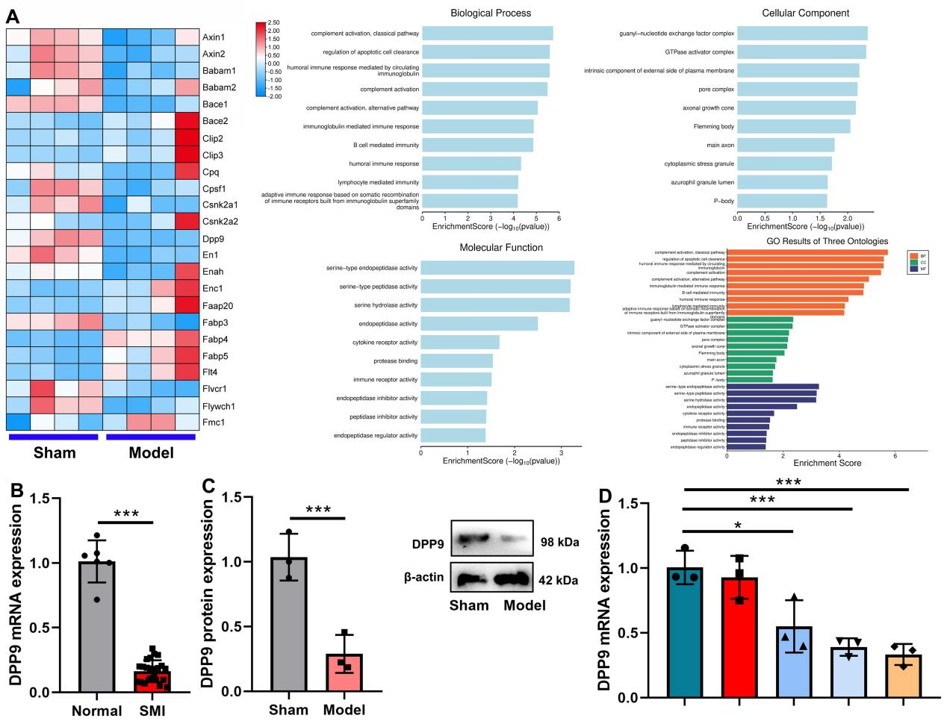
Heat map (A), DPP9 mRNA expression in patients with SMI (B), DPP9 protein expression in mice model (C), DPP9 mRNA expression in vitro model (D).
*, P < 0.05; ***, P < 0.001;

Figure 2. DPP9 expression level in muscle cells of patients with SMI
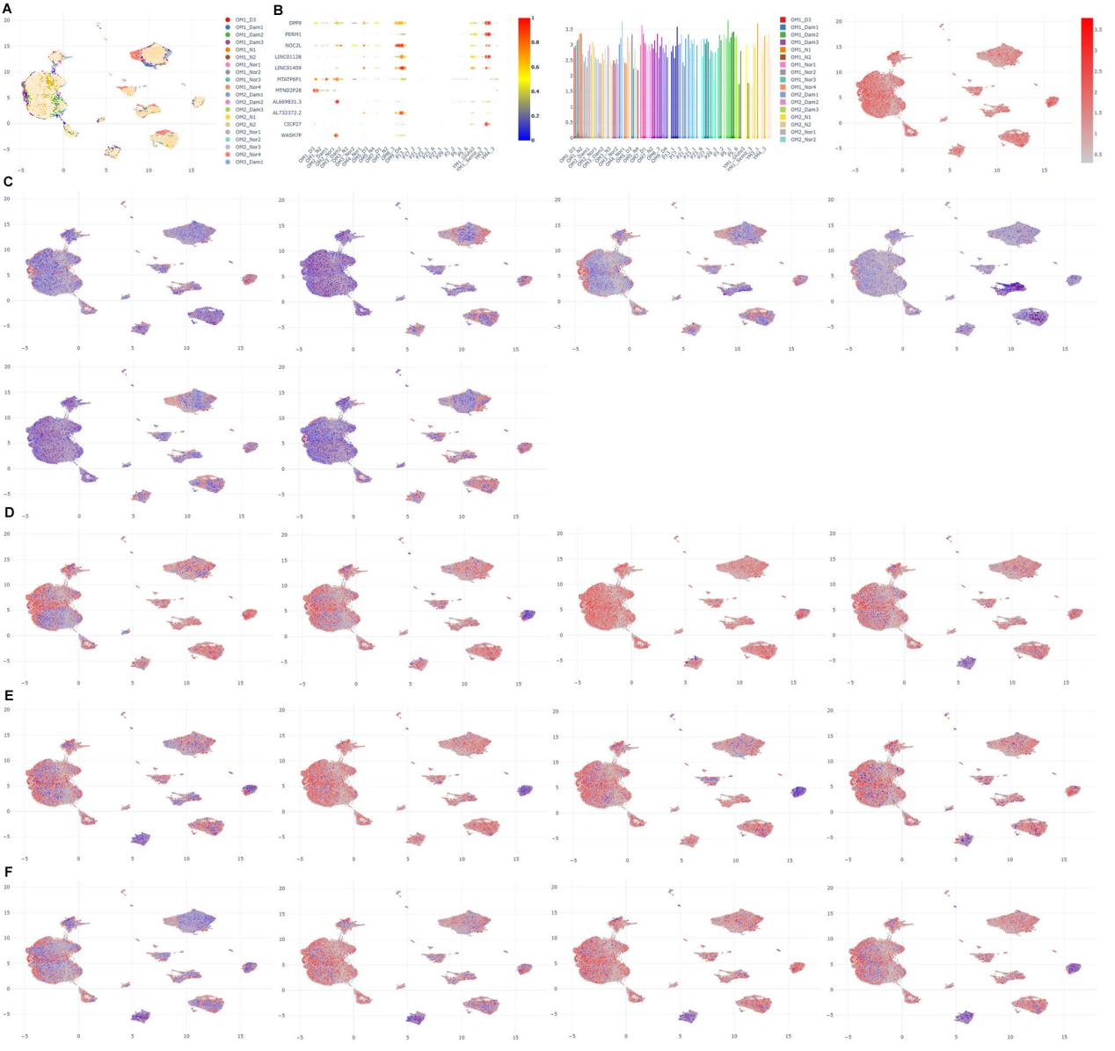
Single-cell sequencing data for DPP9 expression (A, B), DPP9 was found to be expressed in muscle cells (ITGA9, JPH2, KCNAB1, RGS5, SH3BGR, SMOC1, C), B cells (CD24, CD27, CD79A, CD86, D), T cells (CD4, CD8A, CD8B, CD80, E) and macrophage (CD68, CD163, GPR34, JAML, F).

Figure 3. DPP9 reduced subscapularis muscle injury in mice model
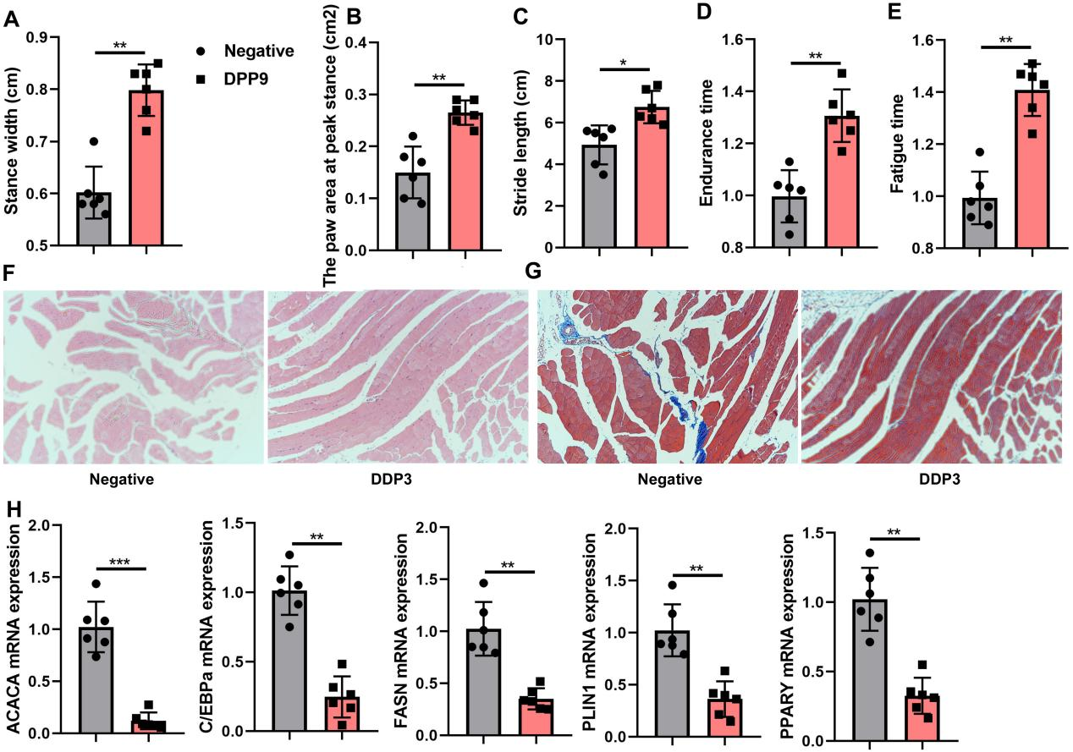
Stance width (A), the paw area at peak stance (B), Stride length (C), and expanded Endurance time (D) and Fatigue time (E), Subscapularis muscle injury (HE and Masson staining) (F, G), ACACA/C/EBPa/FASN/PLIN1/PPARγ mRNA expression (H).
*, P < 0.05; **, P < 0.01; ***, P < 0.001;

Figure 4. DPP9 reduced subscapularis muscle injury in vitro model
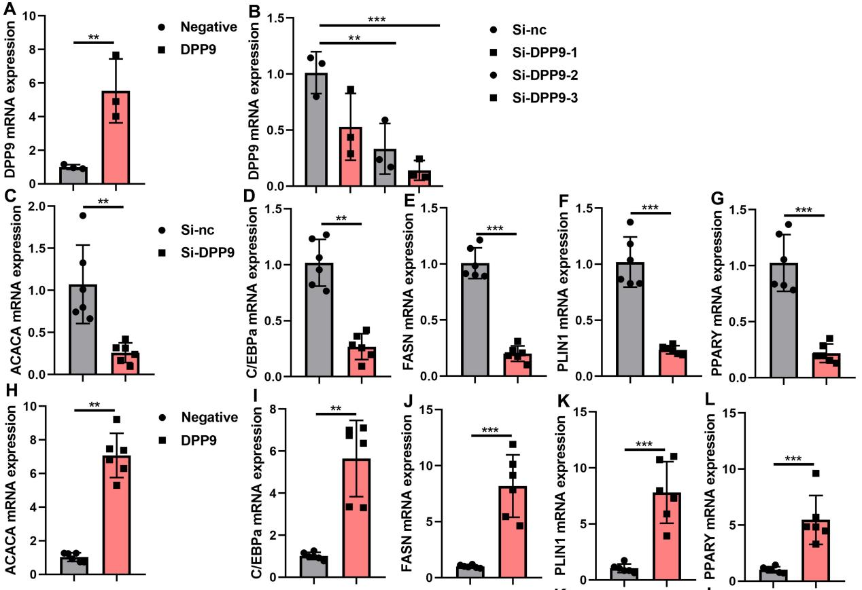
DPP9 expression (A, B),
ACACA/C/EBPa/FASN/PLIN1/PPARγ mRNA expression (C, D, E, F, G) in vitro model by DPP9 up-regulation;
ACACA/C/EBPa/FASN/PLIN1/PPARγ mRNA expression (H, I, J, K, L) in vitro model by si-DPP9;
**, P < 0.01; ***, P < 0.001;

Figure 5. DPP9 reduced inflammation in model of subscapularis muscle injury
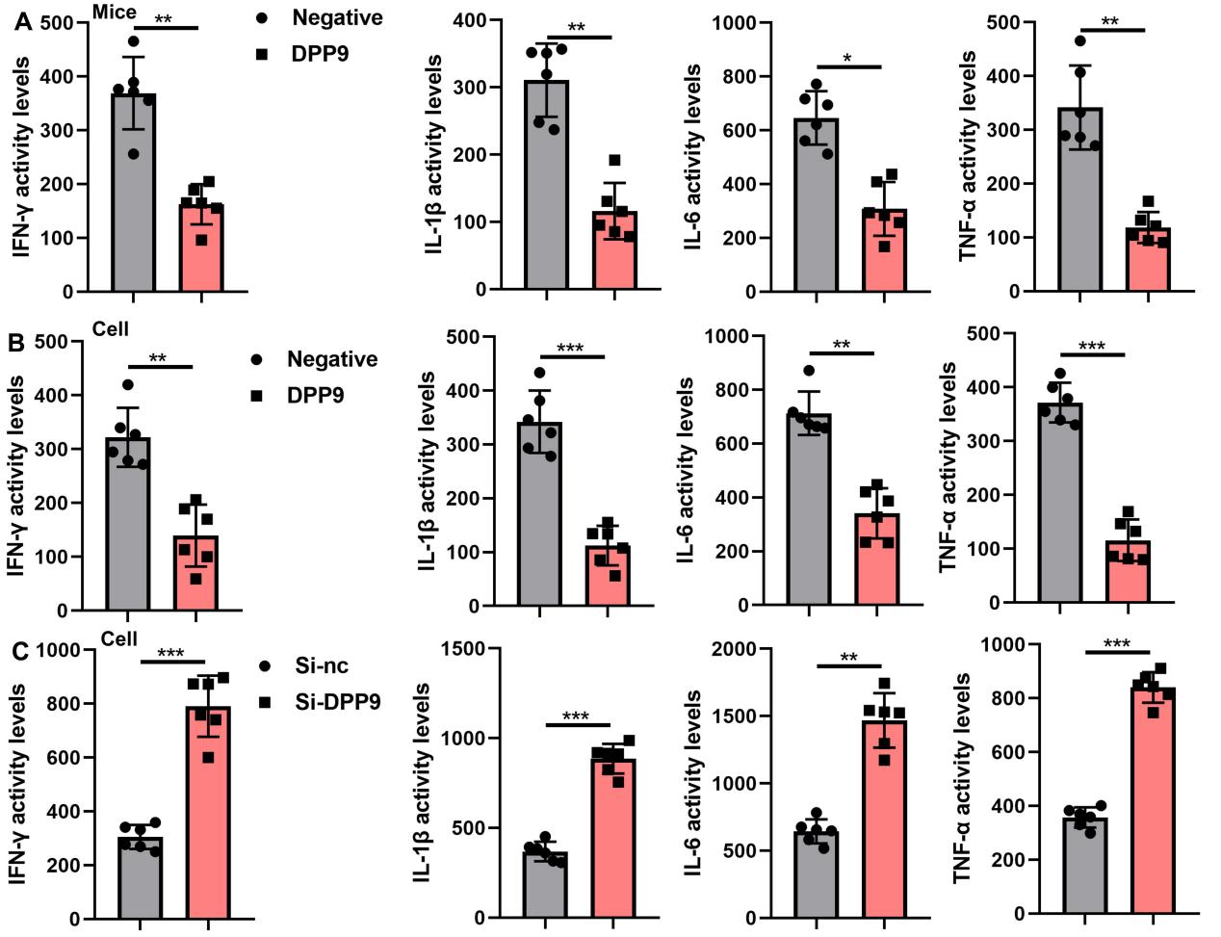
Inflammation (IL-1β, IL-6, TNFα and INF-γ, A) in mice model by DPP9 up-regulation;
Inflammation (IL-1β, IL-6, TNFα and INF-γ, B) in vitro model by DPP9 up-regulation;
Inflammation (IL-1β, IL-6, TNFα and INF-γ, C) in vitro model by DPP9 down-regulation;
*, P < 0.05; **, P < 0.01; ***, P < 0.001;

Figure 6. DPP9 reduced ROS-induced oxidation in model of subscapularis muscle injury
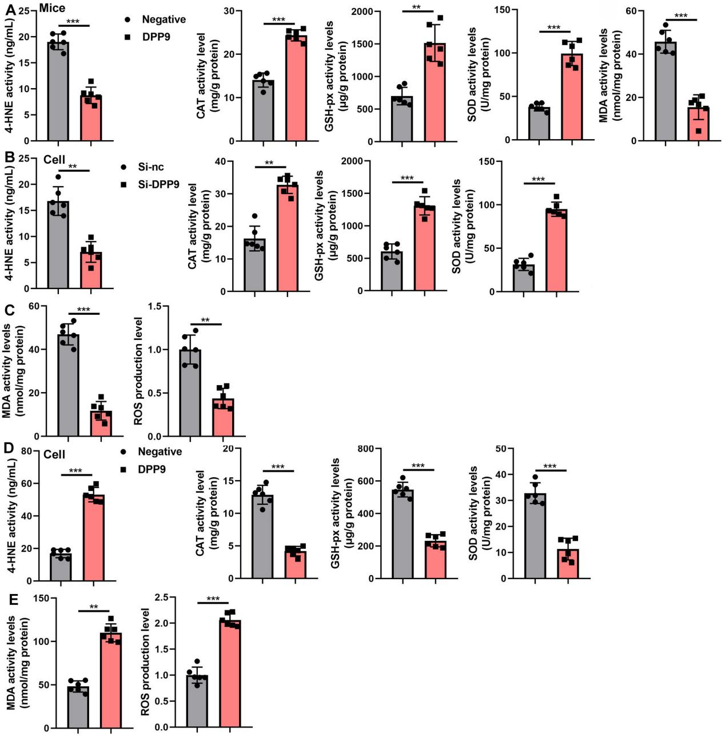
4-HNE/CAT/GSH-PX/SOD/ MDA levels (A) in mice model by DPP9 up-regulation;
4-HNE/CAT/GSH-PX/SOD levels (B), MDA/ROS levels (C) in vitro model by DPP9 up-regulation;
4-HNE/CAT/GSH-PX/SOD levels (D), MDA/ROS levels (E) in vitro model by DPP9 down-regulation;
**, P < 0.01; ***, P < 0.001;

Figure 7. DPP9 reduced mitochondrial damage in model of subscapularis muscle injury
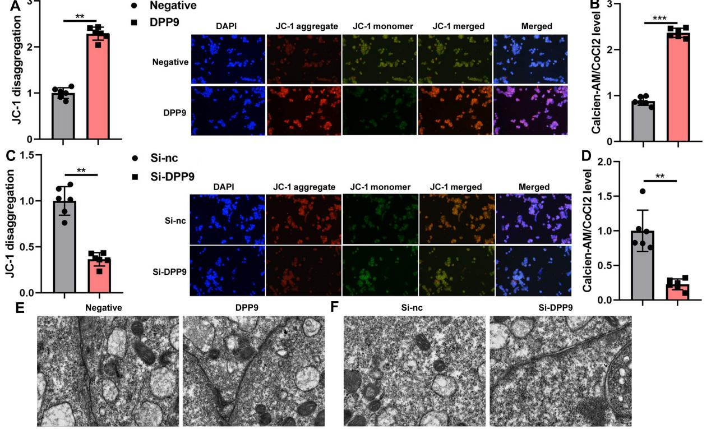
Mitochondria CoCl2 levels (A), JC-1 assay (B) in vitro model by DPP9 up-regulation;
Mitochondria CoCl2 levels (C), JC-1 assay (D) in vitro model by DPP9 up-regulation;
Mitochondrial damage (electron microscope, E, F).
**, P < 0.01; ***, P < 0.001;

Figure 8. DPP9 reduced ferroptosis in model of subscapularis muscle injury
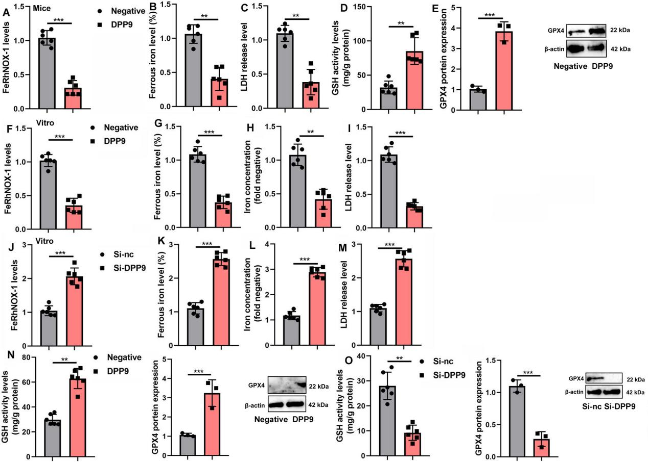
FeRhNOX-1 (A), Ferrous concentration level (B), LDH activity levels (C), GSH/GSH-PX activity level (D, E) in mice model by DPP9;
FeRhNOX-1 (F), Ferrous concentration level (G), Iron concentration level (H), LDH activity levels (I) in vitro model by DPP9 up-regulation;
FeRhNOX-1 (J), Ferrous concentration level (K), Iron concentration level (L), LDH activity levels (M) in vitro model by si-DPP9;
GSH/GSH-PX activity level (N, Q) in vitro model by DPP9 up-regulation or si-DPP9;
**, P < 0.01; ***, P < 0.001;

Figure 9. DPP9 protein interlinked Nrf2 protein in vitro model of SMI
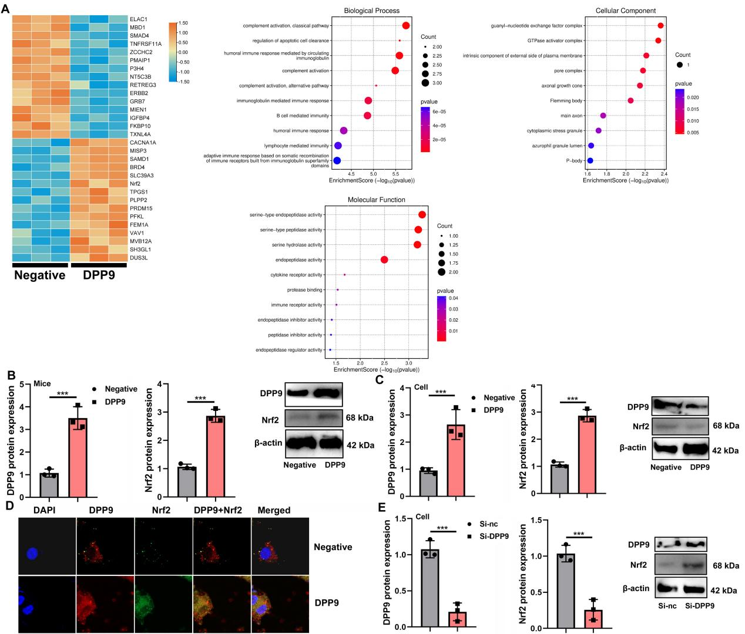
Heat map (A), DPP9 / NRF2 protein expression (B) in mice model, NRF2 expression (in vivo imaging, C), NRF2 expression (Immunohistochemistry, D), NRF2 expression (in vivo imaging, E) in mice model;
***P < 0.001.

Figure 10. Molecular Dynamics Simulation for DPP9 Nrf2 ubiquitination in vitro model of SMI
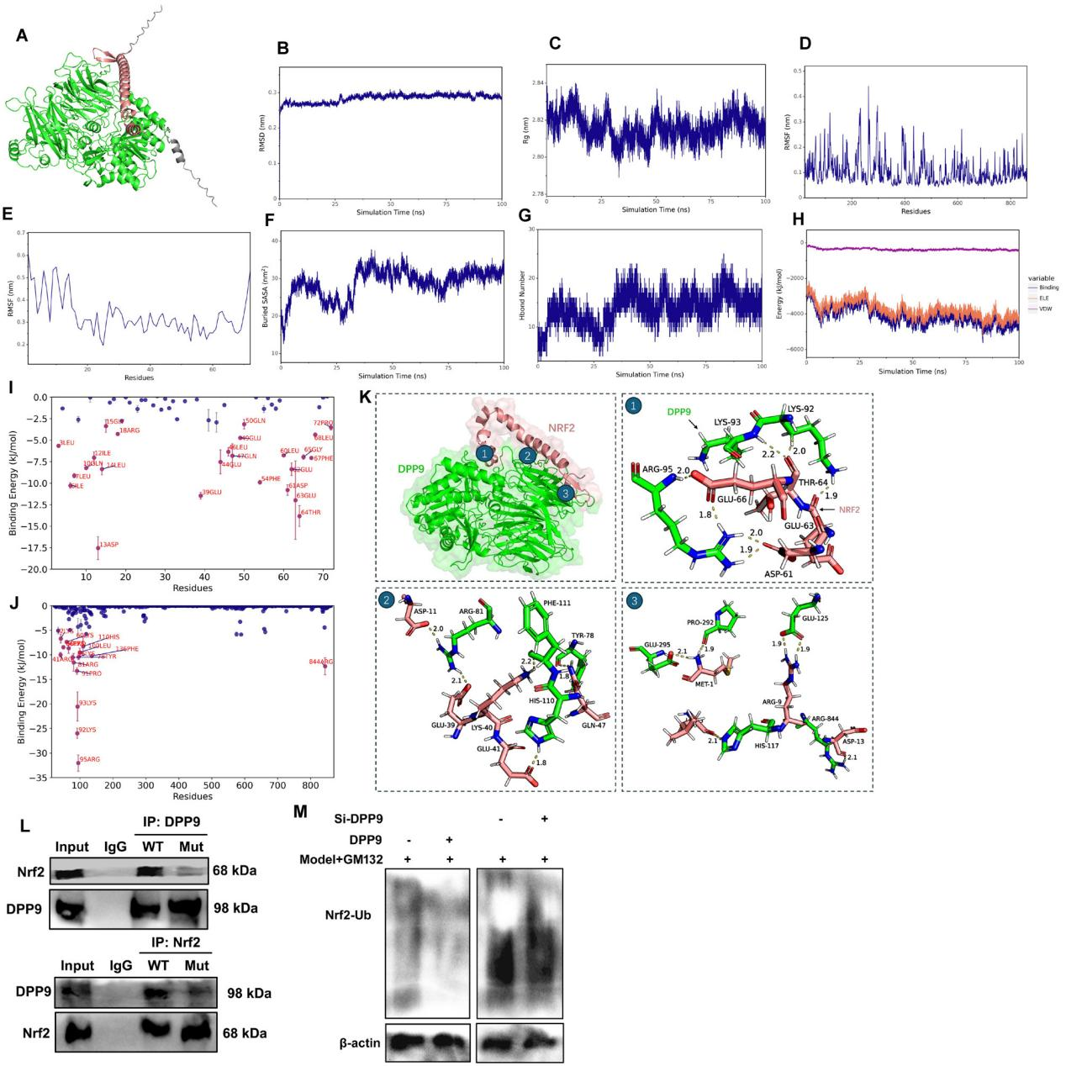
Molecular Docking (A), RMSD (Root Mean Square Deviation, B), Rg (Radius of Gyration, C), RMSF (Root Mean Square Fluctuation, D, E), Buried SASA (F), Evolution of Hydrogen Bond Count (G), Analysis of Electrostatic and van der Waals Interactions (H), Residue Contribution Analysis (I, J), Interaction between Receptor and Ligand Proteins (K). IP assay for DPP9 protein interlinking with NRF2 protein (L), NRF2 ubiquitination (M).
**P < 0.01, ***P < 0.001.

Figure 11. Nrf2 inhibitor reduced the effects of DPP9 on ferroptosis and ROS-induced oxidation in model of subscapularis muscle injury
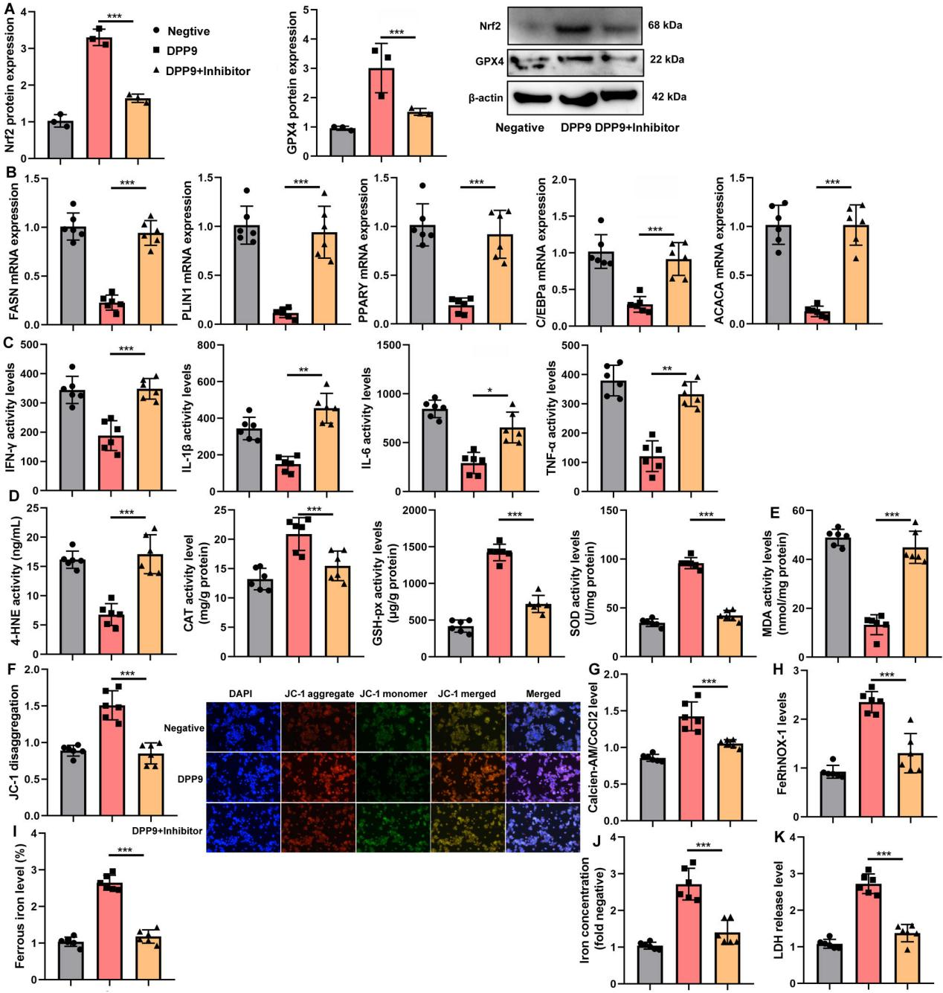
Nrf2/GPX4 protein expression (A), ACACA/C/EBPa/FASN/PLIN1/PPARγ mRNA expression (B), inflammation (IL-1β, IL-6, TNFα and INF-γ, C), oxidative stress (4-HNE levels, CAT, SOD, GSH-PX, D), MDA (E), JC-1 assay (F), Mitochondria CoCl2 levels (G), FeRhNOX-1 (H), Ferrous concentration level (I), Iron concentration level (J), LDH activity levels (K),
*, P < 0.05; **, P < 0.01; ***, P < 0.001;

