Original Research article
Alleviating Systemic Inflammatory Response Index (SIRI) and Systemic Immune Inflammation (SII) via employing Cholecalciferol against cutaneous Human papilloma virus (HPV)-Warts
Ambreen Aisha*¹, Aonuo Xue², Handong Wang ³, Asim hussain⁴, Uzma Amin⁵, Nahhed Bano⁶, Bushra Munir⁷
Affiliation
*¹Department of Biochemistry, Faisalabad Medical University, Faisalabad, Pakistan
Email; aishafmu@gmail.com (corresponding Author)
ORCID; 0000-0002-8006-0307

²Departments of Hematology and Geriatrics, Hospital of Nanjing Medical University, Changzhou, Jiangsu, China. 213000.
Email: xueaonuo_edu@outlook.com

³ Departments of Hematology and Geriatrics, Hospital of Wang Nanjing Medical University, Changzhou, Jiangsu, China. 213000
Email: njhdwang_edu@outlook.com

⁴ KIST School, University of science and technology, Korea republic.
Email: Asimhussain@kist.re.kr

⁵Department of Dermatology, Lahore General Hospital, Lahore, Pakistan
Email: uzmaamindermatologist@gmail.com
ORCID; 0000-0002-9555-406X

⁶Department of fisheries &Aquaculture, MNS-University of Agriculture, Multan
Email: naheed.bano@mnsuam.edu.pk

⁷Institute of Chemistry, University of Sargodha, Sargodha, Pakistan.
Email: bushra.munir@uos.edu.pk
ORCID: 0000-0002-5891-9955

Corresponding Author:
Dr. Ambreen Aisha, orcid; 0000-0002-8006-0307
Assistant Director, University Training and Research Monitoring Cell, Faisalabad Medical University, Faisalabad. Pakistan Contact+923006679766
Email: aishafmu@gmail.com, aisha.fmu@pmc.edu.pk
Abstract
Viral papillomatous skin warts are characterized by benign and painful epidermal proliferations. Goal; to boost immunogenic response through Cholecalciferol treatment of topical warts without surgical intervention. Research; fifty patients who met the inclusion and exclusion criteria were chosen for immune-modulating therapy in a randomized controlled design. Patients received intralesionally Cholecalciferol (5mg/ml) for nine weeks. Systemic immune inflammation (SII) and systemic immune inflammatory response index (SIRI) were evaluated regarding complete blood count. Outcomes; treatment efficiency was considered for more than a 50% reduction in wart dimensions. The mean age of 50 patients was 23.72 ± 14. Trial revealed highly efficacious results (p=0.008), with almost 75-100% reduction in warts lesions than 9 weeks (p=0.012). More than 50% reduction in wart magnitude in 84% of cases. Cholecalciferol therapy significantly reduced HCT%, monocyte, and neutrophil count/L (p= 0.00496, 0.00001, 0.00031 respectively), while viral infection had no significant impact on ESR, WBCs, or lymphocyte counts (p=0.12, p=0.548, and p= 0.1738, respectively). Furthermore, there was a statistically significant difference between the pre- and post-treatment levels of SIRI and SII (p value= 0.00610, 0.00081). Disease prognosis was substantially correlated with 50.9% dynamic change in SIRI. Conclusion; The findings of this study supported intralesional cholecalciferol intervention as a cost-effective, safe, and immunologically rational therapeutic option for HPV-related warts, particularly in resource-limited settings. The results may contribute to improved clinical practice and inform future research on immunotherapy-based dermatological treatments.
Key words: Human Papilloma Virus, Immunotherapy, Cholecalciferol, Warts
INTRODUCTION
Warts, a common manifestation of human papillomavirus (HPV) infection, affect approximately 9.5% of children and young adults, with the highest prevalence observed in individuals under 16 years of age. However, the incidence notably increases in the adult population, reflecting a broader age-related susceptibility [1-3]. Warts most commonly manifest palmoplantar and frontal warts, as these areas are frequently exposed to human papillomavirus (HPV). However, HPV virtually capable of inducing genital and laryngeal warts even leading to cervical carcinoma. While these lesions do not typically pose a life-threatening risk to immunocompetent individuals, they may result in discomfort, aesthetic concerns, or secondary complications, particularly if left unmanaged [4-6]. Human Papillomavirus is a double stranded virus that penetrates the skin via disrupted regions. The proliferative activity facilitates progressive development of the lesion and localized accumulation of cells at the site. Public restrooms, meat handling, and immunosuppression all contribute to the spread of the disease. There are a multitude of distinct treatment possibilities including various topical, homoeopathy, systemic or immunotherapeutic modalities [7]. Invasive interventions like cryotherapy, curettage, chemical cauterization, and electrodessication leave scars and are thus considered invasive and dangerous, hence they are seldom utilized [8]. Traditional wart treatment methods like cryotherapy and salicylic acid have limitations, including pain, recurrence, and long-term use. Alternative treatments are urgently needed, and research is advancing to develop new treatments [9].
Immunotherapy is an encouraging modality since it boosts the innate immunity against viruses, leading to the complete dissolution of warts appearance, cleansing of the surrounding lesions, and reduction in the likelihood of recurrence. Immunotherapeutic drugs such as Mumps antigen, Candida antigen, BCG vaccination and Cholecalciferol have been utilized to treat different forms of warts [10]. Cholecalciferol synthesis in the skin is reduced due to decreased sun exposure [9], which may increase the range of risk factors including microbial and viral infections [1, 11]. Cholecalciferol plays a crucial and multi-directional role in the immune system [12]. Due to its immunomodulatory effects on macrophages and natural killer cells (NK), immune cells are better equipped to combat infections and phagocytize pathogens. Cholecalciferol is an immunotherapeutic drug used to treat warts; it cures warts through the VDR-dependent pathway. As the infected site is flooded with the macrophages, generating pro-inflammatory cytokines IL-1, TNF alpha and IL-6. It has been documented that Cholecalciferol modulates the immune response via the down streaming of pro inflammatory interleukins IL-2, IL-6, TNF alpha, and IL17, which tend to exacerbate monocytes and neutrophils [3, 11, 13]. The anti-inflammatory cytokine IL-37 production reduces both innate and adaptive immunity by suppressing pro-inflammatory molecules and pathways [14]. SII and SIRI are blood cell count inflammatory indicators that have been associated with numerous inflammation-related diseases such as diabetes, arthritis, tumor and gastric cancer (diseases allied with inflammation) [15, 16]. In following work the predictive ability of SII and SIRI and changes in SIRI before and after treatment will be cursor of reduction in inflammation and cure to disease. In relevant studies, Cholecalciferol has shown 78% effectiveness in treating common warts, with limited clinical trials. The findings could make immunotherapy more accessible, especially for patients with multiple warts, Raynaud's phenomenon, or periungual warts, and recommend Cholecalciferol as a treatment for viral warts [17] [18]. This study assesses role of therapeutic agent Cholecalciferol for palmoplantar warts, taking into account demographic parameter such as gender, age, and lesions.
METHODOLOGY:
After receiving approval from the hospital ethical review council, the clinical trial/interventional randomized trial was carried out in the Department of Dermatology, Lahore General Hospital, Lahore, for period of nine weeks (December 2020- August 2021) with ERC no; AMC/PGMI/LGH/ARTICLE NO/005/19. While the study is registered with the Pakistan Clinical Trial Registry (CTR Number: RTCS-0519).Treatment of 50 patients of palmoplantar warts was studied in the dermatology outpatient department
Inclusion criteria; Patients of various age period, and both genders were included. Warts on the hands and feet of any kind, such as common, filiform, or mosaic, single or multiple in number, of any duration, and patients not receiving wart therapy for at least two months were eligible for inclusion in the study. The study parameters followed the Declaration of Helsinki
Exclusion criteria; Immuno-compromised individuals, those with persistent skin conditions such as eczema or autoimmune diseases, diabetes mellitus, skin allergies, pregnancy, and breastfeeding were excluded.
Sample size;
The sample size was calculated based on the primary outcome of treatment efficacy, defined as a ≥50% reduction in wart size after intralesional Cholecalciferol therapy. Using a single-proportion formula with a 95% confidence level (Z = 1.96), an expected response rate of 84% derived from pilot observations, and a precision level of 10%, the minimum required sample size was calculated to be 52 participants. A total of 50 patients were enrolled, which was acceptable for an interventional dermatology trial due to its proximity to the calculated sample size and the logistical feasibility within the study period. This sample size was sufficient to ensure adequate statistical power for detecting clinically meaningful changes in wart dimensions and associated inflammatory biomarkers (SIRI and SII) pre- and post-treatment.
Study plan; Before commencing the intervention, informed consent was taken from all participants. At each appointment, clinical photos were taken and compared to baseline images. A detailed medical history was obtained, followed by a clinical examination. Demographic data, duration, location and number of warts, and morphological features were recorded using a prescribed proforma at the beginning of the study. The blood biochemistry parameters were assessed before initiating immunotherapy and afterward as well. Following lignocaine local anaesthetic, 0.2-0.4 ml Cholecalciferol solution (5mg/ml) was injected gently at the base of the wart using a 26-gauge syringe [19]. In each session, up to four warts were injected, beginning with the largest lesion. Patients were advised to avoid any topical or oral medications after treatment. The procedure was repeated every three weeks for a total of three sessions, with wart size reduction assessed at each visit. Following the final session, patients were monitored for an additional six weeks to check for recurrence.
The efficacy was evaluated at the conclusion of three-week trial. With a remarkable success rate of 75% to 100% in reducing wart size and restoring normal skin coloring, the responses were classified as follows: Optimal response: a decrease of 50-74 %, Reasonable response: 25-49% decrease, Poor response: a decrease of less than 25% . To classify treatment as effective, patients needed to demonstrate either an excellent or good response, defined as a reduction in wart size of at least 50%, or a fair or poor response, defined as a reduction in wart size of less than 50%. Patients were monitored for an additional 6 weeks to observe if the wart lesion reappeared after disappearance.
Hematology and Biochemical Parameters:
SIRI and SII
SII and SIRI, a reliable index, can be used to assess patients with pathological conditions. The study measures multiple blood cell types, including lymphocytes, neutrophils, and platelets, in the collected peripheral venous blood samples using an automated hematology analyzer with reference to × 10³ cells/mL. This research indicates systemic inflammation by calculating SII and SIRI using the following equations:

SII = (platelet count x neutrophil count)/lymphocyte count
SIRI= Peripheral neutrophils count Χ monocytes count
Lymphocytes count
SIRI before the treatment was used as the baseline. The dynamic change in SIRI was calculated as a percentage (SIRI after treatment—baseline (pretreatment) SIRI)/ baseline (pretreatment) SIRI×100] and divided into 3 groups; group1 has decreases>50%, 2nd group has no change (decrease or increase of no more than 50%), and third group has increase >50% [16, 20]

Dynamic change in SIRI= SIRI (after treat) – SIRI (before treat) Χ 100
SIRI (before treatment)

Statistical Analysis: SPSS Version 21 was used to analyze the data. Frequency and percentages were employed for demographic characteristics such as gender and efficacy, while mean and standard deviation were used to express age, duration, and biochemical parameters. Patients were divided into groups based on the duration of illness for investigation, and the correlation between geographical location and response was analyzed [19].
RESULTS
Among 50 cases, 60% were females (mean age 23.7 years) and 40% males (mean age 14.1 years). Lesion duration ranged 1–9 months (mean 3.4 months), and recovery was observed within 6 months. Most warts appeared on soles, palms, and dorsum of hands (23, 11, 7) respectively. Multiple warts were observed in 28 sites (Table 1). There was no significant difference while examining the influence of age and gender on effectiveness (Figure 1). Some subjects experienced Warts subsidence after one or two sessions, and elimination was seen before the completion of the research (Figures 2); these patients did not receive subsequent injections and were simply evaluated for relapse. In 84 percent of instances, the wart size was reduced by more than half. In cases of multiple warts, when a maximum of three doses were injected, a response of eradication of distant warts was noted in 39 percent (n= 11/28 cases of multiple warts). Significant p value (0.001, 0.008, 0.012 respectively) were observed at every visit, i.e. the third, sixth, and ninth week, among those who responded (Table 2). The research was a single-blind interventional controlled trial. Participants were blinded to the group allocation to minimize expectation bias. The allocation sequence was concealed using coded containers prepared by an independent researcher not involved in data collection. Care providers administering the intervention were aware of group assignment due to the nature of the treatment, but the outcome assessors and data analysts remained blinded until database confinement
Few negative impacts were seen, such as soreness and stiffness in 16 percent of instances (n=9) in the entire injected region after the effect of local anaesthetic wore off, but it lasted only for a few hours. On the follow-up visit till 2 to 3 months, 9 patients (18%) had wart recurrence. The SII and SIRI, CRP, ESR are summarized in (Table 3). Pretreatment Neutrophils, hematocrit(HCT) percentage, platelets and lymphocyte count were significantly increased, while post treatment decline was highly significant (Table 3).Complete blood count (CBC) distinguished between the pre-treatment and post-treatment scenarios of warts in patients. After intralesional cholcalceferol therapy, HCT percentage decreased from 40.51± 0.56 to 36.51± 0.21 and neutrophils count/L decreased from 65.04± 0.118 to 55.8 ± 0.56, both of which were within normal ranges (p= 0.00496 and p= 0.00001, respectively). While ESR, WBC, and lymphocyte counts were not significantly affected by viral infection (p=0.12, p=0.548, and p= 0.1738, respectively), The monocytes count decreased considerably from 1090 ± 0.46 to 804± 0.34, with a p value of 0.00031.
DISCUSSION
Twenty females and thirty males were included in the study. Our research included a larger percentage of female participants, which is consistent with the findings of Khozeimeh et al. and Sharma et al.[21]. Warts are more common in women than in men, which may be consistent with the fact that females are more likely to be subjected to household related trauma and have lower immunity than their male counterparts [22]. The treatment's duration and place of effect were also noted. Warts that had been present for two to three months had the best response. It was discovered that 61.1% of the single warts and 43.8% of the multiple warts had recovered (Table 1) as also mentioned by Valhovic [23].
Our research revealed that warts were more prevalent on the soles of the feet rather than the palms of the hands, perhaps owing to factors such as the habit of walking barefoot, dusty carpets and rugs (Figure 2). Because of their thicker skin, feet are more vulnerable to injury and have a slower rate of self-healing [24]. There was a statistically significant difference between warts lasting six and nine weeks (p=0.008), whereas warts lasting 3.4 months (p=0.001) were found in the present investigation (Table 2). Raghukumar et al. reported a 14 to12 month average for his study. In the same way, 11 sessions exhibited extremely significant outcomes (p= 0.001) in comparison to 23 sessions (p=0.008) and 8 sessions with (p=0.012) of intra-lesion cholcalciferol administration (Table 2). In current research, we compared percentage decrease in warts before and after intra-lesion injections; therapy was labelled effective if there was a reduction of more than 32 instances (75-100%) in warts after 6 months. Treatment was shown to be effective in 84% of cases, with considerable outcomes (Table 2). Similarly, Aktas et al. found an 80% success rate in treating warts with 20mg/ml at a 4-week interval. Both Khozeimeh et al. and Halim et al[25] found no statistically significant difference between intralesional Cholecalciferol and ablative therapy in their clinical studies. Cholecalciferol demonstrated to be effective when taken every two weeks for a maximum of four to six weeks treatments[26]. Sixty-one percent of the 22 single and 28 multiple warts that were found recovered (Table 2). Shaldoum et al [27] Also observed a full response with Cholecalciferol in 60% of patients with multiple warts were administered at 3-week spacing for an aggregate of six sessions, with no effect observed in 6.67% of patients. A discrepancy between the findings of Raghukumar et al, and this research, may be due to the fact that Raghukumar et al. used a higher dosage (15g/ml) and a longer treatment period (four sessions), while lower dosage (10mg/ml) and a shorter treatment period (two weeks) were employed in current research. There were very transient side effects, such as soreness after injecting Cholecalciferol intralesionally in 9 individuals (Table 1) as comparable with various studies [28]. While Naseer et al [29, 30] found no serious side effects.
When CYP2R1 and other activating and inactivating enzymes are present, the VDR (vitamin D receptor) gene is able to be expressed (Figure3). Proliferation and/or differentiation of keratinocytes is one of the most important results from the VDR [11, 13]. The VDR and the enzyme 1-hydroxylase are expressed in the majority of organs, but particularly in immunological cells such as monocytes and macrophages, which are involved in the anti-inflammatory response [11, 12, 31]. In (Table 2) wart remission and reduction is clearly seen as a consequence of therapy with Cholecalciferol (vitamin D) as Liu mentioned [32]. Patients with warts saw neutrophil counts drop from 65.04± 0.118 to 55.8± 0. 56. Cellular regeneration and repair are aided by VDR, which collects calcium, therefore suppressing the immune system via the migration of epidermal cells and modifying growth factors, which may be seen in (Figure 3a). A systematic review provided insight on current improvements by immunotherapy techniques such as "Efficacy of photodynamic therapy for warts induced by human papillomavirus infection" compares and emphasizes the efficacy of targeted therapies against HPV-related warts [9]. Phototherapy, particularly involving narrow-band UVB light, is known to enhance the synthesis of vitamin D in the skin, which is converted into Cholecalciferol. Research shows that narrow-band UVB phototherapy can significantly boost vitamin D levels, especially in patients with skin conditions causing vitamin D deficiency[33]. It is also narrated, that some of the benefits of UV exposure for Dermatitis patients are mediated by vitamin D [34] Vitamin D plays a crucial role in promoting keratinocyte proliferation and antimicrobial peptide generation, which can help prevent S. aureus infections in patients with dermatitis. Phototherapy is suggested as to treat tumors and skin diseases by interacting with light, photosensitizers, and oxygen. UV reacts to generate reactive oxygen species (ROS) within cells, and AMPs leading to cell death without damaging surrounding tissue[34]. Chemotaxis, antimicrobial, and autoantibody peptides are all exacerbated by vitamin D deficiency [11, 32]. According to several studies, peptides such as IL-37 play a crucial role in immune regulation. Research has shown that IL-37 can induce metabolic reprogramming and limit the metabolic costs linked to inflammation, thereby reducing inflammatory responses. Emerging evidence also indicates that some functions of IL-37 may indirectly suppress aspects of acquired immunity [35, 36]. When this event occurs, Dihydroxycalcidiol production may be enhanced, according to several findings (Figure 3b). This amplification reflects a rise in 1,25(OH)2D3, which binds to the endogenous VDR and reduces keratinocyte growth, regulates apoptosis, and suppresses the immune system [37]. The reduction in monocyte count from 1090± 0.46 to 804± 0.34 in the present study (Table 2) indicates that cholecalciferol is curative. In monocytes, cholecalciferol binding to VDR regulates gene expression, increasing transcription of the antibiotic protein IL37, which is the potent inducer of the antimicrobial peptide, cathelicidin [38] playing an important role against HPV [38] ( Figure 3a). It means that vitamin D is improving monocyte function and activity along with production of antimicrobial peptides [39, 40]. In other words in scenarios of inflammation, IL-37 is naturally elevated as a defensive strategy [14]. IL-17, IL-6, IL-23, IL-12, and toll-like receptors on monocytes may also be inhibited by cholecalciferol in other studies [18, 41] (Figure 3a). High dosages of cholecalciferol supplementation dramatically reduces the pro-inflammatory cytokine IL-6 generated by peripheral mononuclear cells (1 g twice day for seven days)[13]. After therapy, the HCT percent dropped from 40.51 ±0.56 to 36.51± 0.21 in our study (Table 3). Raghukumar et al also reported a mean age of 23.93 for their research population, which is consistent with our findings; however, Kareem et al.21 found a much lower mean age of 12.50 for theirs, [24]. SIRI, a marker for host inflammation and immune response, is based on peripheral neutrophil, monocyte, and lymphocyte counts. It reflects complex interactions and potentially synergistic effects in microenvironment. An increase in SIRI may indicate pathophysiologic changes with proliferating disease or changes in immune function after viral attack [16] during infection. While decrease in SII and SIRI (Table 3) are expression of reduction in inflammation and infection.
The variance in the studies we conducted could possibly be attributed to the level of Cholecalciferol, which was 5 mg/ml in the present study, whereas it ranged from 7.5 to 20mg/ml in prior investigations. It also suggests that the immune response needed to eradicate warts differs across populations. Hypovitaminosis D, based on the above data, may cause a reduction in immune tolerance as well as an increased risk of viral infection[11]. The particular mechanism underlying the action of IL-37 and the possible therapeutic implications of IL-37 and other peptides amplification should be the focus of future research.
CONCLUSION:
The remission of warts on the hands and feet demonstrated the efficacy of immunotherapy in small population of Punjab, Pakistan. Intralesional administration of Cholecalciferol is suggested as an effective immunotherapeutic agent which enhances production of certain peptides combating the inflammatory reactions. Thereby reducing the inflammation which was cursor by estimating SII and SIRI.
Future recommendations;
Further investigations must be conducted with warts involving the genital area to determine the significance of Cholecalciferol in treating problematic and distressing illnesses like Psoriasis, Atopic dermatitis in our community.
Limitations
Trial limitations included the small sample size (n=50) from a single-center cohort, which may limit generalizability and introduce selection bias. Additionally, the absence of blinding and the reliance on short-term follow-up may contribute to measurement imprecision and potential. Secondly particular mechanism underlying the action of IL-37 and the possible therapeutic implications of IL-37 I s to be revealed.
Declaration for Conflicts of Interest
The authors declare no conflicts of interest.
Data availability statement
The data detail will be provided from corresponding author on request
Funding Declaration
No funding was received (self funded)
Abbreviations:
NK; Natural killer cells
TNF; Tumor necrosis factor
APC; Antigen presenting cells
IL; Interleukins
HCT; Hematocrit
VDR; Vitamin D receptors
TLRs; Toll-Like Receptors
FDA; Food and drug administration authority
CBC; complete blood count
BCG; BacilleCalmette-Guerin (anti tuberculosis vaccine)

Table: 1
Bold characters | Number
Gender | Female | 30
Gender | Male | 20
Age Group | 1-20 Year | 26
 | 21-40 Year | 17
`` | 41-60 year | 7
SITE (Palm, Soles, Dorsum of hands) | Dorsum of hands | 11
SITE (Palm, Soles, Dorsum of hands) | Palm | 16
SITE (Palm, Soles, Dorsum of hands) | Soles | 23
Number of Warts | Multiple | 28
 | Single | 22
Duration of Warts (months)
Duration of Warts (months) | ≤6 Months | 43
Duration of Warts (months) | ˃7 Months | 7
Type of Wart Common | Common | 39
Type of Wart Common | Filiform | 6
Type of Wart Common | Mosaic | 5
Side Effects  No/Pain/Blisters | Blister | 0
Side Effects  No/Pain/Blisters | No | 42
Side Effects  No/Pain/Blisters | Pain | 8

Table 2: Efficiency and duration of Treatment with Cholecalciferol
Observations | Description of efficacy of treatment
 | Status | Frequency (n) | %
1 | Cured | 42 | 84
2 | Not cured | 8 | 16
3 | Cured but recurred | 9 | 18
n=43. Recurrence at follow up=9 | Duration& outcomes | Excellent  (75-100% reduction) | Good  (50-74% reduction)
4 | 1-6 months=36 | 32 | 4
5 | More than 7 months=6 | 3 | 3
Response of treatment according to number of warts

 | Number of warts | Efficacy after treatment | P-value
4 | Single =22 | 61.1% | 0.094
5 | Multiple=28 | 43.8% | 1.413
Pattern of response during treatment sessions

Session | 3 week | 6 week | 9 week
n ( 42/50) | 10 | 24 | 8
p- value | 0.001 | 0.008 | 0.012

Table 3. Hematological parameters of patients before and after treatment.

Sr. no | Parameters | Patients of warts before treatment (n= 50)  (Mean± SD) | Patients of warts after treatment (n= 50)  (Mean± SD) | p-value
 | WBC s/ µL | 10.57 ± 0.16 | 10.12 ± 0.34 | 0.5485
 | Neutrophils count/ µL | 65.04 ± 0.118 | 55.8 ± 0. 56 | 0.00001**
 | Lymphocyte count/ µL | 26.14 ± 0.23 | 28.3 ± 0.04 | 0.17384
 | Monocytes count/ µL | 1090 ± 0.46 | 804± 0.34 | 0.00031**
 | HCT % | 40.51 ± 0.56 | 36.51 ± 0.21 | 0.00496*
 | Platelets/ µL | 304000.5 ± 0.02 | 243000 ± 0.69 | 0.00086**
 | ESR (mm/hr) | 29 ± 0. 601 | 25± 0.021 | 0.12039
 | SӀӀ, % | 756.69±0.51 | 479.20±0.023 | 0.00610*
 | SIRI, % | 2712.07±0.034 | 1585.27±0.49 | 0.00081*
 | Dynamic change in SIRI | 57.90% [Increase>50%]
(**=highly significant, *= significant).CRP C reactive protein, ESR erythrocyte sedimentation rate, SII Systemic immune inflammation index, SIRRI Systemic inflammation response index

Figures:

a)
b)

Figure 1; Prevalence of warts among the sample size. a) Percentage of male and females in the study n = 50, b) Efficacy of treatment ( more than 50 % reduction) according location of warts.

a)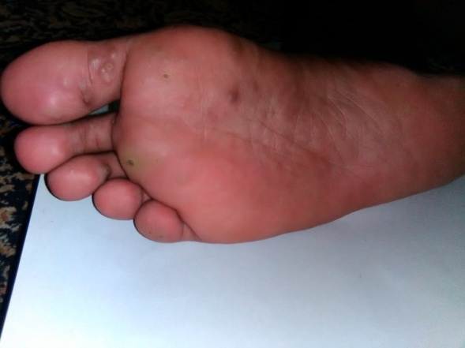 | b)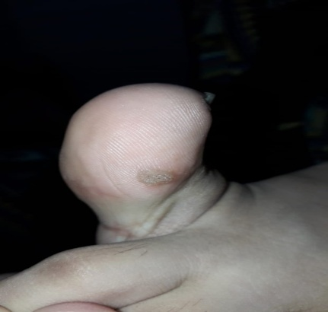
c)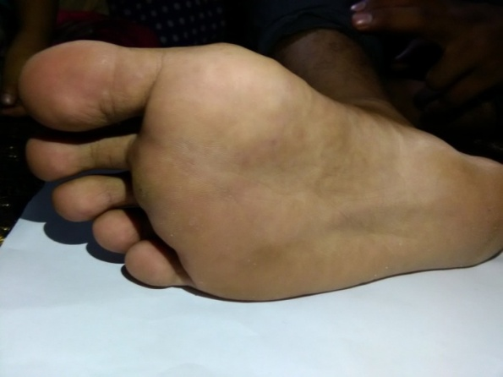 | d)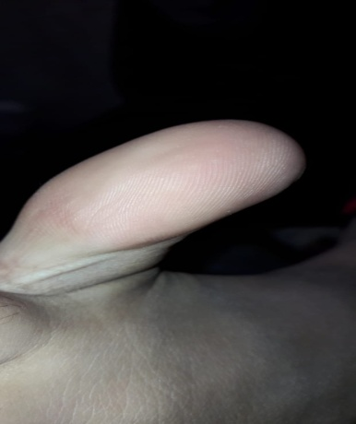
Figure 2; Images of warts on ventral side of foot and lateral side of thumb.
(a & b) before treatment, c& d) after treatment with Cholecalciferol therapy for three weeks.

a)  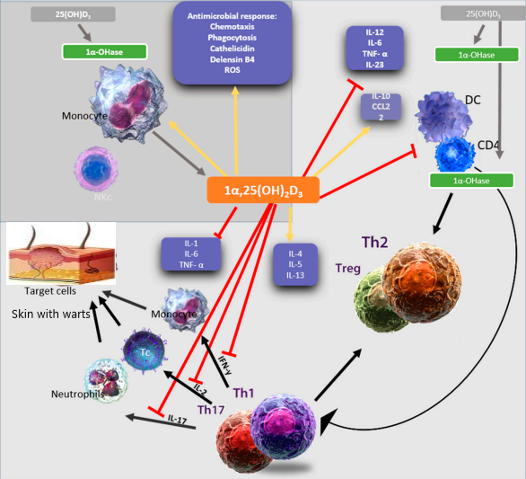 | Figure 3: The Cholecalciferol immunomodulation ;  a) 1,25(OH)₂D₃ targets innate and adaptive immune compartments i.e. level of APC, such as dendritic cells, boosting innate responses through chemotaxis, antimicrobial peptides, and macrophage differentiation. It also enhances adaptive immune responses, such as dendritic cells, by decreasing MHC-II- complexed antigen expression and cytokine generation, thereby altering T cell activation from Th1 and Th17 to Th2.
b)  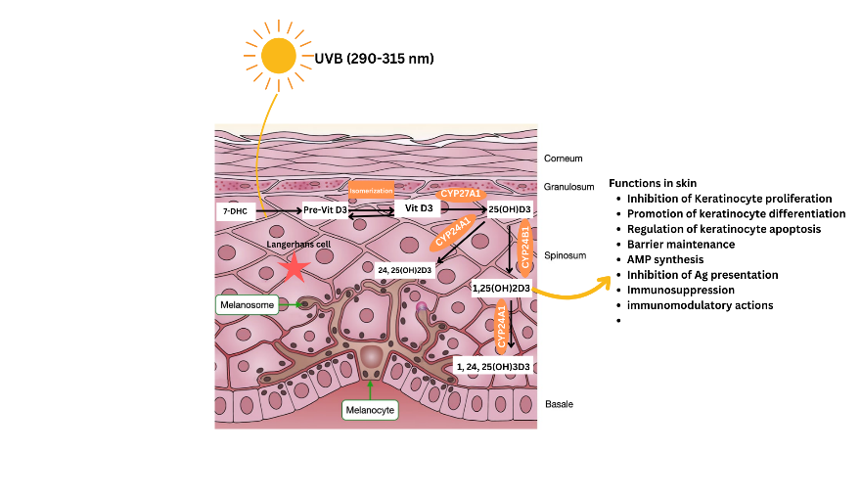 | b) 1,25(OH)₂D₃ procures the fibroblast to activate CYP27B1, A1 and CYP24A1, B1via immune system. Which in turn converts 25(OH)D₂ into 1,25(OH)₂D₃. The main agent debilitating inflammatory process and over comes immune suppression.
Graphical abstract:

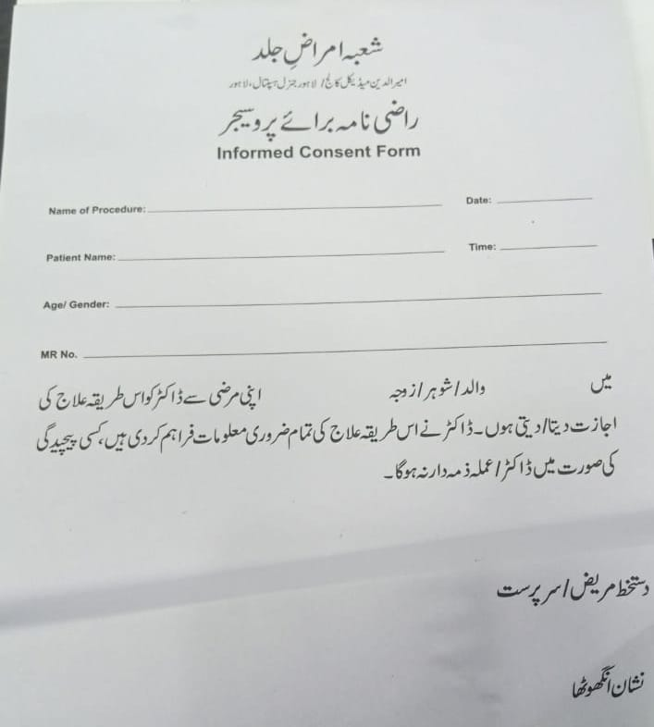

Ethical review certificate;
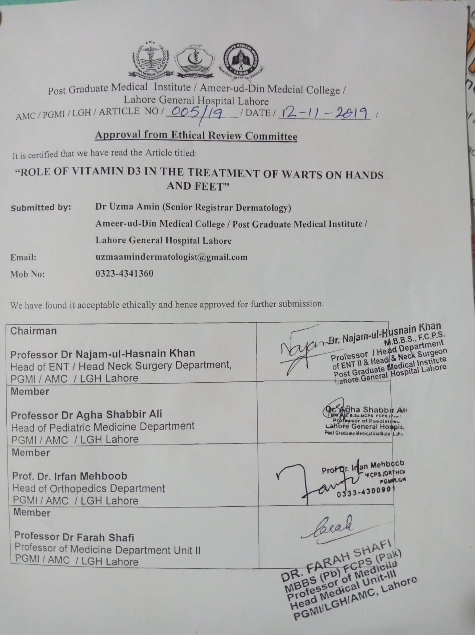
Ethical review committee Registration number;
Institutional Ethical Review Committee, Ameerud din Medical College/Postgraduate Medical Institute/ Lahore General Hospital, Lahore. Registration no: AMC/PGM/LGH/ARTICLENO/ 005/19 dated 12 November 2019.
Clinical trial registration
This study is registered with the Pakistan Clinical Trial Registry (CTR Number: RTCS-0519). Dated 11/12/2025.

References
1. Vazifehdoost, M., F. Eskandari, and A. Sohrabi, Trends in cocirculation of oncogenic HPV genotypes in single and multiple infections among the unvaccinated community. J Med Virol, 2022. 94(7): p. 3376-3385.
2. Skubic, L., et al., An Improved Protocol for Comprehensive Etiological Characterization of Skin Warts and Determining Causative Human Papillomavirus Types in 128 Histologically Confirmed Common Warts. 2022. 14(10): p. 2266.
3. Colotta, F., B. Jansson, and F. Bonelli, Modulation of inflammatory and immune responses by vitamin D. Journal of autoimmunity, 2017. 85: p. 78-97.
4. Onywera, H., et al., Microbiological and behavioral determinants of genital HPV infections among adolescent girls and young women warrant the need for targeted policy interventions to reduce HPV risk. Front Reprod Health, 2022. 4: p. 887736.
5. Tripathi, A. and U. Sahu, An overview of HPV: Causes, symptoms, and clinical manifestations. Immunopathology, Diagnosis and Treatment of HPV Induced Malignancies, 2022: p. 1-19.
6. Zhu, P., et al., Clinical guideline for the diagnosis and treatment of cutaneous warts (2022). Journal of Evidence‐Based Medicine, 2022. 15(3): p. 284-301.
7. Redzic, N., et al., Characterization of type-specific HPV prevalence in a population of persistent cutaneous warts in Flanders, Belgium. 2023. 13(1): p. 17492.
8. Sadeghzadeh‐Bazargan, A., et al., Evaluation and Comparison of the Efficacy and Safety of Cryotherapy and Electrosurgery in the Treatment of Sebaceous Hyperplasia, Seborrheic Keratosis, Cherry Angioma, and Skin Tag: A Blinded Randomized Clinical Trial Study. Health Science Reports, 2024. 7(11): p. e70154.
9. Shen, S., et al., Efficacy of photodynamic therapy for warts induced by human papilloma virus infection: A systematic review and meta-analysis. Photodiagnosis and Photodynamic Therapy, 2022. 39: p. 102913.
10. PugalIa, N., et al., Treatment Modalities of Cutaneous and Genital Warts: A Narrative Review. 2023. 17(7).
11. Cyprian, F., et al., Immunomodulatory Effects of Vitamin D in Pregnancy and Beyond. Front Immunol, 2019. 10: p. 2739.
12. Zanu, H., et al., Dietary calcium and meat and bone meal as potential precursors for the onset of necrotic enteritis. 2020. 76(4): p. 743-756.
13. Siddiqui, M., et al., Immune Modulatory Effects of Vitamin D on Viral Infections. Nutrients, 2020. 12(9).
14. Huang, Z., et al., Insight into interleukin-37: the potential therapeutic target in allergic diseases. Cytokine & growth factor reviews, 2019. 49: p. 32-41.
15. Ren, Z., et al., Systemic Immune-Inflammation Index and Systemic Inflammation Response Index are Associated With Periodontitis: Evidence From NHANES 2009 to 2014. International Dental Journal, 2024.
16. Liu, Z., et al., Dynamic changes in the systemic inflammation response index predict the outcome of resectable gastric cancer patients. Frontiers in oncology, 2021. 11: p. 577043.
17. Fathy, G., M.A. Sharara, and A.H. Khafagy, Intralesional vitamin D3 versus Candida antigen immunotherapy in the treatment of multiple recalcitrant plantar warts: A comparative case-control study. Dermatol Ther, 2019. 32(5): p. e12997.
18. Johnson, C.R., T.D.J.P. Thacher, and I.C. Health, Vitamin D: immune function, inflammation, infections and auto-immunity. 2023: p. 1-11.
19. Kareem, I.M.A., et al., Effectiveness of intralesional vitamin D3 injection in the treatment of common warts: Single‐blinded placebo‐controlled study. Dermatologic therapy, 2019. 32(3): p. e12882.
20. Jiang, S., et al., Systemic inflammation response index (SIRI) independently predicts survival in advanced lung adenocarcinoma patients treated with first-generation EGFR-TKIs. Cancer Management and Research, 2021: p. 1315-1322.
21. Sharma, M.K., et al., Evaluation of the efficacy and safety of the intralesional purifi ed protein derivative of tuberculin versus intralesional vitamin D 3 for the management of recalcitrant warts. 2023. 14(1).
22. Abeck, D., et al., Extragenital cutaneous warts–clinical presentation, diagnosis and treatment. JDDG: Journal der Deutschen Dermatologischen Gesellschaft, 2019. 17(6): p. 613-634.
23. Vlahovic, T.C. and M.T. Khan, The human papillomavirus and its role in plantar warts: a comprehensive review of diagnosis and management. Clinics in Podiatric Medicine and Surgery, 2016. 33(3): p. 337-353.
24. Kareem, I.M.A., et al., Effectiveness of intralesional vitamin D(3) injection in the treatment of common warts: Single-blinded placebo-controlled study. Dermatol Ther, 2019. 32(3): p. e12882.
25. Halim, H.M., et al., Effectiveness and safety of topical application of diphenylcyclopropenone versus podophyllin in treatment of genital warts. 2023: p. 09564624231169330.
26. Jakhar, D., I. Kaur, and R. Misri, Intralesional vitamin D3 in periungual warts. J Am Acad Dermatol, 2019. 80(5): p. e111-e112.
27. Shaldoum, D.R., et al., Comparative clinical study of the efficacy of intralesional MMR vaccine vs intralesional vitamin D injection in treatment of warts. J Cosmet Dermatol, 2020. 19(8): p. 2033-2040.
28. Abd El-Magid, W.M., E.E.A. Nada, and R.A. Mossa, Intralesional injection of vitamin D3 versus zinc sulfate 2% in treatment of plantar warts: a comparative study. J Dermatolog Treat, 2021. 32(3): p. 355-360.
29. Naseer, M., et al., Effectiveness of intralesional vitamin D3 injections for treatment of common warts: An open-label uncontrolled study. 2023. 33(4): p. 1399-1403.
30. Umar, M., et al., Vitamin D and the pathophysiology of inflammatory skin diseases. Skin pharmacology and physiology, 2018. 31(2): p. 74-86.
31. Gubatan, J., et al., Cathelicidin mediates a protective role of vitamin D in ulcerative colitis and human colonic epithelial cells. 2020. 26(6): p. 885-897.
32. Liu, W., et al., The anti-inflammatory effects of vitamin D in tumorigenesis. International journal of molecular sciences, 2018. 19(9): p. 2736.
33. Elmelid, A., et al., The Effect of Narrow-Band Ultraviolet B Phototherapy on Free and Total Vitamin D Serum Levels in Mild to Severe Plaque Psoriasis. Biomolecules, 2023. 13(7): p. 1018.
34. Elmelid, A., et al., Effects of Phototherapy on Free Vitamin D Levels in Ten Patients with Atopic Dermatitis. International Journal of Translational Medicine, 2022. 2(4): p. 586-596.
35. Cavalli, G. and C.A. Dinarello, Suppression of inflammation and acquired immunity by IL‐37. Immunological reviews, 2018. 281(1): p. 179-190.
36. Zeng, H., K. Zhou, and Z. Ye, Biology of interleukin‑37 and its role in autoimmune diseases. Experimental and Therapeutic Medicine, 2022. 24(2): p. 1-10.
37. Umar, M., et al., Vitamin D and the Pathophysiology of Inflammatory Skin Diseases. Skin Pharmacol Physiol, 2018. 31(2): p. 74-86.
38. Wimalawansa, S.J.J.N., Infections and Autoimmunity—The Immune System and Vitamin D: A Systematic Review. 2023. 15(17): p. 3842.
39. He, X., et al., MiR-125b promotes migration and invasion by targeting the vitamin D receptor in renal cell carcinoma. 2021. 18(1): p. 150.
40. Khorasanizadeh, M.H., et al., Vitamin D and the immune system. Nutrition and Immunity, 2019: p. 15-51.
41. Johnson, C.R. and T.D. Thacher, Vitamin D: immune function, inflammation, infections and auto-immunity. Paediatr Int Child Health, 2023. 43(4): p. 29-39.

