ORIGINAL RESEARCH
Role of CGRP expression in the mechanism of Electroacupuncture at “Ciliao” (BL32), Zhongji” (CV3), and “Guan Yuan” (CV4) points to relieve overactive bladder in rats

LIANG Dongdong¹，KONG Chang²，XU KaiWei¹，REN YeLong¹，HUANG LeDan¹，PAN Yuanyuan¹，WANG JunLu¹，ZHU MeiZhen^{1*}

¹ Department of Anesthesiology, The First Affiliated Hospital of Wenzhou Medical University, Wenzhou, Zhejiang, 325000, China.
² Department of Anesthesiology and Critical Care Medicine, Tianjin Nankai Hospital, Tianjin Medical University, Tianjin 300100, China.

Running title : Electroacupuncture relieve rat overactive bladder

Correspondence: ZHU MeiZhen. Department of Anesthesiology, The First Affiliated Hospital of Wenzhou Medical University, Wenzhou, Zhejiang, 325000, China.
Tel : +86-13968831450；Email : 157130649@qq.com.

Abstract:
Background. The occurrence mechanism of catheter-related bladder discomfort (CRBD) is unclear among patients requiring urinary catheterization. This study aimed to investigate the regulatory mechanism of electroacupuncture (EA) in alleviating bladder detrusor hyperactivity in a rat model.
Methods. 21 male Sprague–Dawley rats were randomly divided into three groups: control, model, and EA. The control group received saline perfusion in the bladder, whereas model group received 0.25% acetic acid perfusion for 60 munites. The EA group received EA on “Ciliao” (BL32), “Zhongji” (CV3), and “GuanYuan” (CV4) at 2/100 Hz,1mA, and 30 minutes, followed by 0.25% acetic acid perfusion for 60 munites. Physiological signal acquisition and processing system were used to measure urodynamics and electromyography (EMG). Real-time qPCR, western blot and ELISA were used to measure the levels of Ach, IL-1β, TNF-α, AKT, PI3K and CGRP.
Results. Compared to model group, EA prolonged the inter-urination interval and increased bladder capacity, maximum bladder detrusor pressure, and EMG amplitude, and reduced the expression of bladder Ach, M3R, and PI3K in the spinal cord, as well as CGRP in the dorsal root ganglia. EA also reduced IL-1β and TNF-α levels.
Conclusions. EA can alleviate involuntary contractions of the rat detrusor muscle by reducing CGRP expression.
Keywords: Catheter-related bladder discomfort; Electroacupuncture; Overactive bladder; Detrusor muscle

Introduction
In urological surgeries, indwelling catheters can often cause postoperative frequent urination and pain, accompanied by a strong emotional response termed catheter-related bladder discomfort (CRBD)^{[1]}. CRBD manifests as frequent and acute urinary symptoms, possibly resulting from involuntary contractions of the detrusor muscle^{[2]}. However, the exact reason for its occurrence during urological surgery remains unclear.

Sensory information from the bladder is transmitted via the lumbar visceral afferent nerve and the sacral pelvic visceral nerve to the spinal dorsal root ganglia (DRG) and the corresponding region of the spinal cord^{[2]}. Recent studies have shown that mechanical stimuli in the bladder can cause neurochemical and electrophysiological changes in the transmission of sensory information from neurons innervating the bladder^{[3, 4]}. Neurotransmitters or inflammatory cytokines in the DRG and spinal cord may further activate intracellular signaling kinases and gene transcription in the primary sensory pathways^{[5]}. One important nociceptive marker is the calcitonin gene-associated peptide (CGRP)^{[6]}. In cases of peripheral inflammatory pain and neuralgia, high expression of CGRP has been observed in the DRG^{[7]}. Recently, some researchers found that CGRP expression is increased in the trigeminal ganglia and is concentrated in class C fibers. In addition, it has been shown that CGRP activates the PI3K/AKT pathway. This pathway is widely expressed in the spinal cord, especially in the dorsal horn where injured primary afferent C and Aδ fibers terminate. This pathway is involved in nociceptive signaling, contributing to peripheral sensitization and hyperalgesia^{[8, 9]}.

Electroacupuncture (EA) can generate nerve-conducting impulses through acupoint stimulation and deliver them in the form of electricity. These impulses travel to the spinal cord and cerebral cortex, exerting extensive regulatory effects on neurotransmitters^{[10]}. Some studies have reported that EA can significantly reduce spinal C-fos expression in rats with colorectal hypersensitivity^{[11, 12]}. EA can improve the expression of thalamic antistress-related neuropeptide, raise the threshold of abdominal retraction reflex, and reduce visceral hypersensitivity. However, the connection between the inpulses regulatory effects of EA and neurons innervating the bladder detrusor contraction remains poorly understood.

Therefore, to explore the regulatory mechanism of bladder detrusor overactivity by EA, a rat model of bladder hyperactivity was established to mimic the simulative symptoms of acute and frequent urination.

Material and methods

Animals
All experimental procedures involving rats were conducted strictly in accordance with the National Health Agency Guidelines for the Care and Use of Laboratory Animals. Male Sprague–Dawley rats weighing 220–290 g were selected for the study. The rats were housed in plastic cages and were alternately provided cornflakes and water. They were kept under controlled light/dark conditions with an indoor temperature maintained at 23°C–25℃.
The rats were randomly divided into three groups: control, model, and EA group. Each group initially had seven rats, but the number of rats was adjusted to ensure at least six surviving animals in each group for biochemical analyses. To create the rat bladder detrusor hyperactivity model, acetic acid perfusion was performed. A cannula was placed into the bladder dome for the infusion of either 0.9% saline or 0.25% acetic acid. Rats in the control group received 0.9% saline perfusion at a rate of 0.1 mL/min for 60 minutes. Rats in the model group received 0.9% saline perfusion to obtain baseline bladder urodynamic data (before modeling), followed by 0.25% acetic acid to induce bladder detrusor hyperactivity and obtain post-induction bladder urodynamics data. Rats in the EA group initially received 0.9% saline perfusion to obtain baseline bladder urodynamics data (before EA treatment), followed by EA treatment for 30 minutes, and then bladder perfusion with 0.25% acetic acid for another 60 minutes. Finally, a second round of saline infusion was administered to obtain post-EA bladder urodynamics data.

Acupoints
“Zhongji” (CV3), “GuanYuan” (CV4), and Bilateral “Ciliao” (BL32) acupoints were selected ^{[13]}. BL32 is located 5–10 mm beside the S₂/S₃ spinal process gap in the dorsal region. CV3: The “Shenque” point is located at the intersection of the upper 3/4 and the lower 1/4 between the upper edge of the sternoclavicular joint and the symphysis pubis. The “Zhongji” point is located at the intersection of the upper 4/5 and the lower 1/5 between the “Shenque” point and the symphysis pubis. CV4 is located between the midpoint of the root connection of the two hind limbs and the midpoint of the double iliac crest line. The EA parameters used were as follows: frequency, 2/100HZ; intensity, 1 mA; duration, 30 minutes (Fig. 1).

Laboratory tests
Urodynamic data were recorded using the MedLab-420F system (sampling rate, 100 Hz; pressure range, 0–200 Hg, cutoff frequency of low-pass filter, 20 Hz). The basal bladder pressure value, time interval between urination episodes, maximum bladder detrusor contraction pressure, mean urination pressure value, and bladder capacity were recorded^{[14]}.

After administration of urethane anesthesia, a positive and a negative conductive needle were inserted into the detrusor bladder at a distance of approximately 2 mm from the bladder. The subarea under the electromagnetic (EMG) signal curve was measured, and the detrusor firing activity of the rats was analyzed and recorded. The rat detrusor firing amplitude was calculated as the difference between the increased phase area of EMG signal amplitude and the baseline phase area.

After administration of excessive urethane anesthesia (20%, 1 mL/100g), blood samples, bladder tissue, and (L₅-S₁) DRG and spinal cord tissue were collected from the rats and stored for further analysis.

Total RNA was extracted using the RNeasy™ animal RNA extraction kit. Subsequently, RNA reverse transcription reactions were performed using the RevertAid First Strand cDNA Synthesis Kit. For the internal reservoir GAPDH primer, the forward and reverse sequences were as follows:
Forward: GGACATGCCGCCTGGAGAAAC.
Reverse: AGCCCAGGATGCCCTTTAGT.
For the AKT primer, the forward and reverse sequences were as follows:
Forward: TGAACGACGTAGCCATTGTGAAGG.
Reverse: GCCATCATTCTTGAGGAGGAAGTAGC.

The specimens for western blot analysis were weighed, and lysates were added. The protein concentration in the samples was measured using the Pierce™ BCA Protein Assay Kit. Protein absorbance was measured using a full-wavelength microplate reader at a wavelength of 562 nm. Protein concentrations were calculated by analyzing the absorbance values of the samples. Proteins were detected by SDS-PAGE. The protein bands were visualized using an ECL luminescence reagent, and the band grayscale values were analyzed using Image J software.

For ELISA, samples were weighed and mixed with phosphate buffered saline（PBS） liquid. Standard products with known concentrations were prepared and added to the precoated plate, starting from the highest concentration, and gradually decreasing. Blank control wells were also included, and the samples to be tested were added to the appropriate sample wells. Absorbance was measured at 450 nm using a spectrophotometer. A standard curve was taken as the abscissa and the absorbance as the vertical coordinate, and the corresponding concentrations of Ach, IL-1β, and TNF-α in the samples were calculated by comparing their absorbance values to the standard curve.

Statistical analysis
Data were analyzed using SPSS version 26.0. Descriptive data are represented as the mean ± standard deviation (𝑥 ± s). For comparisons involving multiple factors, ANOVA with Tukey’s multiple comparisons were employed. Pairwise t-tests were performed for post hoc analyses to compare specific groups. In cases where the assumption of equal variance was violated, multiple comparisons were conducted using the Games–Howell method. Statistical significance was considered at P < 0.05.

Results

Bladder urodynamics in rats
No significant difference was observed in urodynamic parameters before molding among the three groups (P > 0.05). However, after the perfusion of 0.25% acetic acid, rats in the model group exhibited significantly shortened urination intervals (P=0.003), increased basal urination pressure (P=0.019), reduced bladder capacity (P=0.003), and decreased maximum bladder detrusor pressure (P=0.001). In contrast, rats in the EA group, which received pretreatment with EA, showed increased urination intervals (P=0.048), bladder capacity (P=0.048), and maximum bladder detrusor pressure compared to the model group (P=0.01).

The model group showed significant differences in urodynamic parameters before and after molding (P < 0.05 or P < 0.001). However, urodynamics in the EA group showed no significant differences before and after molding (P > 0.05; Table 1).

EMG amplitude in rats
No significant differences were observed in the EMG amplitude among the three groups before molding (P > 0.05). However, the model group showed a significantly reduced bladder EMG amplitude compared to the control group (P=0.041). In contrast, the EA group showed reversal of the decreased EMG amplitude after treatment (P=0.005).

The model group showed a significant difference in EMG amplitude before and after molding (P=0.044). However, no significant difference was observed in EMG amplitude in the EA group before and after molding (P > 0.05; Table 2).

Relations between rat urodynamic curve and EMG amplitude
When the liquid in the bladder reaches a certain amount, the urination pressure increases sharply, leading to the appearance of the peak wave of maximum urination pressure. Meanwhile, the detrusor muscle contracts, resulting in the appearance of an EMG waveform, whose size is related to the peak maximum urination pressure. At the end of the voiding process, the voiding pressure line gradually drops and reaches a level equivalent to the baseline pressure line.

The time interval between the maximum pressure peaks was significantly reduced, the basic pressure of urination showed a double peak wave, and the maximum pressure peak wave was significantly reduced in the model group. Simultaneously, the EMG amplitude decreased, and a detrusor involuntary contractive wave appeared at the urination baseline. With EA pretreatment, the rat detrusor contraction rhythm significantly decreased, the time interval between urination intervals significantly increased, the maximum pressure peak value increased, the EMG amplitude increased accordingly, and the basic pressure line shifted downward (Fig. 2).

Ach content and expression of M3R in groups
Compared to the control group, the Ach content (P=0.001) and the expression of M3R (P =0.011) were significantly increased in the model group and significantly decreased in the EA group (P=0.002 and P=0.031, respectively; Fig. 3).

Expression of CGRP in DRG (L5-S1)
The expression of CGRP increased in the DRG (L₅-S₁) compared to the control group (P = 0.001), whereas it was reversed in the EA group (P=0.003; Fig. 4).

Expression of AKT, p-AKT, and PI3K in spinal cord(L5-S1)
The expression of p-AKT (L₅-S₁) showed an increasing trend but did not have a significant difference (P > 0.05) compared to the control group. However, in the EA group, the expression of p-AKT significantly decreased (P=0.028). RT-qPCR showed that AKT-mRNA expression was high in the model group and sharply decreased to a low level in the EA group, but this difference was not statistically significant (P > 0.05). In addition, the expression of AKT protein in the spinal cord did not show a significant difference among the groups (P > 0.05). Compared to the control group, the expression of PI3K was increased (P=0.03) in the model group. In contrast, it was significantly decreased in the EA group (P=0.037; Fig. 5).

Content of IL-1β and TNF-α in groups.
The levels of IL-1β and TNF-α were significantly increased in the model group (P < 0.001) compared to the control group. Compared to the model group, the EA group showed significantly reduced levels of IL-1β and TNF-α (P < 0.001 and P=0.001, respectively; Table 3).

Discussion

CGRP and PI3K/AKT pathway induce bladder overactivity
The DRG plays an extremely important role in transmitting information between the peripheral and central nerves. Within the DRG, the nerve cell bodies of the bladder afferent fibers are located in the thoracic-lumbar (T₁₀-L₂) and lumbosacral (L₅-S₁) regions^{[15]}. Class C afferent fibers are mainly located in the bladder and submucosa. They account for 60% of the bladder afferents and are sensitive to chemical stimulation^{[16]}. It has been shown that injection of acetic acid into the bladder could stimulate nociceptive afferent fibers, induce inflammatory responses, and result in detrusor hyperactivity^{[17]}. Bladder overactivity was defined as involuntary contractions of the detrusor muscle, which may occur spontaneously or in response to certain stimuli^{[18]}. Approximately 90% of detrusor contractions can cause symptoms of urgency and frequent urination. CGRP is an important nociceptive sensory signal involved in mediating hypersensitivity. It is abundantly present in the DRG and can be released from the C fibers, particularly during peripheral inflammation^{[19]}. In the context of bladder-related disorders, such as cyclophosphamide-induced cystitis-related pain in rats, the expression of CGRP-mRNA and CGRP protein was found to be significantly increased in the L₆ ganglia, prompting bladder non-voiding contractions in rats^{[20]}. Furthermore, in studies exploring pain-sensitive signal transduction and the involvement of prostaglandin E₂ (PGE₂)/EP₄ receptor (PGE₂ receptor) in cultured rat DRG neurons, continuous exposure to EP₄ agonists led to the release of CGRP, resulting in enhanced pain sensitivity. Inhibition of PI3K and Akt, which are signaling pathways involved in cellular processes, reduced the sensitivity of nociceptors and attenuated the effects of PGE₂-induced signaling through EP₄ receptors ^{[21]}. These findings suggest that CGRP is involved in the transmission of nociceptive signals and the initiation of peripheral sensitization.

Visceral hypersensitivity is associated with an imbalance in neurotransmitter release and increased sensitivity of sensory nerve terminals to the corresponding mediators, which may involve multiple links including the dorsal horn of the spinal cord and the central nervous system. The spinal cord receives sensory signals from the primary afferent nerve innervating the bladder and descending regulatory signals from the central nervous system, which help modulate the incoming pain signals. These regulatory signals play an important role in maintaining normal bladder function^{[2]}. The PI3K/AKT pathway is a widely recognized intracellular signaling pathway that can initiate peripheral sensitization and hyperalgesia^{[22]}. PI3K activation promotes the conversion of diphosphoinositol to triphosphoinositol, thereby activating Akt^{[23]}. Akt has been recognized as an important component in sensory hypersensitivity and can induce chemical or neurological hyperalgesia^{[24, 25]}. The expression of AKT is closely related to the inflammatory environment; inflammatory factors can promote AKT phosphorylation, leading to the activation of downstream inflammatory factors such as IL-1β and TNF-α, thus aggravating the pain cycle^{[25]}. In this study, it is proposed that nociceptive signals from acetic acid stimulate bladder afferent nerve fibers, leading to an increase in the excitatory CGRP, thus activating the expression of PI3K and promoting Akt phosphorylation, leading to hypersensitivity.

EA affect visceral hypersensitivity

EA is a technique that involves the stimulation of acupoints using electrical energy. This electrical stimulation can generate nerve conduction impulses, which can then reach the spinal cord. EA has been found to have extensive effects on neurotransmitter regulation^{[10]}. In previous studies, EA applied to acupoints could significantly inhibit the expression of CGRP and substance P（SP）. By reducing the expression of these neuropeptides, EA has been shown to reduce the thermal pain threshold and relieve incision pain. It has also been found to block the expression of phosphorylated PI3K in rat spinal cord injury models^{[26],[27]}. Moreover, both low-frequency (2 Hz) and high-frequency (100 Hz) stimulation could downregulate CGRP expression in the L4-L6 spinal ganglia^{[28]}. Collectively, previous studies and the current study showed that EA could block the transmission of nociceptive information by regulating the expression of neurotransmitters in the inflammatory visceral pain.

The nerves in the bladder are mainly distributed by visceral nerves. Sympathetic nerves originating from the T₁₁₋₁₂ and L₁₋₂ segments innervate the bladder wall, whereas parasympathetic nerves mainly arise from the pelvic visceral nerves in the S₂₋₄ sacral segments, innervating the bladder detrusor muscle^{[29]}. The “Zhongji” acupoint is innervated by the terminal nerve of the T₁₂-L₁ spinal segment, the “Ciliao” point corresponds to the S₂ sacral nerve, and the “GuanYuan” point connects to the medial branch of the 12th costal intercostal nerve. When EA is applied to these acupoints, it may stimulate the sacral nerve and reduce the parasympathetic secretion of Ach, ultimately preventing detrusor muscle contraction. Similarly, some studies have shown that EA with “Sanyinjiao,” “Hegu,” and “Ciliao” points can significantly increase the maximum detrusor contraction pressure value and prolong the urination interval time^{[30]}. These findings suggest that EA pretreatment can effectively improve the function of the bladder detrusor muscle. However, the exact electrophysiological effects of electrical signals on bladder sensory nerve afferent fibers warrant further exploration.

Conclusions
EA can alleviate involuntary contractions of the rat detrusor muscle by reducing the expression of CGRP.

Acknowledgments

We would like to thank MogoEdit (https://www.mogoedit.com) for its English editing during the preparation of this manuscript.

Authors’ contributions

Dongdong Liang, JunLu Wang, and MeiZhen Zhu contributed to the conception and study design. Chang Kong and KaiWei Xu contributed to analysis and interpretation. YeLong Ren JiaYu Wu, LeDan Huang and Yuanyuan Pan substantial contributed to the execution, acquisition of data and analysis. Dongdong Liang has written and critically reviewed the article.

Declarations

Ethics approval and consent to participator
This study was approved by the Animal Ethics Committee of the First Affiliated Hospital of Wenzhou Medical University (No. WYYY-AEC-YS-2022-0210). All institutional and national guidelines for the care and use of laboratory animals were followed.

Availability of data and materials
The datasets are available from the corresponding author on reasonable request.

Competing interests
The authors declare that they have no competing interests.

Funding
This paper is supported by Wenzhou Science and Technology Bureau of China (Y20220217).

References
1. Bai Y, Wan X, Li X, Pu C, Yuan H, Tang Y, Li J, Wei Q, Han. P. Management of Catheter-Related Bladder Discomfortin Patients Who Underwent Elective Surgery. J Endourol. 2015;29(6):640-9.
2. Grundy L, Brierley SM. Cross-organ sensitization between the colon and bladder: to pee or not to pee? Am J Physiol Gastrointest Liver Physiol. 2018;314(3):301-8.
3. Xu L, Gebhart GF. Characterization of Mouse Lumbar Splanchnic and Pelvic NerveUrinary Bladder Mechanosensory Afferents. J Neurophysiol. 2008;99(1):244-53.
4. Grundy L, Harrington AM, Caldwell A, Castro J, Staikopoulos V, Zagorodnyuk VP, Brookes SJH, Spencer NJ, Brierley SM. Translating peripheral bladder afferent mechanosensitivity to neuronal activation within the lumbosacral spinal cord of mice. Pain. 2019;160(4):793-804.
5. Million M, Wang L, Wang Y, Adelson DW, Yuan P-Q, Maillot C, Coutinho SV, Mcroberts JA, Bayati A, Mattsson H, Wu V, Wei J-Y, Rivier J, Vale W, Mayer EA, Tache´ Y. CRF2 receptor activation prevents colorectal distension induced visceral pain and spinal ERK1/2 phosphorylation in rats. Gut. 2006;55:172-81.
6. Durham PL, Vause CV. CGRP Receptor Antagonists in the Treatment of Migraine. CNS Drugs. 2010;24(7):539-48.
7. White S, Prado BMd, Russo AF, Hammond DL. Heat hyperalgesia and mechanical hypersensitivity induced by calcitonin gene-related peptide in a mouse model of neurofibromatosis. PLoS One. 2014;9(9):e106767.
8. Pezet S, McMahon SB. Neurotrophins: mediators and modulators of pain. Annu Rev Neurosci 2006;29:507–38.
9. Li D, Chen H, Luo X-H, Sun Y, Xia W, Xiong Y-C. CX3CR1-Mediated Akt1 Activation Contributes to the PaclitaxelInduced Painful Peripheral Neuropathy in Rats. Neurochem Res. 2016;41(6):1305-14.
10. Nakaya K, Nagura Y, Hasegawa R, Ito H, Fukudo S. Dai-Kenchu-To, a Herbal Medicine, Attenuates Colorectal Distention-induced Visceromotor Responses in Rats Journal of Neurogastroenterology and Motility. 2016;22(4):686-93.
11. Wang S-J, Yang H-Y, Wang F, Li S-T. Acupoint Specificity on Colorectal Hypersensitivity Alleviated by Acupuncture and the Correlation with the Brain-Gut Axis. Neurochem Res. 2015;40(6):1274-82.
12. Qiao CX, Zhao G, Zhang LZ, Di AT, Liu PL, Wang YY, Zeng L. Intervention mechanism of electroacupuncture in rats with ulcerative colitis: an analysis based on the Toll-like receptor 4/myeloid differentiation factor 88/nuclear factor-kappa B signaling pathway. Zhen Ci Yan Jiu. 2020;45(3):180-7.
13. Feng YA, Ping W. Dissection and organization of the rats [M]. ISBN: 130312885, Beijing Science Press.1985:32-50. (Chinese).
14. Goldstein RE, Westropp JL. Urodynamic testing in the diagnosis of small animal micturition disorders. Clin Tech Small Anim Pract. 2005;20(1):65-72.
15. Grundy L, Harrington AM, Castro J, Garcia-Caraballo S, Deiteren A, Maddern J, Rychkov GY, Ge P, Peters S, Feil R, Miller P, Ghetti A, Hannig G, Kurtz CB, Silos-Santiago I, Brierley SM. Chronic linaclotide treatment reduces colitis-induced neuroplasticity and reverses persistent bladder dysfunction. JCI Insight. 2018;3(19):e121841.
16. Gebhart GF. Visceral pain—peripheral sensitisation. Gut. 2000;47(Suppl 4):54-5.
17. Mitsui T, Kakizaki H, Matsuura S, Ameda K, Yoshioka M, Koyanagi T. Afferent fibers of the hypogastric nerves are involved in the facilitating effects of chemicalbladder irritation in rats. J Neurophysiol. 2001;86(5):2276-84.
18. Abrams P, Cardozo L, Fall M, Griffiths D, Rosier P, Ulmsten U, Kerrebroeck PV, Victor A, Wein A, Society SS-CotIC. The Standardization of Terminology of Lower Urinary Tract Function: Report from the Standardisation Sub-committee of the International Continence Society. Urology. 2003;61(1):7-49.
19. Yu LC, Hou JF, Fu FH, Zhang YX. Roles of calcitonin gene-related peptide and its receptors in pain-related behavioral responses in the central nervous system. Neurosci Biobehav Rev. 2009;33(8):1185-91.
20. Yu SJ, Xia CM, Kay JC, Qiao LY. Activation of extracellular signal-regulated protein kinase 5 is essential for cystitis- and nerve growth factor-induced calcitonin gene-related peptide expression in sensory neurons. Mol Pain. 2012:8:48.
21. Ma W, Jacques BS. Signalling transduction events involved in agonist-induced PGE2/EP4 receptor externalization in cultured rat dorsal root ganglion neurons Eur J Pain. 2018;22(5):845-61.
22. Uckert S, Stief CG, Lietz B, Burmester M, Jonas U, Machtens SA. Possible role of bioactive peptides in the regulation of human detrusor smooth muscle-functional effects in vitro and immunohistochemical presence. World J Urol. 2002;20(4):244-9.
23. Jin D, Yang JP, Hu JH, Wang LN, Zuo JL. MCP-1 stimulates spinal microglia via PI3K/Akt pathway in bone cancer pain. Brain Res. 2015;1599:158-67.
24. Xu Q, Fitzsimmons B, Steinauer J, O'Neill A, Newton AC, Hua X-Y, Yaksh TL. Spinal phosphinositide 3-kinase-Akt-mammalian target of rapamycin signaling cascades in inflammation induced hyperalgesia. J Neurosci. 2011;31(6):2113-24.
25. Arms L, Vizzard MA. Role for pAKT in rat urinary bladder with cyclophosphamide (CYP)-induced cystitis. Am J Physiol Renal Physiol. 2011;301(2):252-62.
26. Qiao LN, Wang JY, Yang YS, Chen SP, Gao YH, Zhang JL, Liu JL. Effect of Electroacupuncture Intervention on Expression of CGRP, SP, COX-1, and PGE2 of Dorsal Portion of the Cervical Spinal Cord in Rats with Neck-Incision Pain. Evid Based Complement Alternat Med. 2013;2013:294091.
27. Wang Y, Zhao Y, Ma X, Li J, Hou J, Lv X. Beneficial Effects of Electroacupuncture on Neuropathic Pain Evoked by Spinal Cord Injury and Involvement of PI3K-mTOR Mechanisms. Biol Res Nurs. 2019;21(1):5-13.
28. He X-F, Wei J-J, Shou S-Y, Fang J-Q, Jiang Y-L. Effects of electroacupuncture at 2 and 100 Hz on rat type 2 diabetic neuropathic pain and hyperalgesia-related protein expression in the dorsal root ganglion. J Zhejiang Univ Sci B. 2017;18(3):239-48.
29. Shalom DF, Pillalamarri N, Xue X, Kohn N, Lind LR, Winkler HA, Metz CN. Sacral nerve stimulation reduces elevated urinary nerve growth factor levels in women with symptomatic detrusor overactivity. Am J Obstet Gynecol. 2014;211(5):561.
30. Qian M, Shuo Y, Ming WX. Electricity targeting the effects on bladder function in rats with overactive bladder. Shizhen national medicine. 2019;30(5):1244-6. (Chinese).
Tables
Table 1. Urodynamics in groups(‾𝑥±s, n=7)
Groups |  |  | Inter-urination  interval time (s) | Basal urination pressure (cmH₂O) | Maximum bladder detrusor pressure (cmH₂O) | Average urination pressure (cmH₂O) | Bladder capacity  (ml)
Control group |  |  | 175.72±46.59 | 1.27±0.95 | 25.70±5.63 | 10.80±5.49 |  | 0.29±0.08
Model group |  | Before | 163.28±18.23 | 1.85±0.47 | 23.78±6.61 | 7.67±4.01 |  | 0.27±0.03
 |  | After | 79.45±12.62*∆∆ | 3.59±1.58*∆ | 14.78±3.31*∆ | 6.56±1.46 |  | 0.13±0.02*∆∆
EA group |  | Before | 158.47±59.28 | 1.44±0.64 | 20.45±3.70 | 6.80±1.62 |  | 0.26±0.10
 |  | After | 168.27±75.93# | 1.28±0.24# | 21.61±3.90# | 6.69±1.71 |  | 0.28±0.13#
*P<0.05 vs control group; #P<0.05 vs model group; ∆P<0.05, ∆∆P<0.001: self-comparison between the before and the after of model group.

Table 2. EMG amplitude in three groups(‾𝑥±s, n=7)
Groups |  | EMG amplitude (uV*s)
Control group |  | 9.49±4.67
Model group | Before | 6.66±4.40
 | After | 1.65±0.60*∆
EA group | Before | 6.62±3.30
 | After | 5.33±1.40#
*P<0.05 vs control group; #P<0.05 vs model group; ∆P<0.05: self-comparison between the before and the after of model group.

Table 3. Content of IL-1β and TNF-α in each group(‾𝑥±s, n=7)
Groups | IL-1β(ng/L) | TNF-α(ng/L)
Control group | 15.73±3.83 | 75.70±27.21
Model group | 31.87±6.021** | 175.48±33.49**
EA group | 17.53±3.36## | 112.87±16.12#
**P<0.001 vs control group; #P<0.05, ##P<0.001vs model group.

Figures
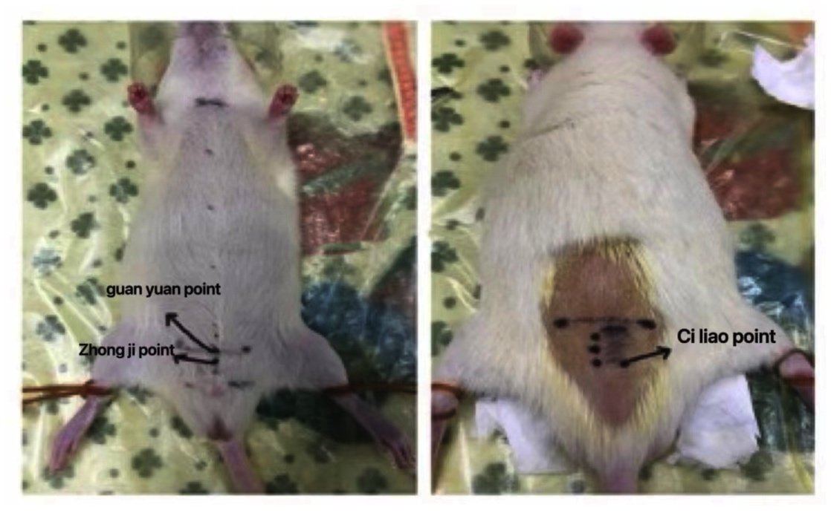
Figure 1. Position of the rat acupoints
The left side shows the "Zhongji point" and "Guan Yuan point" in the abdomen. The right side shows bilateral "ciliao point" in the back.

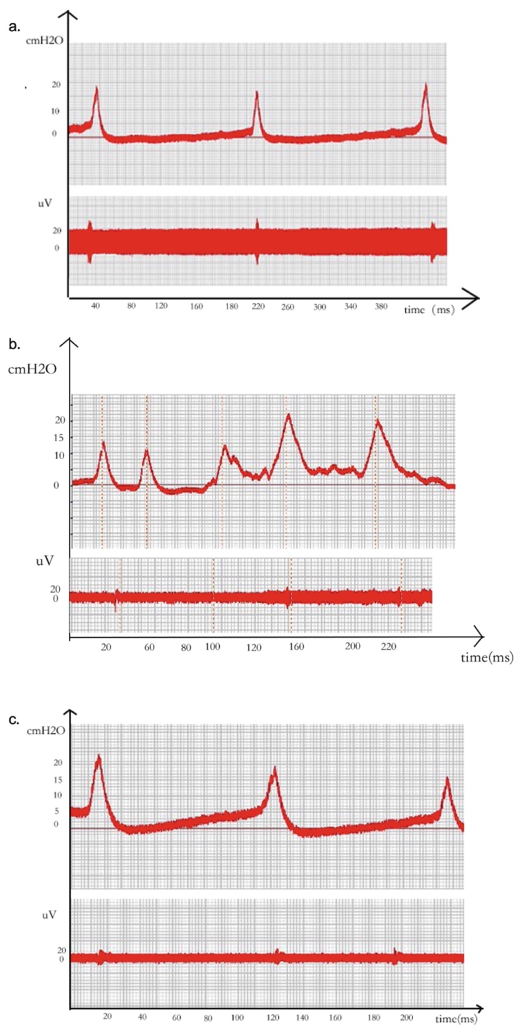
Figure 2.Relations between rat urodynamic curve and detrusor discharge amplitude in each group.
The upper curve shows the urodynamic curve (cmH₂O), and the lower curve shows EMG discharge amplitude (uV). a. The urodynamic curve and EMG in the control group. b. The urodynamic curve and EMG in the model group. c. The urodynamic curve and EMG in the EA group.

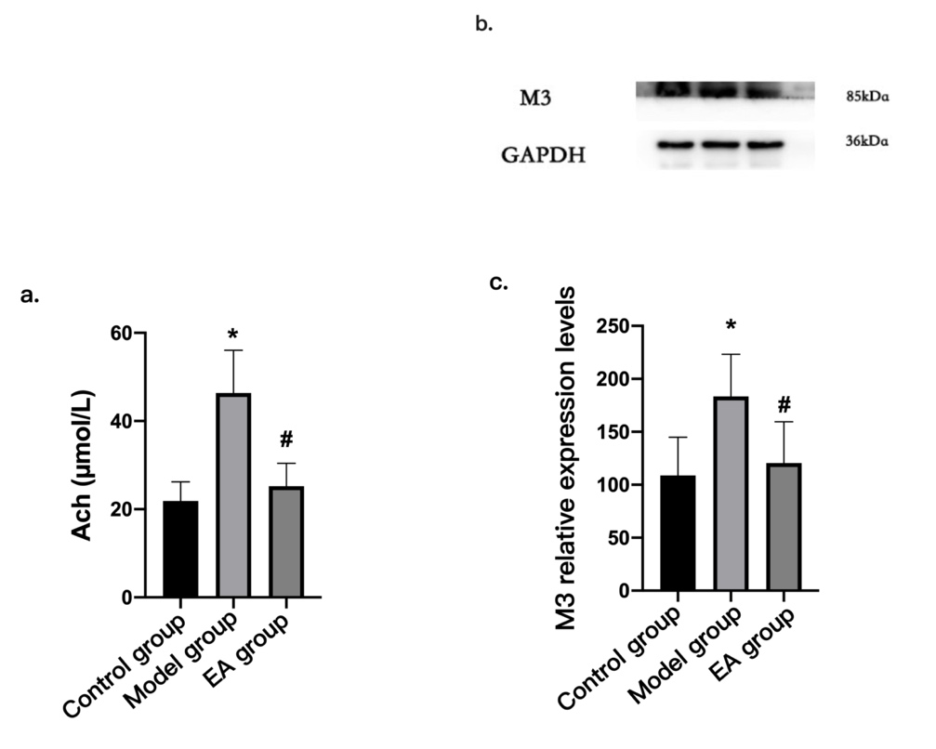
Figure 3. Bladder Ach content and M3R expression in three groups(‾𝑥±s, n=7). a. Bladder Ach content; b. M3 protein strip plots c. M3R relative expression. *P<0.05 vs control group; #P<0.05 vs model group.

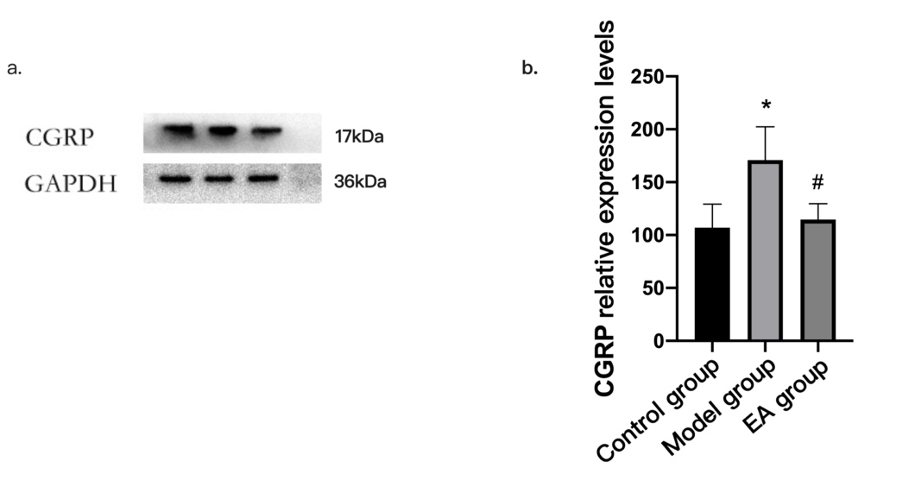
Figure 4. CGRP relative expression in DRG in each group (‾𝑥±s, n=6). a. CGRP strip plots; b. CGRP relative expression in DRG in each group. *P<0.05 vs control group; #P<0.05 vs model group.

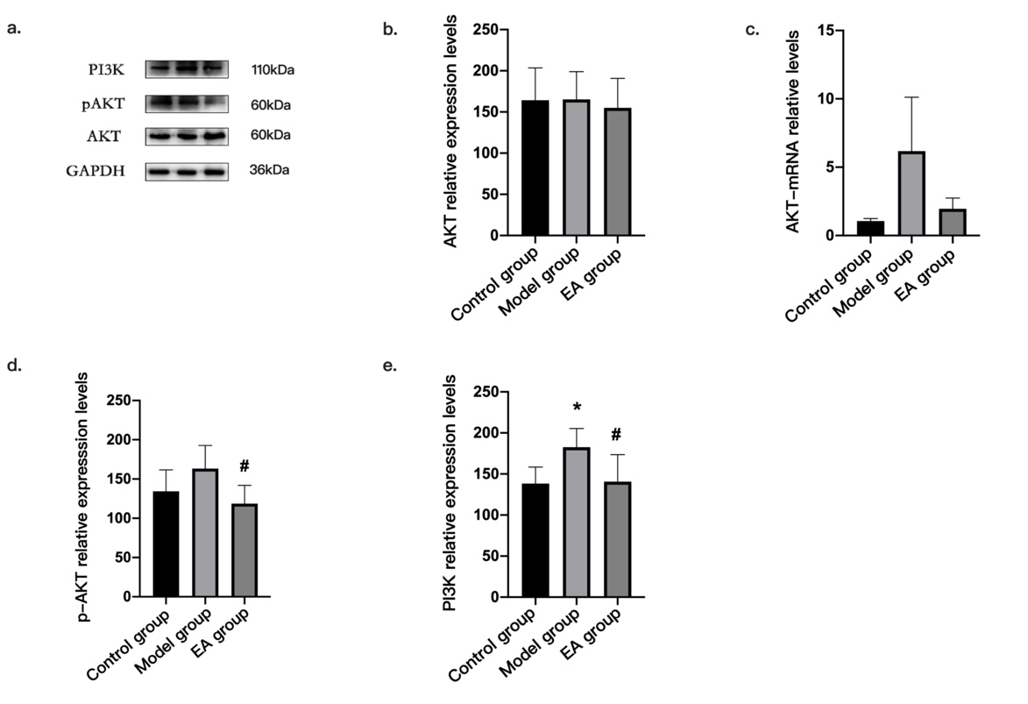
Figure 5. The expression of AKT, p-AKT and PI3K in each group(‾𝑥±s, n=6). a. Protein strip plots; b. AKT relative expression; c. AKT-mRNA levels in spinal cord; d. p-AKT relative expression in each group; e. PI3K relative expression in each group. *P<0.05 vs control group; #P<0.05 vs model group.

