Adaptation of small mammals to arid environment：Renal lncRNA-miRNA-mRNA profiles in Orientallactaga sibirica under water-shortage environments
Rong Zhang ¹, Yongling Jin ¹, Xin Li¹, Linlin Li¹, Dong Zhang¹, Yu Ling¹, Shuai Yuan^{1, 2}, Xueying Zhang², Heping Fu¹, Xiaodong Wu¹*
1 College of Grassland Science, Inner Mongolia Agricultural University, Inner Mongolia, China
2 State Key Laboratory of Animal Biodiversity Conservation and Integrated Pest Management, Institute of Zoology, Chinese Academy of Sciences, Beijing, China.
* Corresponding author: Xiaodong Wu, Email: wuxiaodong_hgb@163.com.
Abstract
Drought caused by climate change threatens the survival of mammals in arid regions, and exploring their molecular adaptation mechanisms is crucial for biodiversity conservation. This study employed whole-transcriptome sequencing to analyze the expression profiles of mRNAs,and non-coding RNAs in the kidneys of Orientallactaga sibirica under water-restriction stress and control conditions. A total of 22,304 differentially expressed mRNAs, 4,955 differentially expressed lncRNAs, 9,349 differentially expressed circRNAs, and 641 differentially expressed miRNAs were identified. Functional enrichment analyses revealed that these differentially expressed RNAs were primarily involved in transmembrane transport, ion homeostasis, lipid metabolism, and hormone secretion pathways, which are closely associated with water-salt balance regulation. Based on the competing endogenous RNA (ceRNA) theory, an lncRNA/circRNA-miRNA-mRNA regulatory network was constructed, identifying key nodes such as TCONS_00089519, circ_0015772, miR-188-3p, and target genes IDUA, XLOC_010352. Further analysis suggested that IDUA may inhibit SLC26A1 activity to reduce kidney stone formation under water stress, while XLOC_010352, regulated by miR-188-3p, may be involved in adjusting reproductive strategies. This study reveals the multi-level regulatory role of non-coding RNAs in O. sibirica's adaptation to water scarcity, providing a theoretical basis for understanding mammalian molecular adaptation to extreme arid environments and supporting biodiversity conservation in arid regions.
Keywords: Desert rodents; Arid adaptation; Arid climate; Biodiversity conservation; ceRNA regulation
Introduction
Climate change is driving persistent trends of warming and aridification, with increasing fluctuations in precipitation and a significant rise in the frequency of droughts and heatwaves[1]. This global change profoundly disrupts ecosystem balance, exacerbating the severity of drought issues[2], which in turn intensifies the risk of species extinction and poses a serious threat to biodiversity[3]. Among these impacts, drought-induced water stress exerts a strong pressure on the survival of organisms; particularly in arid regions, mammals are confronting the severe challenge of dual scarcity of water and food resources[4, 5]. As key components of arid-land ecosystems, small mammals play an irreplaceable role in maintaining ecological balance[6] and simultaneously undertake multiple vital ecosystem service functions, including acting as ecosystem engineers, seed dispersers, and apex predators or prey[7].
To adapt to extreme arid and hot environments, desert mammals has evolved diverse adaptive strategies: on the one hand, they reduce the time exposed to lethal temperatures and arid conditions through behavioral adjustments[8, 9]; on the other hand, they enhance environmental tolerance by modifying regulatory mechanisms at the physiological, biochemical, and molecular levels. As a typical species in arid regions, the Orientallactaga sibirica has developed unique physiological and molecular adaptive mechanisms through long-term evolution, enabling it to efficiently cope with water-scarce environments. From an evolutionary perspective, many desert mammals have exhibited significant phenotypic variations, such as the differentiation in mandible morphology of the fat-tailed jerboa (Pygeretmus pumilio)[10] and the specialization of activity strategies in the O. sibirica[11]. Meanwhile, adaptive traits at the physiological level are also widespread; for instance, camels have evolved multiple resistance traits to adapt to high-salt and water-scarce environments, and achieve precise adaptation to harsh environments through the regulatory network associated with mRNA, miRNA, and lncRNA[12]. Regulation of gene expression is the core mechanism for mammals to adapt to environmental changes.
In the mammalian genome, two major types of gene transcription units are predominantly expressed through the transcription process mediated by RNA polymerase II: protein-coding transcription units and non-coding RNA (ncRNA) transcription units[13]. In recent years, the role of ncRNAs in gene regulation has attracted widespread attention in the academic community[14]. Represented by long non-coding RNAs (lncRNAs) and microRNAs (miRNAs), ncRNAs do not directly participate in protein coding, but can regulate gene expression through multiple molecular pathways. Notably, most lncRNAs may not possess specific functions, yet their transcription process itself holds significant biological significance[15]—these transcription products can interact with chromatin, other RNAs[16], lncRNAs[17], and RNA-binding proteins[18, 19] to form membrane-less structures or molecular condensates. These structures provide a favorable molecular microenvironment for gene regulation[20] and play a crucial regulatory role in processes such as organismal growth and development, disease occurrence, and environmental adaptation[21].
Based on the above background, this study intends to use microarray technology to systematically analyze the expression profile characteristics of lncRNAs and mRNAs in the kidney, a key tissue involved in regulation of water and electrolyte homeostasis, of the O. sibirica under water stress conditions; combine Gene Ontology (GO) and Kyoto Encyclopedia of Genes and Genomes (KEGG) enrichment analyses to predict the biological functions of differentially expressed lncRNAs and the potential signaling pathways they are involved in; and further explore the potential role of differentially expressed lncRNAs in the water stress adaptation mechanism by constructing an lncRNA-miRNA-mRNA regulatory network. This study will not only help reveal the molecular adaptation strategies of mammals in response to extreme arid environments but also provide important theoretical basis and scientific support for biodiversity conservation in arid regions.
Materials and methods
Indoor water deprivation stress experiment
Twenty jerboas rodents (10 females and 10 males) were captured from wild habitats and transported to an indoor seminatural environment for a controlled experiment. The animals were provided with standard rat pellet chow (Beijing KeAo Bioscience Co., Beijing, China) and water. After acclimation to the indoor seminatural environment for 2 weeks, the jerboas were divided into two groups: the control group (CK, provided with food and water ad libitum) and the water-deprivation stress group (WS, provided with food ad libitum but without drinking water). On the basis of our pilot study under the same conditions, some individuals began to die on the eleventh day under water deprivation conditions, so the experiment was carried out for 12 days. At the end of acclimation, the jerboas were euthanized with isoflurane, and the kidneys were collected, quickly frozen in liquid nitrogen, and stored in a -80°C freezer.
Comparative RNA sequencing analysis of O. sibirica kidney tissues
The RNA from the kidney tissues was sequenced, and 4 biological replicates were established for DEG analysis. After quality inspection, a chain-specific library was constructed via ribosomal RNA removal. Prior to DEG analysis, the read counts of each sequencing library were adjusted via a proportional normalization factor via the edge R package. Samples were subjected to DEG analysis via the edge R package (3.12.1), and p value adjustments were performed via the Benjamini & Hochberg method. DEG significance was assessed as a corrected p value < 0.05 and |log2folodchange| >1.
Real-Time Quantitative PCR (RT-qPCR)
The RT-qPCR experiment was performed as follows: the cDNA samples (1μL) were utilized as a template for the following PCR reaction applying gene-specific primers (S1 Table). Using the reverse transcription kit (TUREscript 1st Stand cDNA SYNTHESIS Kit, PC1802 from Adlai) and the fluorescent reagent kit (2×SYBR® Green MIX, PC3302, Adlai), we performed reverse transcription operations, The final total reaction volume of 20μL contained 5μL of 2×SYBR® Green Supermix, 0.5μL of forward primer, 0.5μL reverse primer, and 3μL RNase-free ddH2O. After the first polymerase ac tivation step at 95°C for 3min, amplification was carried out by 39 cycles (95°C for 10 s and 60°C for 30 s +plate read). The built-in melting curve was completed after the process (60 ℃~ 95 ℃ + 1 ℃/cycle, holding time 4s). Using Gapdh expression as an internal reference, the relative amount of gene expression in each sample (repeat count = 3) was calculated using 2−ΔΔCT methods [22].
Sequencing and Data Analysis Methods for Non-Coding RNAs
Starting Materials and rRNA Removal
Total RNA was used as the starting material for the analysis of all three types of RNAs, with a precise amount of 2 μg required specifically for circRNA analysis. For animal samples, ribosomal RNA (rRNA) was uniformly removed using the TruSeq Stranded Total RNA Library Prep Gold kit (Illumina, Cat. No. 20020599). For circRNA analysis, after rRNA removal, the residual components were purified by ethanol precipitation, followed by digestion of linear RNA with RNase R (Epicentre, USA) at a ratio of 3 U per μg RNA to enrich circRNAs.
Library Construction for Non-Coding RNAs
The NEBNext Ultra Directional RNA Library Prep Kit for Illumina (NEB E7420) was used for library construction. RNA was fragmented in the presence of divalent cations at high temperature using the corresponding 5× reaction buffer. First-strand cDNA was synthesized using M-MuLV reverse transcriptase (with or without RNase H activity) with random hexamers as primers. Second-strand cDNA was then synthesized using DNA polymerase I and RNase H, with dUTP substituting dTTP in the circRNA reaction system. After end-repair to generate blunt ends and adenylation of the 3' ends, NEBNext hairpin adapters were ligated. Library fragments were purified using the AMPure XP system (Beverly, USA), and fragments of 370-420 bp in length were selected. Following the addition of 3 µL USER enzyme (NEB, USA), the mixture was incubated at 37°C for 15 minutes and treated at 95°C for 5 minutes. PCR amplification was performed using Phusion high-fidelity DNA polymerase and corresponding primers, and the purified PCR products constituted the final library.
The NEBNext® Multiplex Small RNA Library Prep Set for Illumina® (NEB, Cat. No. E7300L) was utilized. 3' and 5' adapters were ligated to both ends of small RNAs, respectively. First-strand cDNA was synthesized by hybridization with reverse transcription primers. After PCR amplification and purification, libraries were constructed by selecting insert fragments of 18-40 bp in length.
Library Quality Control and Sequencing
All three types of libraries were quality-checked using the Agilent 5400 system (Agilent, USA) and quantified to 1.5 nM by QPCR. Qualified libraries were pooled according to their effective concentrations and required data volume, then sequenced on the Illumina platform at Novogene (Beijing, China). The paired-end 150 bp (PE150) strategy was used for lncRNA and circRNA sequencing, while the single-end 50 bp (SE50) strategy was employed for miRNA sequencing.
For lncRNA and circRNA, raw FASTQ data were processed using self-developed Perl scripts to obtain clean reads by removing adapter-containing reads, poly-N-containing reads, and low-quality reads. Q20, Q30, and GC content were calculated for quality assessment, and all downstream analyses were based on qualified clean reads. For miRNA, raw data were processed using self-developed Perl and Python scripts to generate clean reads by filtering out various unqualified reads. Q20, Q30, and GC content were calculated, and sequences within a specific length range were selected for subsequent analyses. For animal samples, a rRNA proportion < 40% was used as the quality pass criterion.
Alignment for lncRNA and circRNA, reference genome sequences and gene annotation files were downloaded first. The Hisat2 v2.0.5 software was used to build genome indexes and align paired-end clean reads. This software can construct a splice site database based on gene annotations, which improves the efficiency and accuracy of alignment. Alignment for miRNA, the Bowtie software [23] was employed to align small RNA tags with reference sequences in a zero-mismatch mode. This alignment enabled the clarification of the expression levels and distribution characteristics of miRNAs.
Expression Quantification
The StringTie v1.3.3b software was used to count the number of reads aligned to each lncRNA gene, and FPKM (Fragments Per Kilobase of transcript per Million mapped reads) values were calculated. This metric corrects for both sequencing depth and transcript length, thereby accurately reflecting the expression levels of lncRNAs. Normalization of circRNA expression was performed using the TPM (Transcripts Per Million) method [24]. The formula for normalization is: Normalized expression level = (circRNA read count × 10⁶) / Library size (total circRNA read count of the sample). This method eliminates the impact of differences in sequencing depth between samples. miRNA expression levels were normalized using the TPM method. The normalization formula is: Normalized expression level = (miRNA-mapped read count / Total read count) × 10⁶. This normalization enables the comparison of miRNA expression levels across different samples.
Differential Expression Analysis
The edgeR v3.22.5 software was used for lncRNA differential expression analysis between two groups. First, read counts were normalized, followed by differential expression analysis. P-values were adjusted using the Benjamini & Hochberg method, with a Corrected P-value < 0.05 as the threshold for screening differentially expressed lncRNAs. Differential expression analysis of circRNAs was performed using DESeq2 v1.20.0 based on a negative binomial distribution model (with 2 biological replicates per group). After P-value adjustment, a corrected P-value < 0.05 was set as the criterion for defining differentially expressed circRNAs. Differential expression analysis of miRNAs between two groups was conducted using DESeq v1.8.3. A corrected P-value < 0.05 after adjustment was used as the threshold for identifying differentially expressed miRNAs.
Functional Enrichment Analysis
For differentially expressed lncRNAs and circRNAs, the cluster Profiler R package was used to conduct both GO and KEGG enrichment analyses. To avoid bias caused by differences in gene length, a gene length correction step was incorporated into the GO enrichment analysis. A corrected P-value < 0.05 was uniformly set as the threshold to define significantly enriched GO terms and KEGG pathways, ensuring the reliability of the enriched functional annotations. Since miRNAs exert biological functions primarily by regulating their target genes, functional enrichment analysis of differentially expressed miRNAs was performed based on their predicted candidate target genes. The GOseq method[25] was adopted, which also includes a gene length correction procedure to eliminate the impact of gene length differences on enrichment results, thereby accurately identifying the biological processes, cellular components, and molecular functions involved in miRNA-regulated networks. The KOBAS software[26] was used to analyze the candidate target genes of differentially expressed miRNAs, the screening criterion for significantly enriched GO terms and KEGG pathways was a corrected P-value < 0.05.
Analysis of Exclusive Characteristics
LncRNA single Nucleotide Polymorphisms (SNPs) were detected using GATK v4.1.1.0. High-quality SNP datasets were obtained by filtering with the following criteria: cluster=3, WindowSize=35, QD < 2.0, FS > 30.0, and DP < 10. The rMATS v4.1.0 software was used to detect splicing events such as exon skipping. Differences in alternative splicing between samples and their regulatory significance were analyzed. STAR-Fusion v1.9.0 was employed to identify potential fusion genes and explore their biological significance.
CircRNAs were identified by combining the find_circ tool and CIRI2 software. Circos software was used to construct circular plots for visualizing the genomic distribution of circRNAs. The miRanda software was utilized to predict miRNA target sites within the exon regions of circRNAs. Cytoscape software was used to construct circRNA-miRNA-gene networks, visualizing the interaction relationships among these molecules. IRESfinder was used to predict IRES (Internal Ribosome Entry Site) scores. Combined with CPC (Coding Potential Calculator), CNCI (Coding-Non-Coding Index), and PAFM analyses, the protein translation potential of circRNAs was evaluated.
Using miRBase 20.0 as the reference database, a modified version of miRdeep2[27] and srna-tools-cli were employed to predict known miRNAs and construct their secondary structures. Self-developed scripts were used to calculate expression levels, analyze nucleotide preference, and characterize distribution patterns of these known miRNAs. Small RNA tags were aligned against the RepeatMasker database, Rfam database, and species-specific sequences to filter out tags derived from non-target RNAs. Novel miRNAs were predicted by combining miREvo[28] and miRdeep2 software, based on characteristics such as precursor hairpin structures. Expression levels were quantified, and nucleotide features of these novel miRNAs were analyzed using custom scripts. To ensure each unique small RNA was assigned to only one annotation category, a priority classification system was implemented: known miRNAs > rRNA > tRNA > snRNA > snoRNA > repetitive sequences > genes > NAT-siRNA > novel miRNAs > ta-siRNA. Small RNA tags were aligned with mature miRNA sequences (allowing 1 mismatch) to detect base editing events within the seed region. Known miRNAs were classified into families using the miFam.dat database, while novel miRNAs were searched against the Rfam database to determine their family affiliation. These analyses helped reveal the evolutionary conservation patterns of miRNAs. For plant miRNAs, target genes were predicted using the psRobot_tar tool[29]. For animal miRNAs, target gene prediction was performed using miRanda software [30], accounting for differences in miRNA-target interaction mechanisms between plants and animals.
Statistical analysis
Heatmaps and enrichment maps were created via an online platform dedicated to data analysis and visualization (https://www.bioinformatics.com.cn), and pathway plots were generated by Adobe Illustrator 2023.
Data Availability Statement
In this study, the raw sequencing data cannot be made publicly available temporarily due to subsequent related research. Other data, such as the enrichment data presented in the manuscript, are included in the article and its supplementary materials. For further inquiries regarding the data, please contact the corresponding author directly.

Results

Overview of RNA sequencing

Whole-transcriptome sequencing was performed on the kidneys of O. sibirica from each (n = 10 per group) of the water-shortage stress group (WS) and the control group (CK). A total of 719,338,710 raw reads were generated. Quality control (QC) analysis was conducted on the obtained raw reads, yielding 627,918,090 clean reads in total, accounting for 87.29% of the raw reads. Additionally, the Q30 value of all samples exceeded 91%, indicating that the sequencing data were of high quality and suitable for subsequent analyses (S2 Table and S3). After quality filtering, a total of 26,671 mRNAs were identified. Based on the structural characteristics of ncRNAs and their functional feature of non-encoding proteins, a series of strict screening criteria were set, resulting in the identification of 22,590 lncRNAs. Classification of these lncRNAs according to their genomic locations revealed that all the identified lncRNAs were intergenic non-coding RNAs (lincRNAs) (S1 Fig.). Additionally, 13,481 circRNAs were obtained, among which 8,253 circRNAs had a Transcripts Per Million (TPM) value (an indicator of expression level) greater than 40, while the remaining circRNAs exhibited extremely low expression levels (S4 Table). Statistical analysis of the source information of circRNAs showed that 76.97% of the identified circRNAs were derived from exons, 18.17% from intergenic regions, and 4.15% from introns (S2 Fig.).

The types (denoted by "uniq") and quantities (denoted by "total") of miRNAs were identified, and the length distribution of miRNAs was statistically analyzed (S5 Table). The alignment and annotation results of all miRNAs against various types of RNAs were summarized. Since a single miRNA might align to multiple different annotation entries, a priority order (known miRNA > rRNA > tRNA > snRNA > snoRNA > repeat > NAT-siRNA > gene > novel miRNA > ta-siRNA) was adopted to ensure each unique miRNA had a single, unambiguous annotation. Based on this priority, the types of RNAs that miRNAs aligned to were counted (S6 Table). In total, 828 miRNAs were identified, and most of these miRNAs had extremely low TPM-based expression levels (S7 Table).

Compared with CK, a total of 22,304 differentially expressed mRNAs (DEmRNAs) were identified in WS (with a fold change threshold of ≥ 2 and P-value < 0.05). Among these DEmRNAs, 276 showed significant differences, including 175 upregulated and 101 downregulated ones. To further verify the sequencing and analysis results, some key differential genes (DEGs) identified in the CK versus WS group were detected by RT-qPCR. Compared to the CK group, the WS group exhibited significant upregulation of redox-related genes lipase e, hormone sensitive type (Lipe) and calcium homeostasis modulator 3 (Calhm3), significant upregulation of genes related to the renin-angiotensin system, including complement c1q c chain (C1qc), sodium channel epithelial 1 subunit alpha (Scnn1a), and WNK lysine deficient protein kinase 4 (Wnk4); and significant upregulation of genes related to protein digestion and absorption, including collagen type VI alpha 3 chain (Col6a3) and chloride channel accessory 4 (Clca4) (S3 Fig.). These results further confirm the O. sibirica upregulated the transcription processes that were involved in osmoregulation and metabolic processes under water shortage and support the sequencing and bioinformatics analysis results.

Differentially expressed non-coding RNAs (DEncRNAs) identified in this study were statistically summarized. Compared with the CK, a total of 4,955 differentially expressed lncRNAs (DElncRNAs) were detected in the WS, among which 593 showed significant differences (477 upregulated and 116 downregulated). Additionally, 9,349 differentially expressed circRNAs (DEcircRNAs) were identified, with 49 exhibiting significant differences (24 upregulated and 25 downregulated); 641 differentially expressed miRNAs (DEmiRNAs) were also found, including 9 with significant differences (3 upregulated and 6 downregulated) (Fig. 1a). Cluster analysis was performed on DEmRNAs, DElncRNAs, DEcircRNAs, and DEmiRNAs, and the results were presented as a heatmap (Fig. 1b). The stress-group ncRNAs with differential expression were intersected with those from the control group; the intersection analysis revealed 1,156 overlapping mRNAs, 682 overlapping lncRNAs, 12 overlapping circRNAs, and 51 overlapping miRNAs (Fig. 1c).

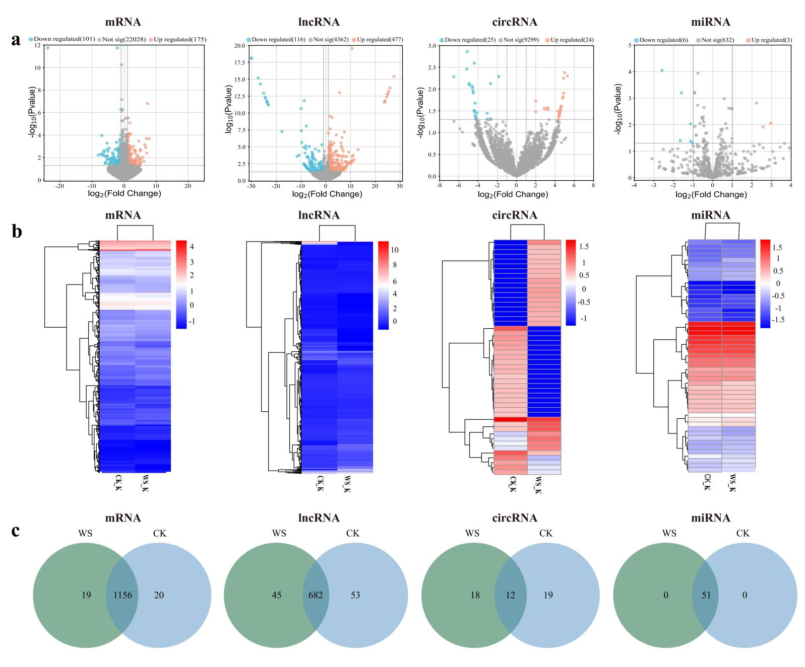

Fig 1. Detected mRNAs and non-coding RNAs in the kidneys of O. sibirica exposed to water-shortage stress (WS). (a)Volcano plot comparing the DEGs in WS versus control group (CK); blue indicates downregulated genes, and red indicates upregulated genes. (b) Cluster analysis of differentially expressed genes (DEGs) in different groups, where the x-axis indicates the sample name and the y-axis indicates the normalized fragments per kilobase of transcript per million mapped reads (FPKM) value of the DEGs. A darker red colour indicates stronger expression, whereas a darker blue colour indicates lower expression. (c)Venn analysis of mRNA, lncRNA,circRNAs and miRNAs detected between the two groups.

Prediction of mRNAs targeted by DEncRNAs
Based on the competing endogenous RNA (ceRNA) theory, this study aimed to identify lncRNA-target gene pairs sharing common miRNA binding sites, and to construct a ceRNA regulatory network with lncRNAs and circRNAs as decoys, miRNAs as core molecules, and mRNAs as targets. For the association analysis between lncRNAs/circRNAs and mRNAs, An intersection analysis was performed to identify the association between the target genes of differentially expressed lncRNAs/circRNAs and differentially expressed mRNAs. A total of 342 DEncRNA-mRNA targeting relationships were obtained in the WS versus CK groups, including 247 lncRNA-mRNA pairs, 44 circRNA-mRNA pairs, and 51 miRNA-mRNA pairs.
Since lncRNAs can serve as precursor molecules of miRNAs, it was necessary to filter out lncRNAs that might be miRNA precursors when identifying miRNA-targeting lncRNAs. The targeting relationships between lncRNAs/circRNAs and miRNAs were further predicted, resulting in 1,686 DEncRNA-miRNA targeting relationships, including 1,606 lncRNA-miRNA pairs and 80 circRNA-miRNA pairs (S8 Table and S9).
Functional annotation of tar get mRNAs
GO and KEGG pathway enrichment analyses identified 49 significantly enriched GO terms (31 upregulated, 18 downregulated; Fig. 2a, S10 Table) and 46 significantly enriched KEGG pathways (27 upregulated, 29 downregulated; Fig. 2b, S11 Table). Notably, substance metabolism-related pathways were prominently enriched. Upregulated terms included: GO terms: fatty acid transport (GO:0015908), long-chain fatty acid transport (GO:0015909), lipid metabolic process (GO:0006629), arachidonic acid secretion (GO:0050482), and fatty acid derivative transport (GO:1901571); KEGG pathways: aldosterone synthesis and secretion (rno04925) and insulin secretion (rno04911). In contrast, the following pathways were significantly downregulated: oxidation-reduction process (GO:0055114), endoplasmic reticulum membrane (GO:0005789), folate biosynthesis (rno00790), and arginine and proline metabolism (rno00330).
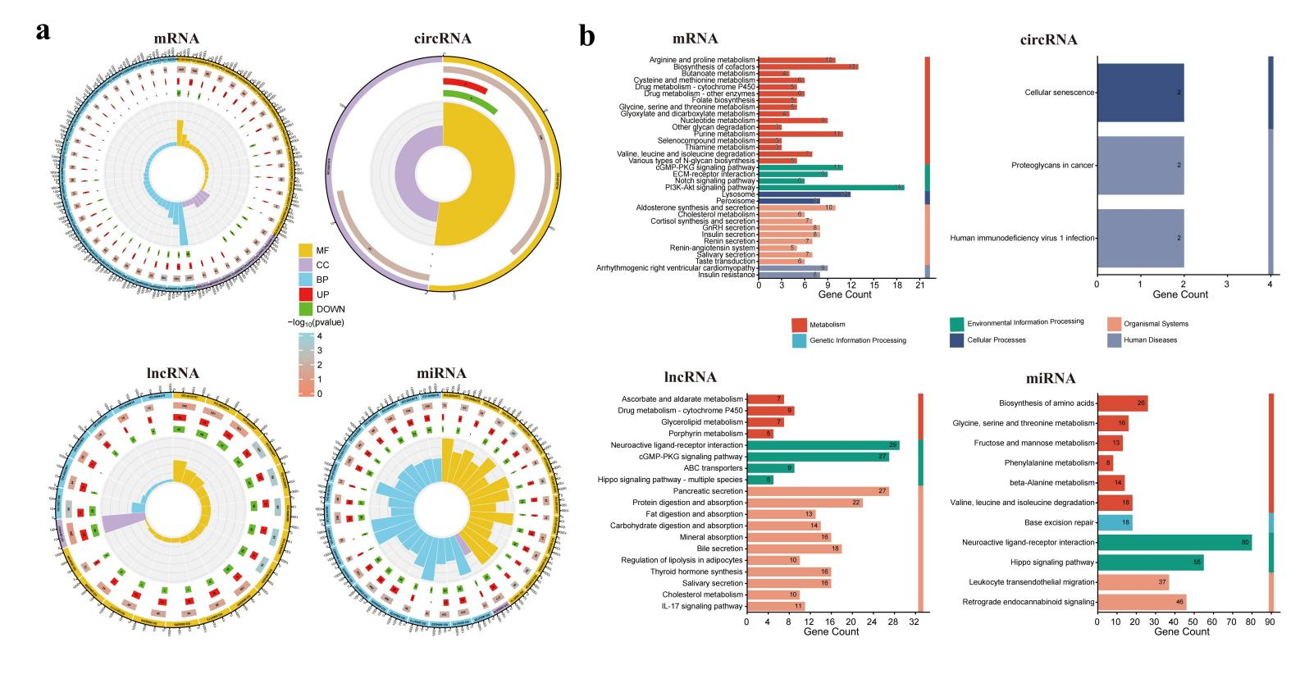
Fig 2. Functional analysis of differentially expressed target mRNAs and DEncRNAs via GO and KEGG enrichment analyses. (a) Results of GO enrichment analysis for the four types of RNAs. There are four circles from the outside to the inside. The first circle represents the enrichment factor value of each category (the number of differentially expressed genes in the category divided by the number of background genes), and each small grid of the auxiliary background line represents 0.1. The second circle shows the number of background genes in each category and their Q-values or P-values: longer bars indicate a larger number of genes, and darker red indicates a smaller value. The third circle indicates the upregulated or downregulated status of enrichment: red represents upregulation, and green represents downregulation. The fourth circle shows the enrichment categories: longer bars indicate a larger number of genes, and different colors represent different categories. Note: BP=Biological Process, CC=Cellular Component, MF=Molecular Function.(b) Kyoto Encyclopedia of Genes and Genomes (KEGG) pathway analysis. The P-value of significantly enriched KEGG pathways is < 0.05, and different colors represent different enriched categories. Both GO and KEGG analyses were visualized using a bioinformatics tool, which is a free online platform for data analysis (www.bioinformatics.com.cn).
Functional Annotation of Non-Coding RNAs
Functional enrichment analysis of differentially expressed lncRNAs identified 33 significantly upregulated and 75 significantly downregulated GO terms (S12 Table), as well as 8 significantly upregulated and 4 significantly downregulated KEGG pathways (S13 Table). In the co-localization relationship analysis, 36 significantly upregulated and 43 significantly downregulated GO terms were detected (S14 Table). Additionally, this analysis found 10 significantly upregulated and 3 significantly downregulated KEGG pathways. (S15 Table). Notably, transmembrane transport-related pathways were significantly enriched in both upregulated GO term datasets, including transmembrane transporter activity (GO:0022857), active transmembrane transporter activity (GO:0022804), transmembrane transport (GO:0055085), ion transmembrane transporter activity (GO:0015075, GO:0015081), and cation transmembrane transporter activity (GO:0008324). Additionally, several salt ion exchange-related pathways were prominently enriched, such as neurotransmitter:sodium symporter activity (GO:0005326), solute:cation symporter activity (GO:0015294), and solute:sodium symporter activity (GO:0015370) (Fig. 2a). For KEGG pathways, those related to substance metabolism and absorption were significantly upregulated, including Pancreatic secretion (rno04972), Glycerolipid metabolism (rno00561), and Fat digestion and absorption (rno04975). In contrast, downregulated pathways included Metabolic pathways (rno01100), Cholesterol metabolism (rno04979), and the Citrate cycle (TCA cycle) (rno00020) (Fig. 2b).
Functional enrichment analysis was conducted on the identified differentially expressed circRNAs. In the co-expression relationship analysis, 145 upregulated GO terms and 126 downregulated GO terms were obtained, among which only transcription regulator activity (GO:0140110) was significantly enriched (Fig. 2a, S16 Table). For KEGG pathway analysis, 16 significantly upregulated pathways and 57 significantly downregulated pathways were detected (S17 Table). Among these, only the upregulated pathway Proteoglycans in cancer (rno05205) and the downregulated pathways Cellular senescence (rno04218) and Human immunodeficiency virus 1 infection (rno05170) were significantly enriched (Fig. 2b).
Functional enrichment analysis was performed on the identified differentially expressed miRNAs. In the co-expression relationship analysis, 46 significantly upregulated GO terms and 48 significantly downregulated GO terms were obtained (S18 Table); meanwhile, 16 significantly upregulated KEGG pathways and 14 significantly downregulated KEGG pathways were detected (S19 Table). Among these results, pathways related to ion transmembrane transport were significantly enriched, including G-protein coupled receptor activity (GO:0004930), potassium ion transport (GO:0006813), metal ion transport (GO:0030001), gated channel activity (GO:0022836), ion gated channel activity (GO:0022839), and potassium channel activity (GO:0005267). In contrast, terms such as Wnt signaling pathway (GO:0016055), apoptotic process (GO:0006915), cell death (GO:0008219), and programmed cell death (GO:0012501) were significantly downregulated (Fig. 2a). For KEGG pathways, those related to substance metabolism were significantly upregulated, including Insulin secretion (rno04911), Fatty acid biosynthesis (rno00061), Fatty acid metabolism (rno01212), and Fatty acid degradation (rno00071). Conversely, Fructose and mannose metabolism (rno00051) and Carbon metabolism (rno01200) were significantly downregulated.

lncRNA/circRNA-miRNA-mRNA Network Analysis
Using the overlapping mRNAs between lncRNA-mRNA pairs and miRNA-mRNA pairs, a three-component (lncRNA/miRNA/mRNA) ceRNA regulatory network was constructed to identify RNAs associated with water-deficit adaptation in the kidney cells of O. sibirica under water-restriction stress. Based on the negative regulatory relationships between miRNAs and lncRNAs/circRNAs, we conducted a comparative analysis between the target mRNAs of downregulated DElncRNAs and DEmRNAs between the WS group and CK group. The results showed that only 1 DEmRNA might be directly regulated by DElncRNAs. In contrast, there was no overlap between the source genes (targets) of DEcircRNAs and DEmRNAs, indicating that DEmRNAs in the kidneys of O. sibirica under water-restriction stress are not directly regulated by DEcircRNAs (Fig. 3a).
To establish the lncRNA-miRNA, circRNA-miRNA, and miRNA-mRNA interactions between DEmRNAs of the WS and CK groups across the three networks, a Pearson correlation coefficient of ≥ 0.85 was used to identify lncRNAs and protein-coding genes. Subsequently, the lncRNA-miRNA-mRNA co-expression network was constructed using Cytoscape software. The analysis yielded 140,680 mRNA results that had targeting relationships with miRNAs and met the Pearson threshold; over 1.4 million lncRNA results that had targeting relationships with miRNAs and satisfied the Pearson threshold; and 338,617 circRNA results that had targeting relationships with miRNAs. Additionally, 5,973 correlation analysis results were obtained for mRNAs and lncRNAs that simultaneously had targeting relationships with miRNAs (S20 Table and S21).
The network revealed associations among 23 lncRNA nodes, 2 miRNA nodes, 2 mRNA nodes, and 3 circRNA nodes. Among these, downregulated lncRNAs (TCONS_00089519, TCONS_00089860, TCONS_00048848, TCONS_00091190), downregulated circRNAs (circ_0015772, circ_0014425, circ_0018269), a downregulated novel gene XLOC_010352, alpha-L-iduronidase (IDUA), and upregulated miRNAs (miR-188-3p, miR-143-5p) were identified as the most affected RNAs (Fig. 3b). The network was further refined to construct an lncRNA/circRNA-miRNA-mRNA network, which consisted of 27 lncRNA-miRNA pairs, 2 mRNA-miRNA pairs, and 4 circRNA-miRNA pairs, including 4 lncRNA hubs (TCONS_00041669, TCONS_00090772, TCONS_00052130, TCONS_00056896) and 1 circRNA hub (circ_0015772) (Fig. 3c).

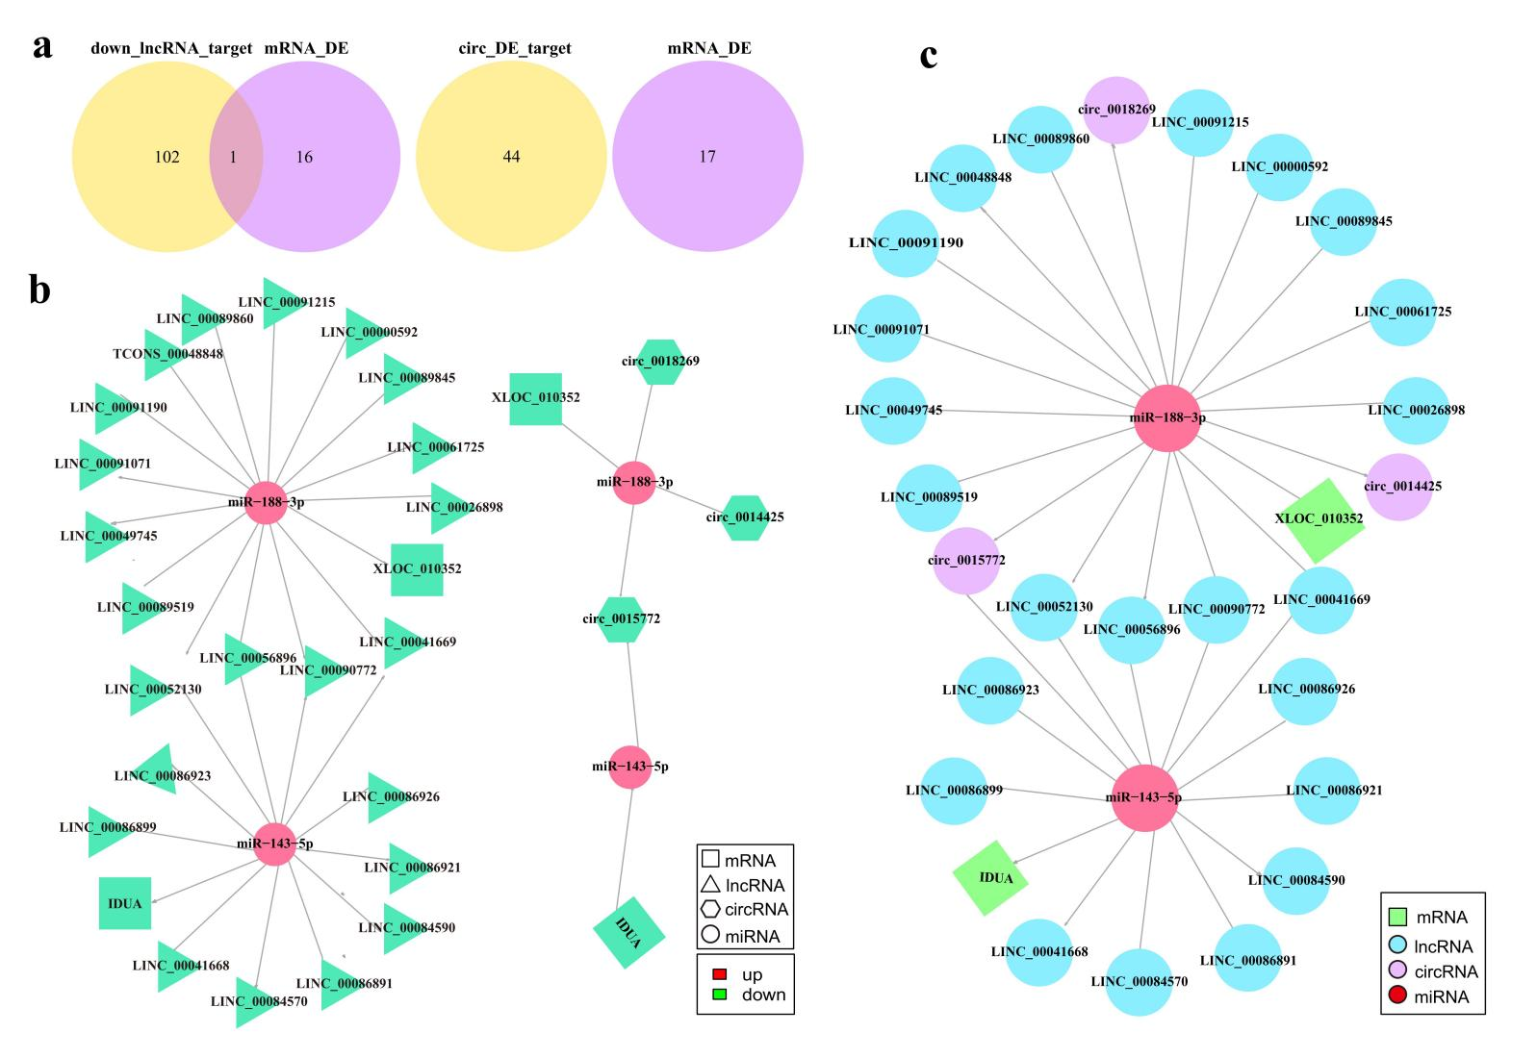

Fig 3. Analysis of ncRNA interaction networks. (a) Venn diagram of comparative analysis between mRNAs targeted by DElncRNAs/DEcircRNAs and DEmRNAs between the WS and CK groups. (b) Analysis of ncRNA interaction networks. Triangular nodes represent lncRNAs; hexagonal nodes represent circRNAs; circular nodes represent miRNAs; square nodes represent mRNAs. Red nodes indicate upregulated genes, and green nodes indicate downregulated genes. (c) Construction of lncRNA/circRNA-miRNA-mRNA network relationships. Blue nodes represent lncRNAs; purple nodes represent circRNAs; red nodes represent miRNAs; green nodes represent mRNAs. The network was analyzed using miRanda software and visualized using Cytoscape V3.2 (http://cytoscape.org/).

Discussion

Mechanism of Non-Coding RNAs in Water Stress Adaptation of O. sibirica
Through whole-transcriptome analysis in this study, a variety of differentially expressed non-coding RNAs (including lncRNAs, miRNAs, and circRNAs) were identified in the kidney tissues of O. sibirica. These molecules play crucial regulatory roles in the process of water stress adaptation. The functions of target genes of DElncRNAs are mainly involved in pathways that support O. sibirica’s adaptation to arid environments, such as transmembrane proteins, ion transmembrane transport, regulation of tissue cell processes, tissue cell responses to stimuli, and lipid metabolism[31, 32].
Under water stress conditions, O. sibirica may regulate the expression of these lncRNAs to maintain cellular ion homeostasis and normal metabolism, thereby enhancing tolerance to water stress. For instance, the enrichment of functions related to transmembrane proteins and ion transmembrane transport facilitates the precise regulation of water and ion exchange between the intracellular and extracellular environments during water scarcity, ensuring the stability of cellular physiological functions[33]. In contrast, the functions of target genes of DEmiRNAs (e.g., miR-143-5p) are concentrated in ion exchange and transport. miRNAs can inhibit the expression of target mRNAs through complementary base pairing, thereby regulating ion exchange and transport processes. This regulation enables O. sibirica to maintain water-salt balance under water stress, supporting its adaptation to water-deficient environments[34].
In the constructed lncRNA-miRNA-mRNA and circRNA-miRNA-mRNA regulatory networks, the XLOC_010352 (novel gene) and IDUA genes were identified as key molecules involved in the adaptation of O. sibirica kidneys to water-deficient environments. Among them, the enzyme encoded by IDUA may be involved in the lysosomal degradation of glycosaminoglycans, and mutations in IDUA can cause multi-organ damage [4, 35]. Meanwhile, IDUA can act as a promoter and enhancer for solute carrier family 26 member 1 (SLC26A1) [36-38]. Previous studies have shown that SLC26A6 affects kidney stone susceptibility by mediating chloride/oxalate exchange[39]; biallelic mutations in SLC26A1 were detected in two unrelated patients with calcium oxalate kidney stones, and all mutations resulted in reduced transporter activity, thereby leading to recessive Mendelian kidney stones[40]. Additionally, a homozygous missense mutation in SLC26A1 was found in samples from a kidney stone patient, who exhibited normal renal function and normal 24-hour urinary oxalate levels[40, 41]. SLC26A1 primarily mediates anion transport through electroneutral sulfate-oxalate, sulfate-bicarbonate, or oxalate-bicarbonate exchange[42-44], and its critical role in mammalian oxalate and sulfate homeostasis is considered to be closely associated with kidney stone disease[45].
Based on this, it is hypothesized that in O. sibirica, the regulatory network may inhibit SLC26A1 activity by downregulating IDUA expression, thereby reducing the formation of urinary oxalate and sulfate stones in the kidneys during water scarcity and protecting tissues from damage(Fig 4).
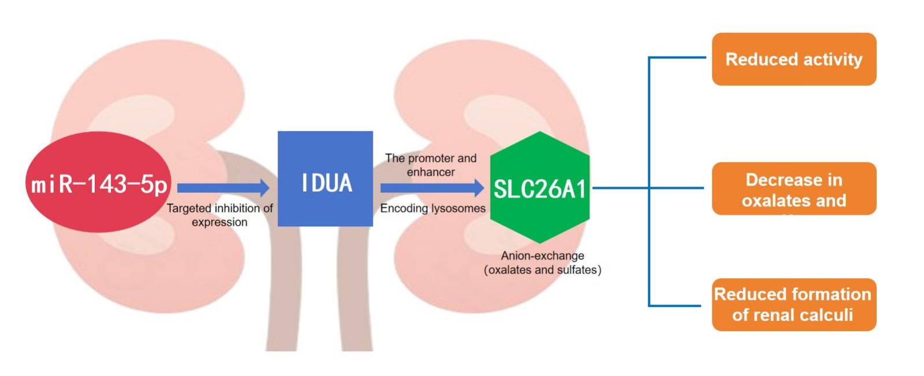
Fig 4. Mechanism of miRNA-mediated IDUA regulation in inhibiting kidney stone formation under water stress. Red represents miRNAs, blue and green represent regulated genes, and orange represents biological effects; arrows indicate the direction of regulation. This figure was created using Adobe Illustrator 2023 software.

As a newly identified gene, the function of XLOC_010352 remains unclear; however, it is known to be regulated by miR-188-3p and may be involved in spermatogenesis pathways [46, 47]. This potential association with spermatogenesis is particularly relevant to the drought adaptation of rodents—an order of mammals renowned for their exceptional ability to thrive in arid and semi-arid regions (e.g., deserts, steppes) via specialized physiological traits. Unlike large mammals that rely on long-distance water foraging, rodents have evolved intrinsic water-saving mechanisms (e.g., producing highly concentrated urine via elongated renal loops of Henle, minimizing respiratory water loss through nasal countercurrent heat exchange) and metabolic water utilization (generating water from fat oxidation, as seen in kangaroo rats Dipodomys spp.) to survive with minimal or no free water intake [48-50]. For these species, balancing survival-focused water/energy conservation and spermatogenesis is not just a physiological trade-off, but a key evolutionary adaptation—one where ncRNAs likely act as fine-tuning regulators. MiRNAs participate in various processes during embryonic development, including cell proliferation, stem cell differentiation, developmental timing regulation, and stem cell division[51]. In studies related to spermatogenesis, miRNAs have been confirmed to dynamically regulate multiple physiological processes and associated proteins, indirectly affecting sperm maturation, motility, and Sertoli cell maturation[52-54], as well as promoting spermatogenesis by facilitating the development of spermatogenic cells[47]. For drought-adapted rodents, this miRNA-mediated regulatory network exhibits species-specific adjustments aligned with their arid survival strategies:. In obligate desert rodents (e.g., Dipodomys merriami), miR-188-3p may adopt a "prioritized conservation" mode: while maintaining low-level expression of XLOC_010352 to preserve spermatogonial stem cell viability (preventing permanent reproductive failure), it simultaneously upregulates targeting of genes involved in energy-wasting late spermatogenic stages (e.g., reducing acrosome maturation-related protein synthesis) [47]. This ensures that metabolic resources are diverted to renal water reabsorption (via genes like aquaporin 2(AQP2)) and fat storage, without completely halting sperm production [55, 56].
In facultative arid rodents (e.g.,Mus musculus in semi-arid grasslands), miR-188-3p’s regulation of XLOC_010352 may be more plastic: during short-term drought, it moderately suppresses spermatogenesis to save water/energy [57]; once rainfall resumes, it rapidly downregulates inhibition of XLOC_010352, triggering a "reproductive rebound"—a trait critical for rodents with short lifespans and high population turnover [58, 59]. Notably, the regulatory link between XLOC_010352 and miR-188-3p intersects with rodent-specific drought adaptation pathways in unique ways. This "tissue-crossing" regulation by a single miRNA reflects a key evolutionary innovation in rodents—consolidating reproductive and osmoregulatory adaptation into a streamlined ncRNA network(Fig. 5). Such integration ensures that even under extreme water scarcity, rodents can maintain sufficient spermatogenic activity to sustain populations, while maximizing survival via their signature water-saving traits [60]. This underscores that rodent drought adaptation is not just a collection of isolated physiological features, but a coordinated system where reproductive regulation via ncRNAs acts as a vital bridge between individual survival and species persistence in arid environments.
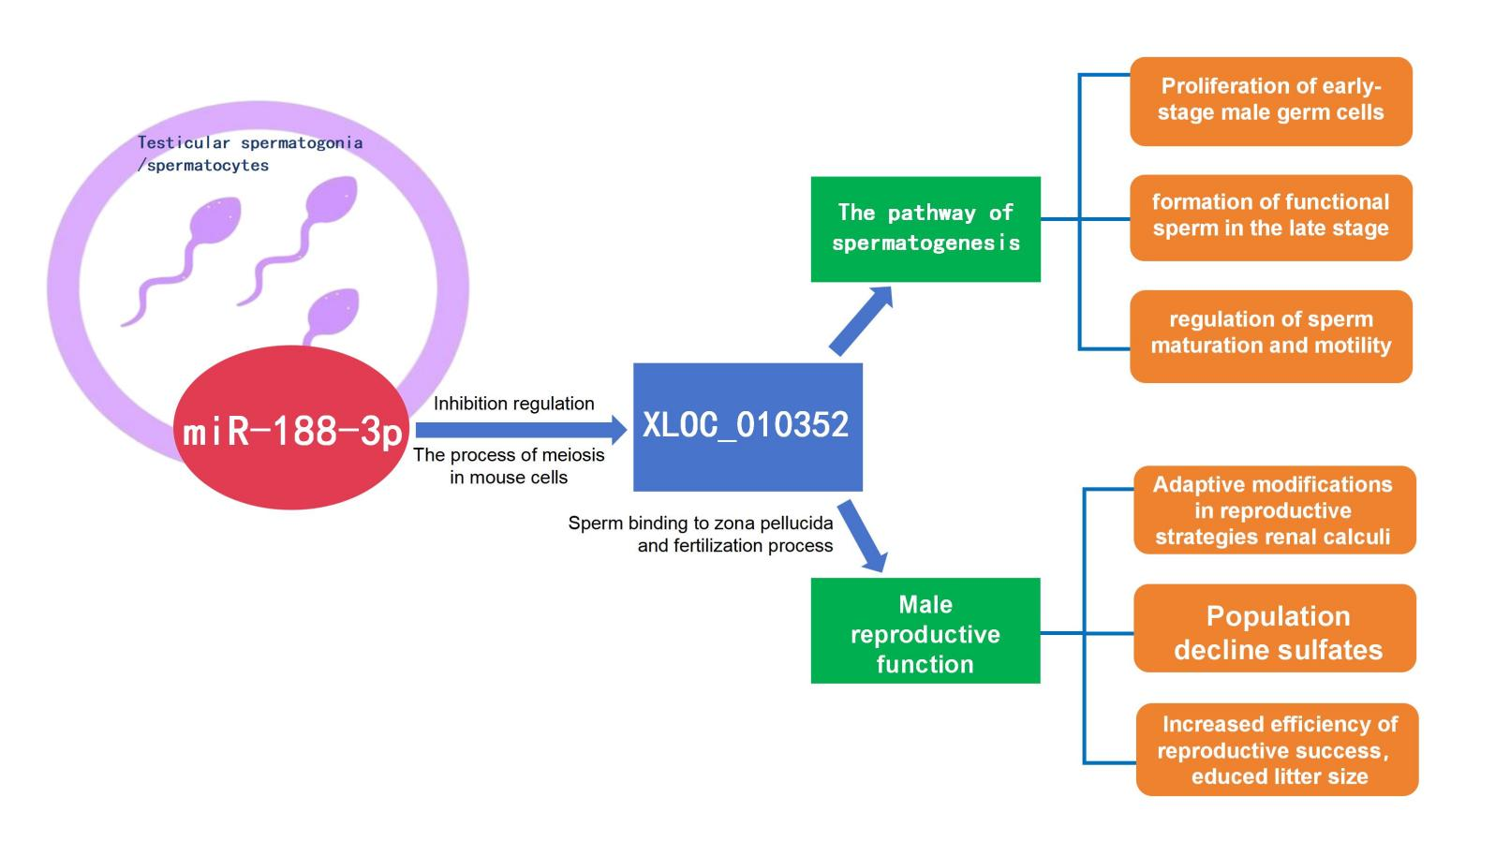
Fig 5. miRNA-mediated regulation of XLOC_010352 involved in reproductive strategies under water stress. Red represents miRNAs, blue represents regulated genes, green represents involved mechanisms, and orange represents biological effects; arrows indicate the direction of regulation. This figure was created using Adobe Illustrator 2023 software.

Comparison and Association with Other Regulatory Factors or Pathways
In the complex process of mammalian adaptation to environmental changes, the regulation of ncRNAs does not exist in isolation; instead, it forms an elaborate coordinated network with various regulatory factors and signaling pathways. Transcription factors, as classical regulators of gene expression, have been extensively studied for their mechanism of directly activating or repressing gene transcription by recognizing specific DNA sequences[14]. For instance, under drought stress, certain transcription factors in mammals—such as members of the NF-κB family—can enhance cellular tolerance by activating the expression of downstream anti-apoptotic genes and stress-responsive genes.
Compared with these transcription factors, the regulation of ncRNAs exhibits more prominent spatiotemporal specificity and multi-level characteristics[31]. This multi-level regulatory mode enables O. sibirica to adjust its gene expression profile more rapidly and precisely under water stress. For example, in kidney tissues, lncRNAs can regulate the transcription of adjacent ion channel genes through cis-acting effects, while miRNAs inhibit the translation of these genes by targeting their 3' untranslated regions (3'UTRs). Through these synergistic activities, the dynamic balance of ion transport was maintained.
The crosstalk between ncRNAs and other signaling pathways is particularly prominent in the water stress adaptation of O. sibirica. The renin-angiotensin system (RAS), a core pathway regulating water-salt balance, contains key molecules such as angiotensin II (AngII), which can promote renal reabsorption of water and sodium by activating the AT1 receptor. In this study, it was found that the differentially expressed lncRNA XLOC_010352 may sequester miR-188-3p to relieve the inhibition of the angiotensin-Converting Enzyme 2 (ACE2) gene. As a negative regulator of the Rat Sarcoma Oncogene (RAS) pathway, upregulated ACE2 expression can attenuate the effect of AngII. This suggests that ncRNAs may regulate the balance of the RAS pathway to prevent kidney damage caused by excessive reabsorption under water stress[33].
In addition, the role of the cellular autophagy pathway in responding to nutrient and water deficiency has been confirmed. The enrichment of autophagy-related GO terms (e.g., autophagy) in this study implies that lncRNAs may be involved in activating cellular autophagy by regulating the expression of autophagy-related genes such as Beclin 1 Autophagy Related(Beclin1) and Microtubule-Associated Protein 1 Light Chain 3(LC3). Together with the RAS pathway, they form a dual protective mechanism of "water conservation-damage repair." Similar crosstalk between pathways has been reported in plant stress responses; for example, ncRNAs can simultaneously regulate the Abscisic Acid (ABA) signaling pathway and MAPK pathway to enhance drought resistance in plants[61].
This study used whole-transcriptome sequencing of kidneys from water-stressed (WS) and control (CK) Orientallactaga sibirica to reveal ncRNAs’ core role in drought adaptation. A ceRNA-based regulatory network was constructed, these core nodes enrich in transmembrane transport (e.g., ion balance) and substance metabolism (e.g., lipid processing) pathways.
miR-143-5p targets IDUA to reduce SLC26A1 activity and kidney stones; miR-188-3p regulates XLOC_010352 to adjust reproduction. NcRNAs also crosstalk with RAS and autophagy, forming a "water retention-damage repair" system. In summary, the lncRNA/circRNA-miRNA-mRNA network coordinates ion balance, metabolism, and reproduction for adaptation. that XLOC_010352, regulated by miR-188-3p, may act on spermatogenesis pathways influencing the reproductive process of O. sibirica and implying adaptive changes in its reproductive strategy under water stress. However, its specific action pathways and functions require further verification in subsequent studies.
This study provides a paradigm for mammalian extreme environment adaptation mechanisms. In-depth analysis of the interactions between ncRNAs and other regulatory networks still faces numerous challenges. Current regulatory network models are mainly based on bioinformatics predictions, lacking in vivo and in vitro functional validation. Future studies could use CRISPR-Cas9 technology to specifically knockout lncRNA XLOC_010352 in the kidneys of O. sibirica. Through transcriptome sequencing and metabolome analysis, the downstream target genes it regulates and the signaling pathways it affects could be systematically identified. Meanwhile, dual-luciferase reporter gene assays could be used to verify the direct interactions between lncRNAs, miRNAs, and target mRNAs. By integrating multi-omics data and functional experiments, it is expected to construct a more comprehensive regulatory network for water stress adaptation in O. sibirica, thereby providing a model for understanding the molecular evolutionary mechanisms underlying mammalian adaptation to extreme environments.
Conclusion
This study used whole-transcriptome sequencing of kidneys from water-stressed (WS) and control (CK) Orientallactaga sibirica to reveal ncRNAs’ core role in drought adaptation. High-quality data (Q30 > 91%) identified 22,304 DEmRNAs, 4,955 DElncRNAs, 9,349 DEcircRNAs, and 641 DEmiRNAs, validated by RT-qPCR. A ceRNA-based regulatory network (342 DEncRNA-mRNA, 1,686 DEncRNA-miRNA interactions) was constructed, with core nodes including TCONS00089519, circ_0015772, miR-188-3p/143-5p, and IDUA/XLOC_010352. These RNAs enrich in transmembrane transport (e.g., ion balance) and substance metabolism (e.g., lipid processing) pathways.
Key mechanisms: miR-143-5p targets IDUA to reduce SLC26A1 activity and kidney stones; miR-188-3p regulates XLOC_010352 to adjust reproduction. NcRNAs also crosstalk with RAS and autophagy, forming a "water retention-damage repair" system. In summary, the lncRNA/circRNA-miRNA-mRNA network coordinates ion balance, metabolism, and reproduction for adaptation. This study provides a paradigm for mammalian extreme environment adaptation mechanisms.
Supporting information
S1 Fig. Distribution of lncRNA types of O.sibirica’s kidney
S2 Fig. Source statistics of circRNA of O.sibirica’s kidney
S3 Fig. Relative expression levels of 26 drought adaptation-associated genes in the kidney of O.sibirica
S1 Table. RT-qPCR primer synthesis information
S2 Table. Raw sequencing data statistics for transcriptome sequencing of O.sibirica kidney under water restriction stress
S3 Table. Reads compared to the reference genome of O.sibirica kidney under water restriction stress
S4 Table. CircRNAs in the Top 10 TPM Values of Expression Levels
S5 Table. Length distribution statistics of miRNAs fragments in kidney of O.sibirica
S6 Table. miRNAs classification annotations in kidney of O.sibirica
S7 Table. Statistics of the number of miRNAs at different TPM levels in kidney of O.sibirica
S8 Table. Top10 targeting results of lncRNA and miRNA
S9 Table. Top10 targeting results of circRNA and miRNA
S10 Table. GO enrichment analysis of mRNA regulation mechanism of O.sibirica’s kidney
S11 Table. KEGG enrichment analysis of mRNA regulation mechanism of O.sibirica’s kidney
S12 Table. Top 20 GO enrichment analysis of lncRNA co-expression regulation mechanism of O.sibirica’s kidney
S13 Table. KEGG enrichment analysis of lncRNA co-expression regulation mechanism of O.sibirica’s kidney
S14 Table. GO enrichment analysis of lncRNA co-location regulation mechanism of O.sibirica’s kidney
S15 Table. KEGG enrichment analysis of lncRNA co-location regulation mechanism of O.sibirica’s kidney
S16 Table. Top 10 circRNAs GO enrichment analysis of differentially expressed genes in kidney of O.sibirica
S17 Table. Top10 KEGG enrichment analysis of circRNA regulation mechanism of O.sibirica’s kidney
S18 Table. Top 10 miRNAs GO enrichment analysis of differentially expressed genes in kidney of O.sibirica
S19 Table. KEGG enrichment analysis of miRNA regulation mechanism of O.sibirica’s kidney
S20 Table. Top10 Targeting results of lncRNA and miRNA
S21 Table. Top10 Targeting results of circRNA and miRNA
Acknowledgments
We would like to express our gratitude to Fan Bu and other graduate students from the College of Grassland science, Inner Mongolia Agricultural University, as well as Dr. Suwen Yang from the College of Grassland science, Xinjiang Agricultural University, for their valuable support during the sample collection process. The authors have reviewed and edited the output and take full responsibility for the content of this publication.
References
1. Shukla PR, Skeg J, Buendia EC, Masson-Delmotte V, Prtner HO, Roberts DC, et al. Climate Change and Land: an IPCC special report on climate change, desertification, land degradation, sustainable land management, food security, and greenhouse gas fluxes in terrestrial ecosystems. 2019. https://philpapers.org/rec/SHUCCA-2.
2. Zhang L, Yuan F, He X. Probabilistic assessment of global drought recovery and its response to precipitation changes. Geophysical Research Letters. 2024;51(1):e2023GL106067. doi:10.1029/2023GL106067.
3. Riddell E, Iknayan K, Hargrove L, Tremor S, Patton J, Ramirez R, et al. Exposure to climate change drives stability or collapse of desert mammal and bird communities. Science. 2021;371(6529):633-6. doi:10.1126/science.abd4605.
4. Wang G, Zhang Q, Pokhrel Y, Farinotti D, Wang J, Singh VP, et al. Exogenous moisture deficit fuels drought risks across China. npj Climate and Atmospheric Science. 2023;6(1):217. doi:10.1038/s41612-023-00543-8.
5. Juillard LQ, Ramp D. The impacts of drought on the health and demography of eastern grey kangaroos. Animals. 2022;12(3):256. doi:10.3390/ani12030256.
6. Jiang G, Liu J, Xu L, Yu G, He H, Zhang Z. Climate warming increases biodiversity of small rodents by favoring rare or less abundant species in a grassland ecosystem. Integrative Zoology. 2013;8(2):162-74. doi:10.1111/1749-4877.12027.
7. Lacher Jr TE, Davidson AD, Fleming TH, Gómez-Ruiz EP, McCracken GF, Owen-Smith N, et al. The functional roles of mammals in ecosystems. Journal of Mammalogy. 2019;100(3):942-64. doi:10.1093/jmammal/gyy183.
8. Kearney, M., Shine, R. & Porter, W. P. The potential for behavioral thermoregulation to buffer "cold-blooded" animals against climate warming. Proceedings of the National Academy of Sciences.2009;106:3835-3840. doi:10.1073/pnas.0808913106.
9. Scheffers BR, Edwards DP, Diesmos A, Williams SE, Evans TA. Microhabitats reduce animal's exposure to climate extremes. Global change biology. 2014;20(2):495-503. doi:10.1111/gcb.12439
10. Kryštufek B, Janžekovič F, Shenbrot G, Ivajnšič D, Klenovšek T. Phenotypic plasticity under desert environment constraints: mandible variation in the dwarf fat-tailed jerboa, Pygeretmus pumilio (Rodentia: Dipodidae). Canadian Journal of Zoology. 2019;97(10):940-51. doi:10.1139/cjz-2019-0029
11. Ji Y, Yuan S, Fu H, Yang S, Bu F, Li X, et al. Activity strategy and pattern of the Siberian jerboa (Orientallactaga sibirica) in the Alxa desert region, China. PeerJ. 2021;9:e10996. doi:10.7717/peerj.10996.
12. Zhang D, Pan J, Zhou H, Cao Y. Evidence from ileum and liver transcriptomes of resistance to high-salt and water-deprivation conditions in camel. Zoological letters. 2020;6(1):8. doi:10.1186/s40851-020-00159-3.
13. Nojima T, Proudfoot NJ. Mechanisms of lncRNA biogenesis as revealed by nascent transcriptomics. Nature reviews Molecular cell biology. 2022;23(6):389-406. doi:10.1038/s41580-022-00551-1.
14. Li X, Melo LA, Bussemaker HJ. Benchmarking and building DNA binding affinity models using allele-specific and allele-agnostic transcription factor binding data. Genome Biology. 2024;25(1):284. doi:10.1186/s13059-024-03424-2.
15. Roden C, Gladfelter AS. RNA contributions to the form and function of biomolecular condensates. Nature Reviews Molecular Cell Biology. 2020;22(3):183-95. doi:10.1038/s41580-020-0264-6.
16. So BR, Dreyfuss G, editors. Myriad RNAs and RNA-binding proteins control cell functions, explain diseases, and guide new therapies. Cold Spring Harbor Symposia on Quantitative Biology; 2020: Cold Spring Harbor Laboratory Press. doi:10.1101/sqb.2019.84.040469.
17. Quinodoz SA, Jachowicz JW, Bhat P, Ollikainen N, Banerjee AK, Goronzy IN, et al. RNA promotes the formation of spatial compartments in the nucleus. Cell. 2021;184(23):5775-90. e30. doi:10.1016/j.cell.2021.10.014.
18. Markaki Y, Chong JG, Wang Y, Jacobson EC, Luong C, Tan SY, et al. Xist nucleates local protein gradients to propagate silencing across the X chromosome. Cell. 2021;184(25):6174-92. e32. doi:10.1016/j.cell.2021.10.022.
19. Hallegger M, Chakrabarti AM, Lee FC, Lee BL, Amalietti AG, Odeh HM, et al. TDP-43 condensation properties specify its RNA-binding and regulatory repertoire. Cell. 2021;184(18):4680-96. e22. doi:10.1016/j.cell.2021.07.018.
20. Bhat P, Honson D, Guttman M. Nuclear compartmentalization as a mechanism of quantitative control of gene expression. Nature Reviews Molecular Cell Biology. 2021;22(10):653-70. doi:10.1038/s41580-021-00387-1.
21. Deng X, Tang L, Liu L. GATLncLoc+ C&S: Prediction of LncRNA subcellular localization based on corrective graph attention network. bioRxiv. 2024:2024.03. 08.584063. doi:10.1101/2024.03.08.584063.
22. Schmittgen TD, Livak KJ. Analyzing real-time PCR data by the comparative CT method. Nature protocols. 2008;3(6):1101-8. doi:10.1038/nprot.2008.73.
23. Langmead B, Trapnell C, Pop M, Salzberg SL. Ultrafast and memory-efficient alignment of short DNA sequences to the human genome. Genome biology. 2009;10(3):R25. doi:10.1186/gb-2009-10-3-r25.
24. Zhou L, Chen J, Li Z, Li X, Hu X, Huang Y, et al. Integrated profiling of microRNAs and mRNAs: microRNAs located on Xq27. 3 associate with clear cell renal cell carcinoma. PloS one. 2010;5(12):e15224. doi:10.1371/journal.pone.0015224.
25. Young MD, Wakefield MJ, Smyth GK, Oshlack A. goseq: Gene Ontology testing for RNA-seq datasets. R Bioconductor. 2012;8:1-25. https://www.researchgate.net/publication/238769214.
26. Mao X, Cai T, Olyarchuk JG, Wei L. Automated genome annotation and pathway identification using the KEGG Orthology (KO) as a controlled vocabulary. Bioinformatics. 2005;21(19):3787-93. doi:10.2307/1592215.
27. Friedländer MR, Mackowiak SD, Li N, Chen W, Rajewsky N. miRDeep2 accurately identifies known and hundreds of novel microRNA genes in seven animal clades. Nucleic acids research. 2012;40(1):37-52. doi:10.1093/nar/gkr688.
28. Wen M, Shen Y, Shi S, Tang T. miREvo: an integrative microRNA evolutionary analysis platform for next-generation sequencing experiments. BMC bioinformatics. 2012;13(1):140. doi:10.1186/1471-2105-13-140.
29. Wu H-J, Ma Y-K, Chen T, Wang M, Wang X-J. PsRobot: a web-based plant small RNA meta-analysis toolbox. Nucleic acids research. 2012;40(W1):W22-W8. doi:10.1093/nar/gks554.
30. Enright A, John B, Gaul U, Tuschl T, Sander C, Marks D. MicroRNA targets in Drosophila. Genome biology. 2003;4(11):P8. doi:10.1186/gb-2003-4-11-p8.
31. Zhao J, Xia H, Wu Y, Lu L, Cheng C, Sun J, et al. CircRNA_0026344 via miR-21 is involved in cigarette smoke–induced autophagy and apoptosis of alveolar epithelial cells in emphysema. Cell Biology and Toxicology. 2021;39(3):929-44. doi:10.1007/s10565-021-09654-5.
32. Mably JD, Wang D-Z. Long non-coding RNAs in cardiac hypertrophy and heart failure: functions, mechanisms and clinical prospects. Nature Reviews Cardiology. 2024;21(5):326-45. doi:10.1038/s41569-023-00952-5.
33. Kang H, Lee CJ. Transmembrane proteins with unknown function (TMEMs) as ion channels: electrophysiological properties, structure, and pathophysiological roles. Experimental & Molecular Medicine. 2024;56(4):850-60. doi:10.1038/s12276-024-01206-1.
34. Yang XZ, Wang CZ, Wang DH, Zhang XY. Specific Adaptive Mechanisms in Water‐Sodium Regulation in a Desert Rodent Fed With Salty Diets. Comprehensive Physiology. 2025;15(3):e70015. doi:10.1002/cph4.70015.
35. Li P, Wood T, Thompson JN. Diversity of mutations and distribution of single nucleotide polymorphic alleles in the human α-l-iduronidase (IDUA) gene. Genetics in Medicine. 2002;4(6):420-6. doi:10.1097/00125817-200211000-00004.
36. Sindic A, Schlatter E. Renal electrolyte effects of guanylin and uroguanylin. Current opinion in nephrology and hypertension. 2007;16(1):10-5. doi:10.1097/MNH.0b013e328011cb4a.
37. Soleimani M, editor Expression, regulation and the role of SLC26 Cl−/HCO3− exchangers in kidney and gastrointestinal tract. Epithelial Anion Transport in Health and Disease: The Role of the SLC26 Transporters Family: Novartis Foundation Symposium 273; 2006: Wiley Online Library. doi:10.1002/0470029579.ch7.
38. Kere J, editor Overview of the SLC26 family and associated diseases. Epithelial Anion Transport in Health and Disease: The Role of the SLC26 Transporters Family: Novartis Foundation Symposium 273; 2006: Wiley Online Library. doi:10.1002/0470029579.ch2.
39. Soleimani M. The role of SLC26A6-mediated chloride/oxalate exchange in causing susceptibility to nephrolithiasis. The Journal of Physiology. 2008;586(Pt 5):1205. doi:10.1113/jphysiol.2007.150565.
40. Gee HY, Jun I, Braun DA, Lawson JA, Halbritter J, Shril S, et al. Mutations in SLC26A1 cause nephrolithiasis. The American Journal of Human Genetics. 2016;98(6):1228-34. doi:10.1016/j.ajhg.2016.03.026.
41. Pfau A, López-Cayuqueo KI, Scherer N, Wuttke M, Wernstedt A, Fassrainer DG, et al. SLC26A1 is a major determinant of sulfate homeostasis in humans. The Journal of Clinical Investigation. 2023;133(3).doi:10.1172/JCI161849.
42. Xie Q, Welch R, Mercado A, Romero MF, Mount DB. Molecular characterization of the murine Slc26a6 anion exchanger: functional comparison with Slc26a1. American Journal of Physiology-Renal Physiology. 2002;283(4):F826-F38. doi:10.1152/ajprenal.00079.200.
43. Krick W, Schnedler N, Burckhardt G, Burckhardt BC. Ability of sat-1 to transport sulfate, bicarbonate, or oxalate under physiological conditions. American Journal of Physiology-Renal Physiology. 2009;297(1):F145-F54. doi:10.1152/ajprenal.90401.20.
44. Wu M, Heneghan JF, Vandorpe DH, Escobar LI, Wu B-L, Alper SL. Extracellular Cl− regulates human SO42−/anion exchanger SLC26A1 by altering pH sensitivity of anion transport. Pflügers Archiv-European Journal of Physiology. 2016;468(8):1311-32. doi:10.1007/s00424-016-1823-8.
45. Dawson PA, Russell CS, Lee S, McLeay SC, van Dongen JM, Cowley DM, et al. Urolithiasis and hepatotoxicity are linked to the anion transporter Sat1 in mice. The Journal of clinical investigation. 2010;120(3):706-12. doi:10.1172/JCI31474.
46. Song WY, Meng H, Wang XG, Jin HX, Yao GD, Shi SL, et al. Reduced micro RNA‐188‐3p expression contributes to apoptosis of spermatogenic cells in patients with azoospermia. Cell proliferation. 2017;50(1):e12297. doi:10.1111/cpr.12297.
47. Wang Y, Tian C-C, Jiao Y-Y, Liu M-R, Ma X-S, Jin H-X, et al. miR-188-3p-targeted regulation of ATG7 affects cell autophagy in patients with nonobstructive azoospermia. Reproductive Biology and Endocrinology. 2022;20(1):90. doi:10.1186/s12958-022-00951-0.
48. Cornejo-Latorre C, Cortés-Calva P, Álvarez-Castañeda ST. Peromyscus fraterculus (Rodentia: Cricetidae). Mammalian Species. 2021;53(1008):112-24. doi:10.1093/mspecies/seab010.
49. Schmidt-Nielsen K. Animal physiology: adaptation and environment: Cambridge university press; 1997. doi:10.2307/2403350.
50. Donald J, Pannabecker TL. Osmoregulation in desert-adapted mammals. Sodium and water homeostasis: comparative, evolutionary and genetic models: Springer; 2015. p. 191-211. doi:10.1007/978-1-4939-3213-9.
51. Salilew-Wondim D, Gebremedhn S, Hoelker M, Tholen E, Hailay T, Tesfaye D. The role of MicroRNAs in mammalian fertility: from gametogenesis to embryo implantation. International journal of molecular sciences. 2020;21(2):585. doi:10.3390/ijms21020585.
52. Khawar MB, Mehmood R, Roohi N. MicroRNAs: Recent insights towards their role in male infertility and reproductive cancers. Bosnian journal of basic medical sciences. 2019;19(1):31. doi:10.17305/bjbms.2018.3477.
53. Marcon E, Babak T, Chua G, Hughes T, Moens P. miRNA and piRNA localization in the male mammalian meiotic nucleus. Chromosome Research. 2008;16(2):243-60. do :10.1007/s10577-007-1190-6.
54. Dai B, Jiang J. Increased miR‐188‐3p in Ovarian Granulosa Cells of Patients with Polycystic Ovary Syndrome. Computational and Mathematical Methods in Medicine. 2021;2021(1):5587412. doi:10.1155/2021/5587412.
55. Schmidt-Nielsen K, Schmidt-Nielsen B. Water metabolism of desert mammals. Physiological Reviews. 1952;32(2):135-66. doi:10.1152/physrev.1952.32.2.135.
56. Pannabecker TL. Aquaporins in desert rodent physiology. The Biological Bulletin. 2015;229(1):120-8. doi:10.1086/BBLv229n1p120.
57. Kordonowy LL, MacManes MD. Characterization of a male reproductive transcriptome for Peromyscus eremicus (Cactus mouse). PeerJ. 2016;4:e2617. doi:10.7717/peerj.2617.
58. Sarli J, Lutermann H, Alagaili AN, Mohammed OB, Bennett NC. Reproductive patterns in the Baluchistan gerbil, Gerbillus nanus (Rodentia: Muridae), from western Saudi Arabia: the role of rainfall and temperature. Journal of Arid Environments. 2015;113:87-94. doi :10.1016/j.jaridenv.2014.09.007.
59. Sarli J, Lutermann H, Alagaili AN, Mohammed OB, Bennett NC. Seasonal reproduction in the Arabian spiny mouse, Acomys dimidiatus (Rodentia: Muridae) from Saudi Arabia: the role of rainfall and temperature. Journal of arid environments. 2016;124:352-9. doi :10.1016/j.jaridenv.2015.09.008.
60. Delany M. Ecology of small rodents in Africa. Mammal review. 1986;16(1):1-41. doi :10.1111/j.1365-2907.1986.tb00016.x.
61. Verma S, Dubey N, Mishra V, Kumar S, Sharma R, Sharma S, et al. Functional Genomics of Salt and Drought Stress Tolerance in the Temperate Crop Apple (Malus domestica). Journal of Plant Growth Regulation. 2024;43(11):3941-57. doi:10.1007/s00344-024-11363-2.
Funding
This work was supported by grants from the Inner Mongolia Agricultural University Major Projects (RZ1900001196), the Inner Mongolia Natural Science Foundation (2023MS03025), the Science and Technology Fundamental Resources Investigation Programme (2023FY100305), the Grassland Ecological Protection and Restoration Treatment Subsidy (Z75070050001-2110405), the 2022 Inner Mongolia Autonomous Region Youth Science and Technology Talent Development Plan (NJYT22044), and the basic scientific research business expenses of universities directly under Inner Mongolia Autonomous Region (BR220106, BR221307, BR221037).

Animal research
This study was conducted in accordance with the guidelines issued by the Animal Care and Treatment Ethics Committee of Inner Mongolia Agricultural University. The committee requires all researchers and students involved in wildlife and experimental animals to be certified in accordance with the requirements of the Inner Mongolia Agricultural University Ethics Committee (Protocol Number: NND2022093 and date of approval is 09.2022). All surgery was performed under isoflurane anesthesia, and all efforts were made to minimize suffering.
Conflicts of Interest
The animals were fed standard rat pellet chow (provided by Beijing KeAo Bioscience Co., Ltd., Beijing, China).Beijing KeAo Bioscience Co., Ltd. did not interfere with co-authors’ access to all of the study’s data, analysing and interpreting the data, preparing and publishing manuscripts independently. All authors declare no conflicts of interest.
Author Contributions:
Conceptualization, R.Z., and Y.L.J; methodology, R.Z., Y.L.J., D.Z., Y.L.and X.Y.Z.; formal analysis and data curation, X.L. , L.L.L. , R.Z. and Y.L.J.; writing—original draft preparation, R.Z.; writing—review and editing, X.D.W., S.Y., D.Z., Y.L., H.P.F. and X.Y.Z.; project administration, X.D.W.; funding acquisition, X.D.W., S.Y. and H.P.F. All authors have read and agreed to the published version of the manuscript.
Data availability
All genome-sequencing data generated in this project are available at NCBI BioProject under accession code PRJNA1181308.

